Contents
1 Hydris Field Glasses at a glance 6
1.1 Executive summary 6
1.2 Vision and principles 6
1.3 The problem in wastewater plants 7
1.4 Personas and jobs 8
1.5 The product family 9
1.6 One account, every surface 10
1.7 The operator's day 10
1.8 The core loops 11
1.9 Status, gaps and the path to pilot 13
1.10 How to read this book 14
2 Website and demo 15
2.1 Purpose and problem 15
2.2 Users and jobs 15
2.3 Scope 15
2.4 Key flows 16
2.5 Requirements 17
2.6 Experience notes 18
2.7 Success metrics 18
2.8 Status, gaps and next steps 18
3 Operator console 19
3.1 Purpose, users and information architecture 19
3.2 Overview dashboard 21
3.3 Plant model: sites, assets, sensors and the plant map 22
3.4 Telemetry and sensor monitoring 23
3.5 Alarms 24
3.6 Inspections and maintenance 26
3.7 Documents and SOPs 27
3.8 Field glasses fleet 28
3.9 Audit documents: review and approval 30
3.10 Reports, insights and the assistant 31
3.11 Organization admin 31
3.12 Console success metrics and gaps 32
4 Glasses app (heads-up and phone) 34
4.1 Purpose and problem 34
4.2 Users and jobs 34
4.3 Scope 34
4.4 Runtimes 35
4.5 Screen map and navigation 36
4.6 Lifecycle and pairing 36
4.7 Core experience 38
4.8 UI profiles 39
4.9 Voice entry point 40
4.10 Requirements 41
4.11 Success metrics 42
4.12 Status, gaps and next steps 42
5 Hydris Field Android app 43
5.1 Purpose and problem 43
5.2 Users and jobs 43
5.3 Scope 43
5.4 Navigation 44
5.5 Session and sync 44
5.6 Home dashboard 46
5.7 Work 47
5.8 Glasses tab 49
5.9 Permissions 49
5.10 Performance and native principles 49
5.11 Requirements 50
5.12 Success metrics 50
5.13 Status, gaps and next steps 51
6 Ray-Ban Meta integration 52
6.1 Purpose and problem 52
6.2 Users and jobs 52
6.3 Scope 52
6.4 What the glasses can do 53
6.5 The Meta AI app dependency 53
6.6 DAT lifecycle 53
6.7 Two integration routes 55
6.8 Registering glasses as a Hydris device 56
6.9 Setup guide 57
6.10 Troubleshooting 58
6.11 Requirements 58
6.12 Success metrics 59
6.13 Limitations and publishing constraints 59
6.14 Hardware acceptance status 59
7 Audit document scanning 60
7.1 Purpose and problem 60
7.2 Users and jobs 60
7.3 Scope 60
7.4 From paper to verified PDF 60
7.5 Guided capture 62
7.6 Reading the page twice 63
7.7 Structuring and cross-checking 64
7.8 Accuracy design 65
7.9 Review, verify and approve 65
7.10 Requirements 66
7.11 Success metrics 66
7.12 Status, gaps and next steps 67
8 Hey Hydris voice assistant 68
8.1 Purpose and problem 68
8.2 Users and jobs 68
8.3 Scope 68
8.4 Wake word flow 68
8.5 Speech engines 69
8.6 Grounded answering 70
8.7 Guardrails 71
8.8 Requirements 72
8.9 Success metrics 72
8.10 Status, gaps and next steps 72
9 Platform: API, data and integrations 74
9.1 Architecture in one picture 74
9.2 The modular API 74
9.3 The request lifecycle 76
9.4 Identity, sessions and device tokens 76
9.5 Realtime events 77
9.6 The data model by domain 78
9.7 Tenancy and data isolation 80
9.8 Telemetry ingestion and integrations 81
9.9 AI services and the human in the loop 81
9.10 Background jobs 82
9.11 Key architecture decisions 82
9.12 Platform requirements and NFRs 83
9.13 The technical debt that matters 84
10 Security, delivery and operations 85
10.1 Security model 85
10.2 Compliance mapping 87
10.3 Deployment topologies 87
10.4 Quality 89
10.5 Operations 90
10.6 Known gaps register 92
11 Roadmap and future products 94
11.1 Purpose of the roadmap 94
11.2 Horizons: now, next, later 94
11.3 Timeline, Q4 2026 to Q4 2027 95
11.4 Known gaps to close first 95
11.5 Future products in brief 96
11.6 Value versus effort 98
11.7 Success metrics per horizon 99
11.8 Release cadence 99

1 Hydris Field Glasses at a glance

1.1 Executive summary
Wastewater operators spend their shift walking the plant: reading instruments, checking pumps and blowers, sampling effluent, writing values on paper and responding to alarms that usually reach a control room before they reach the person standing next to the equipment. The records they leave behind are the evidence a plant shows its regulator, and much of that evidence is still on paper.
Hydris Field Glasses puts the live state of the plant, the next task and the approved procedure in the operator's line of sight, hands free, and turns every reading, check and paper record they touch into a record that can be trusted. It does this through a family of connected products that share one API, one tenant model and one permission matrix: a public website with a live demo, an operator console, a glasses heads-up app, the native Android app Hydris Field, a Ray-Ban Meta integration, audit scanning, a grounded voice assistant and the platform underneath.
5  product surfaces  website, console, glasses app, Android app, API |  | 143  API routes  across 15 modules |  | 67  automated tests passing  26 domain + 41 API, 22 Oct 2026 |  | 10  demo scenarios  deterministic, demo tenants only

6  roles  38 permissions, one fixed matrix |  | 16  measurands  pH to residual chlorine |  | 12  glasses screens  six-key directional input |  | 42  database tables  row-level security on every tenant table

The platform core is Built and runs at https://hydrisview.vercel.app in demo mode, with named guest accounts on synthetic plant data. The main gaps before a customer pilot are validation of the glasses paths on physical Ray-Ban Meta hardware, email delivery for invitations and password resets, continuous integration, a scheduled-job cadence suited to real data on serverless hosting, and an offline outbox in the Android app. The plan sequences these into hardening in Q4 2026, a pilot at one or two Indian plants in Q1 2027 and general availability in Q2 2027 (plan, not commitment).
DECISION
Hydris is read-only towards the plant. It never writes to PLCs, SCADA or equipment. The grounded assistance endpoint states "Hydris does not control equipment" in every response, and every voice-assistant tool is read-only. This keeps Hydris outside the plant's control-system safety case.

1.2 Vision and principles
Vision. Every operator in a water or wastewater plant sees what matters, does the next right thing and leaves behind a record that stands up to an audit, without putting down their tools. In three years we want Hydris to be the default way an Indian ETP, STP or CETP runs its rounds, responds to alarms and keeps its compliance records.
Four principles carry most of the weight. When requirements conflict, they decide.
Table 1. The four principles that shape every Hydris product
Principle | What it means for users | How the product enforces it
Advisory only | Hydris informs and guides; people operate the plant | No write path to equipment; assistant tools are read-only; safety notice on every grounded answer
Hands-free | Every operator action works with six directional keys or voice; the camera runs only on intent | Glasses input vocabulary (up, down, left, right, select, back); "Hey Hydris"; camera only on scan screens
Grounded | A number is never a guess; every value has a source and an age | Freshness states (live, delayed, stale, no data); provenance on every reading; assistant answers only from tool results
Human verification | Machines propose, a person confirms, a different person approves | Audit document review and four-eyes approval; corrections append, originals stay visible

Figure 1. The advisory boundary: Hydris reads from the plant and informs people, who stay in control
Hydris sits beside the control system, never inside it. Data flows in from instruments and paper; decisions and actions stay with people, who use the plant's own controls.

1.3 The problem in wastewater plants
Effluent, sewage, water and common effluent treatment plants (ETPs, STPs, WTPs, CETPs) run continuously, with operators walking fixed rounds through intake, equalization, aeration, clarification, filtration, disinfection, sludge handling and the discharge point. Four problems recur:
- Paper rounds drift from reality. Readings are written on clipboards and transcribed later. Nobody can tell which value was observed and which was copied.
- Alarms reach the wrong person. The operator nearest the pump finds out last, and acknowledging an alarm gets confused with fixing it.
- Compliance evidence is unsearchable. Logbooks, lab sheets and checklists are paper, so producing evidence for an inspection means digging through files.
- Phones are the wrong tool at the asset. Gloves, ladders, wet hands and sampling bottles make phones awkward.
Indian compliance context. Discharges are regulated under the Water (Prevention and Control of Pollution) Act, 1974, through consents to establish and operate issued by State Pollution Control Boards (SPCBs) and Pollution Control Committees. General discharge standards are set under the Environment (Protection) Rules, 1986, with plant-specific limits in each consent. In 2014 the Central Pollution Control Board (CPCB) directed the 17 categories of highly polluting industries, and CETPs, to install online continuous effluent and emission monitoring systems (OCEMS) connected to CPCB and SPCB servers.
NOTE
Hydris does not certify compliance and is not a certified OCEMS. It produces records (telemetry with provenance, inspection results, verified documents and an append-only audit trail) that make compliance easier to demonstrate. OCEMS analyzers can feed Hydris through the gateway ingestion API so operators see the values the regulator sees.

Why now. Camera glasses such as Ray-Ban Meta are light, affordable and acceptable on a plant floor; Meta opened a device access toolkit (DAT) to third-party apps; and language models can now answer spoken questions from structured plant data reliably enough to help, provided they are grounded and constrained.

1.4 Personas and jobs
Six personas map onto the six roles in the permission matrix; a seventh, the Hydris platform administrator, is a flag on the user.
Table 2. Personas, primary surfaces and top jobs
Persona | Role | Primary surface | Top jobs
Field operator (Ravi) | Field operator | Glasses, Android app | Walk the round, see live values at the asset, acknowledge alarms, scan paper logs, ask by voice
Shift supervisor (Meena) | Supervisor | Console, Android app | Dispatch rounds, triage and assign alarms, review inspections, verify scans
Maintenance engineer (Arjun) | Maintenance engineer | Android app, glasses | Work orders and checklists, resolve alarms, SOPs at the asset
Plant manager (Priya) | Factory manager | Console | KPIs and reports, alarm rules, approve documents, decide what the glasses show
Compliance auditor (Mr Rao) | Viewer with report access | Console, PDF exports | Read approved records and their verification trail; never change anything
Organization admin | Org admin | Console | Members, invitations, sites, glasses UI profiles
Platform admin | Platform flag | Console platform page | Create and suspend customer organizations

Table 3. Jobs to be done
Job | When ... I want ... so that ...
J1 Round | When I start my round, I want my inspections in order, so I do not miss an asset
J2 Trust | When I stand at an asset, I want its live readings and their age, so I can trust what I record
J3 Alarm | When an alarm fires near me, I want to acknowledge it and see the action and SOP, so the right person is accountable
J4 Evidence | When I fill a paper log, I want to capture it once and have it verified, so the record is searchable and defensible
J5 Voice | When my hands are busy, I want a short spoken answer grounded in our data
J6 Control | As a manager, I want to control what each role sees on the glasses without an app update
J7 Devices | As an admin, I want to pair, reassign, suspend or revoke glasses in seconds
J8 Audit | As an auditor, I want every approved document traceable to a person and a time
J9 Evaluate | As a prospect, I want to try the product in minutes without talking to sales

1.5 The product family
Hydris is one platform with eight products. Each has its own part in this book, written as a compact PRD.
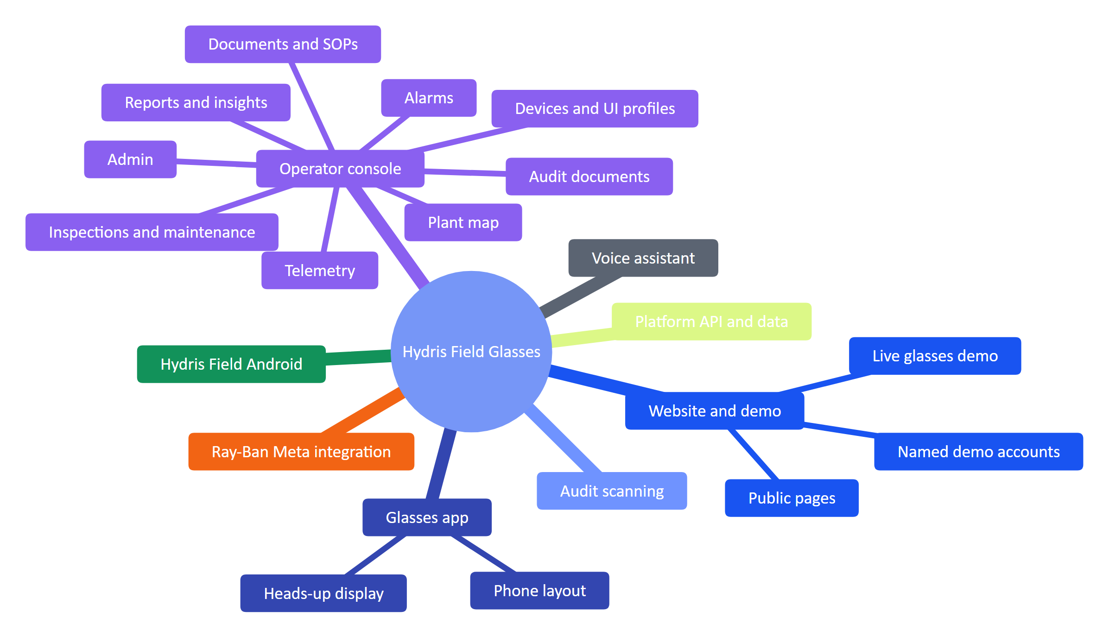
Figure 2. The Hydris product family and its sub-products
Table 4. Products, what they do and where they stand
Product | What it does | Status
Website and demo | Seven public pages, contact and demo request, live glasses demo, one-click named demo accounts | Built
Operator console | Sixteen sections in five groups (Operate, Work, Plant, People and devices, Insight) plus admin and platform pages | Built
Glasses app | Twelve heads-up screens with directional input, offline inspection queue, scan and voice; phone layout and browser simulator | Built (web); native display rendering Planned
Hydris Field Android | Sign-in, home, work, alarms, sensors, audit scan with on-device OCR, "Hey Hydris", glasses connection | Partial: built in code, glasses paths not validated on hardware
Ray-Ban Meta integration | Camera, capture button, microphone and speakers through Meta DAT 1.0.1; registration as a Hydris device | Partial: not validated on physical glasses
Audit scanning | Guided A4 capture, dual OCR, optional vision engine, field review, four-eyes approval, searchable PDF | Built
Voice assistant | Wake phrase, short spoken answers from tenant data through read-only tools, rules fallback | Built (English); other languages Planned
Platform API and data | 143 routes, row-level security, realtime events, append-only audit trail, demo mode | Built

1.6 One account, every surface
A user signs in once and gets the same permissions and data on the console, the glasses and the phone. Every surface talks to one API; the database enforces tenant isolation, not the application code.
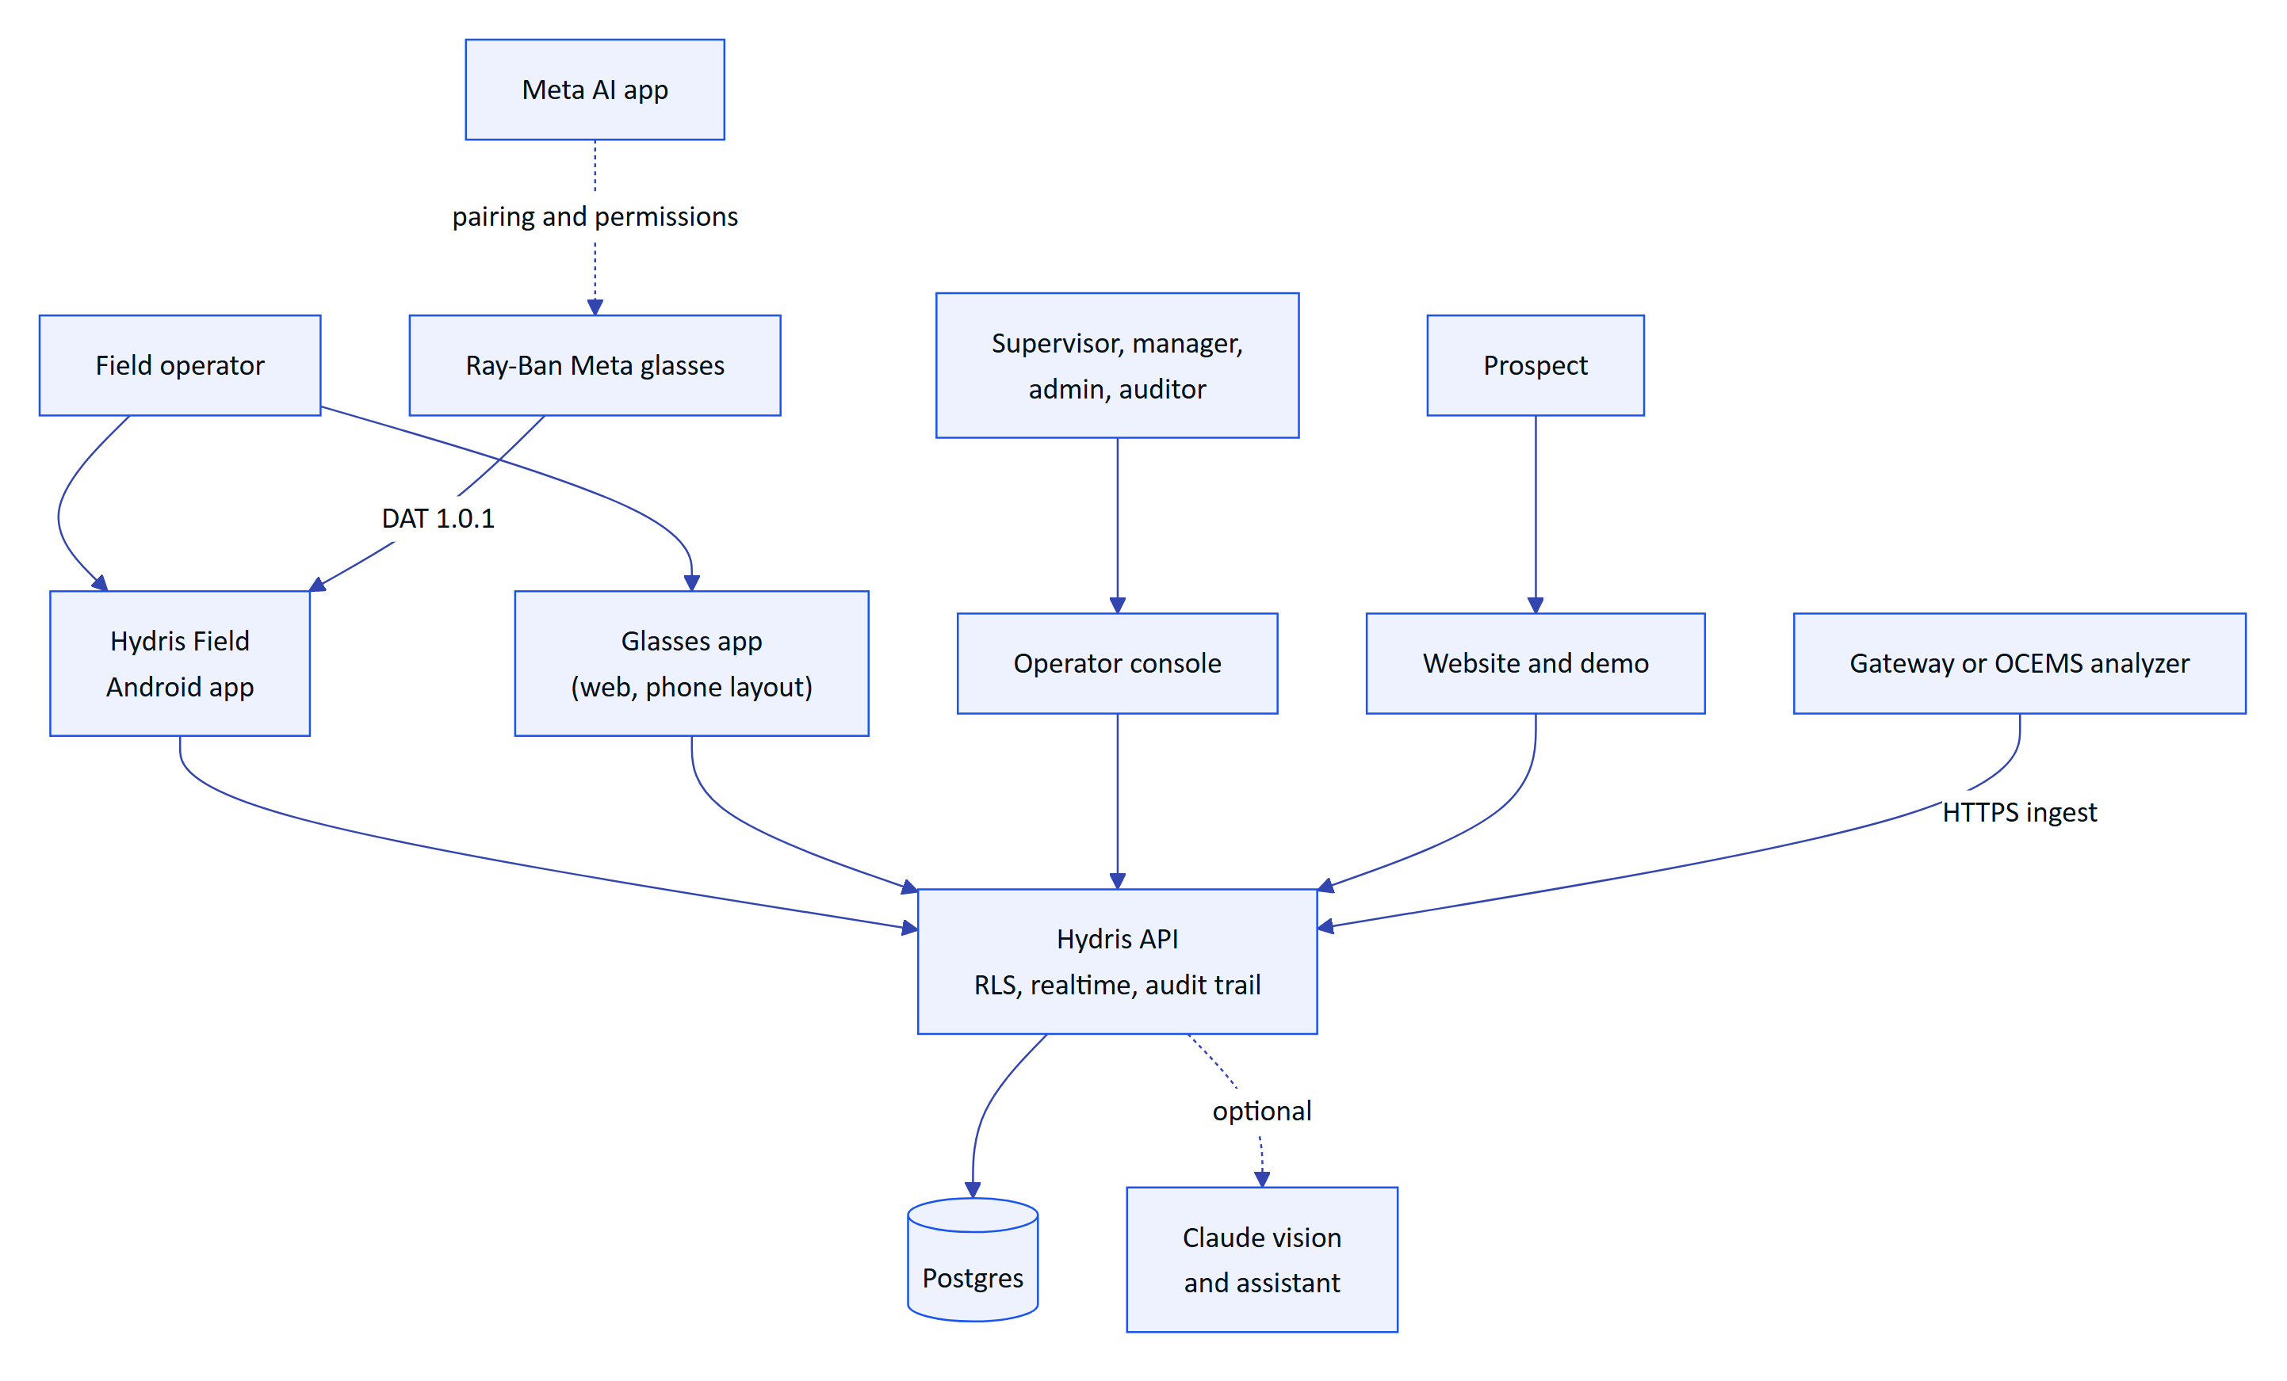
Figure 3. System context: people, Hydris surfaces and external systems
IMPORTANT
Ray-Ban Meta glasses reach third-party apps only through Meta's DAT, and they are paired and permissioned through the Meta AI app. That app must stay installed on every operator phone; Hydris Field checks for it and sends the user there to connect.

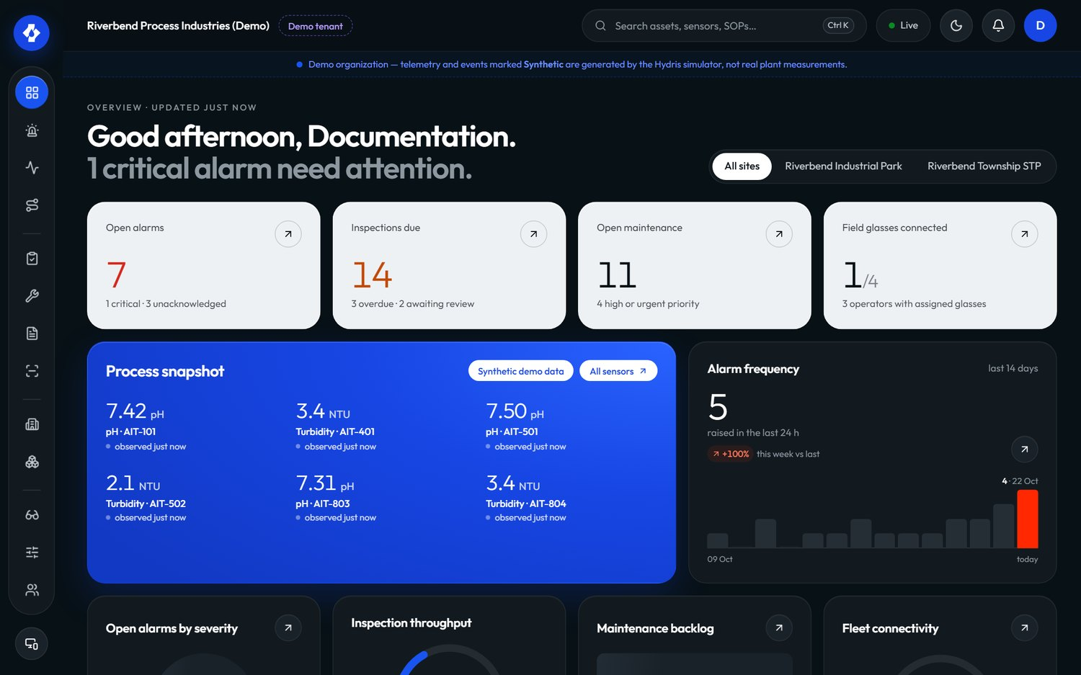
Figure 4. The operator console overview: KPIs, open alarms and live measurements

1.7 The operator's day
The journey below is the target state for a field operator across one shift. Scores are design targets (1 to 5), not measurements.
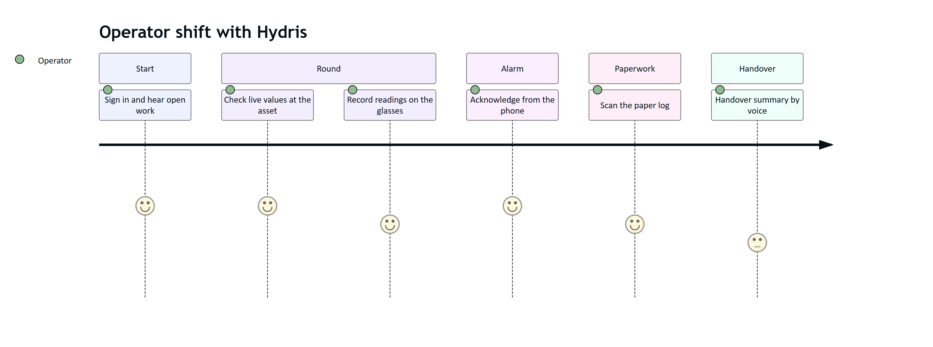
Figure 5. Field operator journey across one shift (target state)
The product is strongest today at alarm acknowledgement, scanning and voice lookups. The handover summary is Planned, and inspection execution on the Android app is Planned; rounds are executed in the glasses app today.
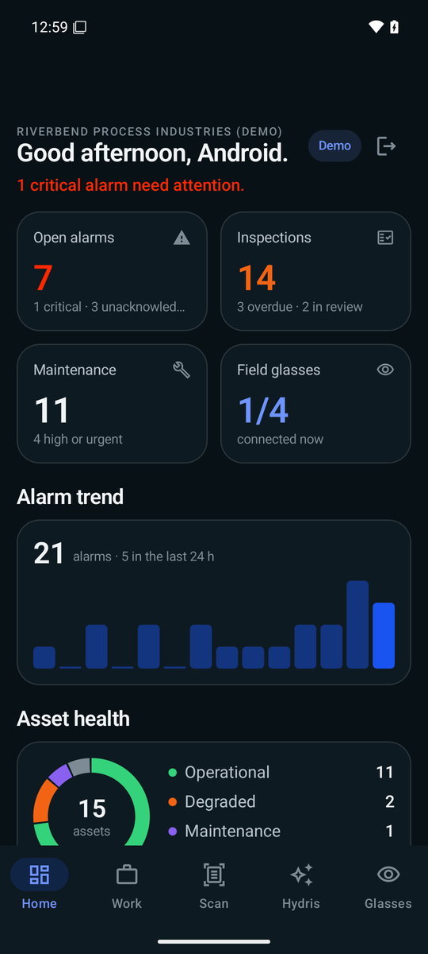
Figure 6. Hydris Field home: greeting, alarm trend, asset health and live measurements

1.8 The core loops
Four loops explain the whole product. Each crosses several products, which is why they share one platform.

See and act on the plant
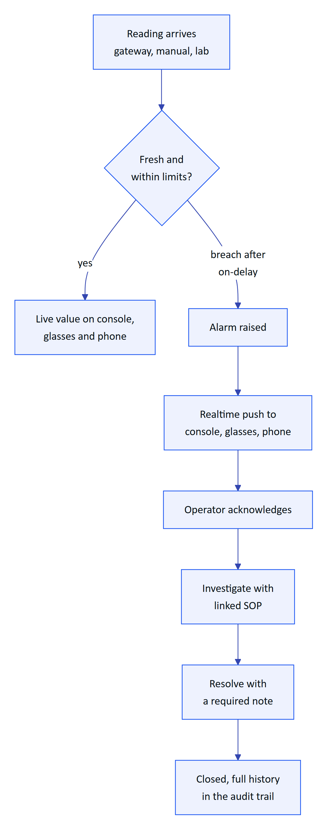
Figure 7. Loop one: a reading becomes an alarm, the right person acts and the record closes
Every reading passes one ingestion path with provenance. Alarm rules use deadband and on-delay so values that hover do not flap, and the lifecycle refuses to resolve an alarm without a note, so "acknowledged" is never mistaken for "fixed".

Do the work right
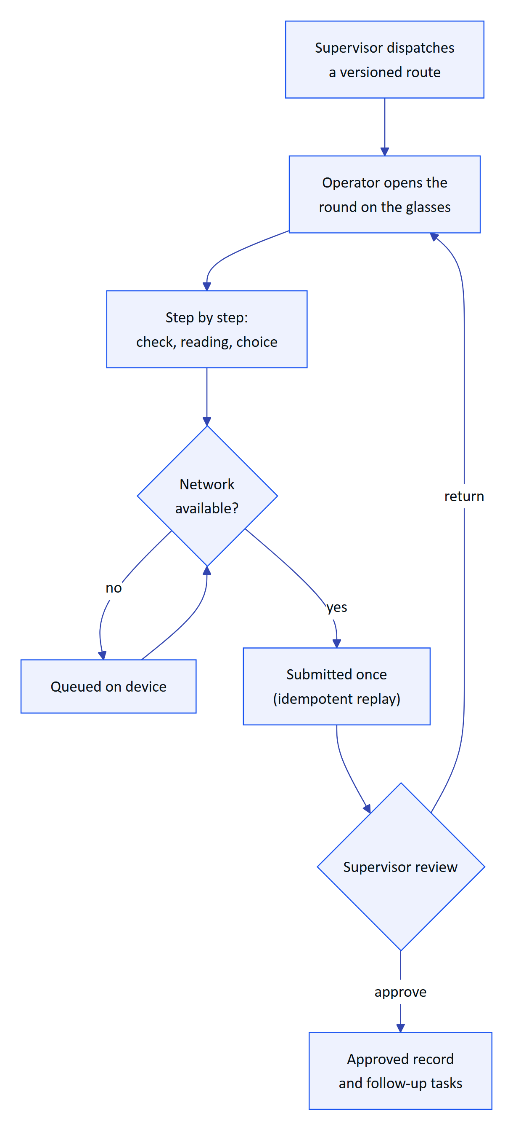
Figure 8. Loop two: a dispatched round is executed hands-free, even offline, and reviewed
Inspection templates are versioned, so a round keeps the version it was dispatched with. Responses are queued locally and replayed exactly once when the network returns.

Paper to verified record
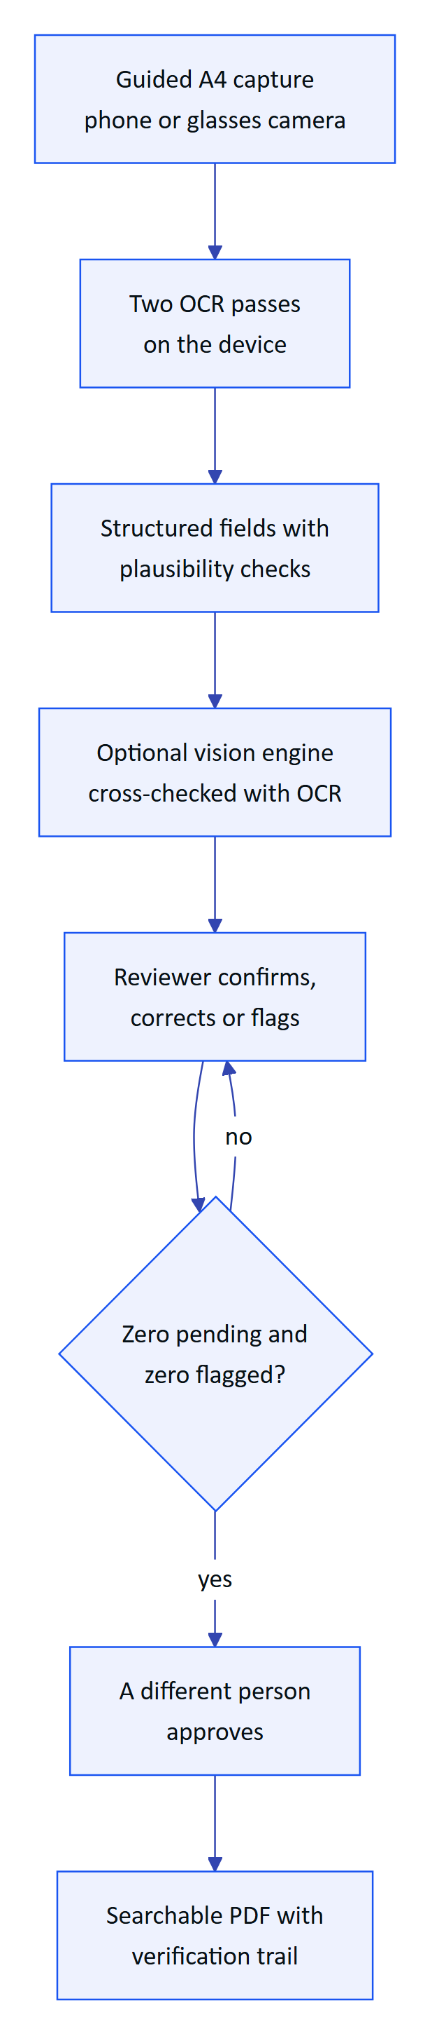
Figure 9. Loop three: a paper log becomes a verified, approved, searchable record
Machines propose and people decide. The original extracted value is kept beside every correction, and approval must come from someone other than the verifier, except in demo tenants where self-approval is allowed and recorded.

Ask the plant
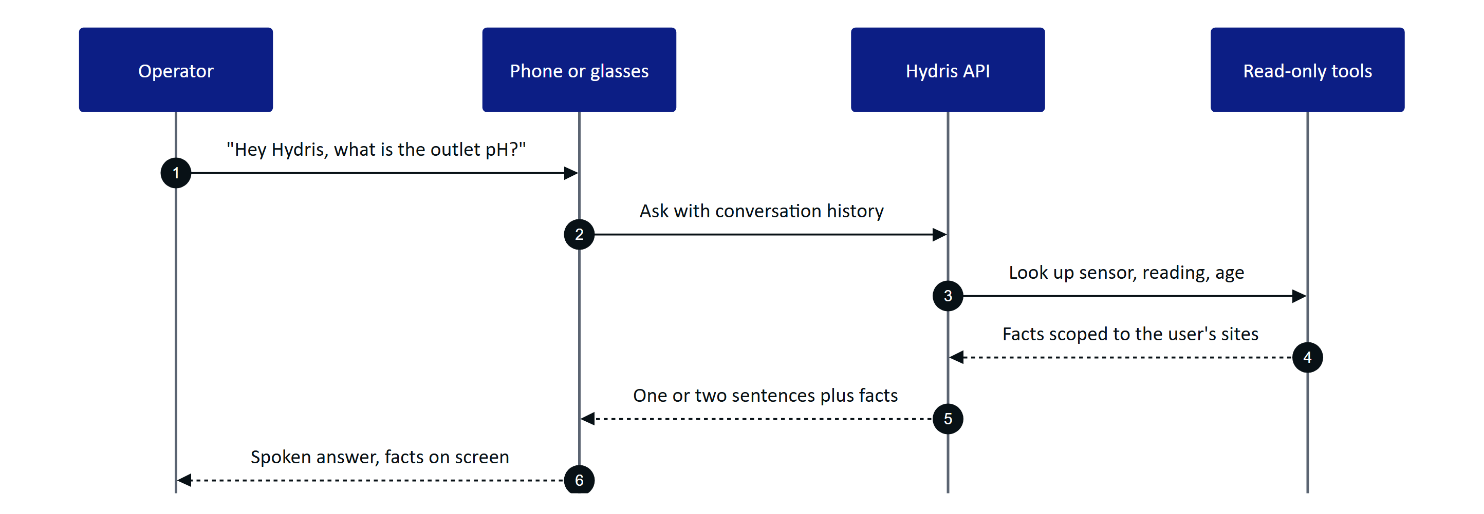
Figure 10. Loop four: a spoken question answered from the tenant's own data
The assistant answers only from tool results in the same conversation and states the age of each reading. If the model is unavailable, a rules engine answers instead, and an unknown question gets "can't answer", never a guess.

1.9 Status, gaps and the path to pilot
Table 5. Top gaps before a customer pilot
Gap | Effect today | Plan
Glasses paths not run on physical Ray-Ban Meta | Camera, capture button and glasses microphone are Partial | Hardware test matrix, Q4 2026 to Q1 2027
Email not sent | Invitations and resets sit in an outbox | Email transport in hardening, Q4 2026
No continuous integration | Regressions can reach the demo | CI gates on every change, Q4 2026
Daily cron on serverless hosting | Stale-data alarms evaluated once a day | Per-minute schedule, Q4 2026
No Android offline outbox | Phone actions need connectivity | Planned for GA, Q2 2027

North star  verified field records per active operator per week  rises only with real, trusted field use |  | 95 %  on-time rounds  pilot target |  | Under 5 min  median alarm acknowledgement  pilot target, critical and high |  | 0  hallucinated numbers  target for voice answers

1.10 How to read this book
Each product part follows the same spine: purpose and problem, users and jobs, scope, key flows, requirements (with the stable FR IDs from the PRD and status Built, Partial or Planned), experience notes, success metrics (targets labelled as targets) and status with next steps.
Table 6. Part map
Part | Read it if you want to know
Hydris Field Glasses at a glance | What Hydris is, for whom, and how the products fit together
Website and demo | How a prospect discovers and tries Hydris in minutes
Operator console and its sub-products | How supervisors, managers and admins run the plant, the work and the devices
Glasses app | What the operator sees and does on the heads-up display and phone layout
Hydris Field Android app | The native companion app for operators and engineers
Ray-Ban Meta integration | How the glasses' camera, button, microphone and speakers reach Hydris
Audit scanning | How paper becomes verified, approved evidence
Voice assistant | How "Hey Hydris" answers from plant data without guessing
Platform API and data | Tenancy, security, realtime and the shared data model underneath
Roadmap and future products | What comes next, in what order, and how we will know it worked

2 Website and demo

2.1 Purpose and problem
Industrial buyers rarely get to touch a product before a sales cycle starts, and smart-glasses software is hard to picture without the hardware. The website explains Hydris and, more importantly, lets a prospect try it in minutes: drive the real glasses viewport in the browser, then sign in to the console or the Android app with just a name. Everything runs on synthetic data that is labelled as such and can never reach a customer tenant.

2.2 Users and jobs
Table 7. Users of the website and demo
User | Job
Prospect (plant manager, IT lead, consultant) | Understand the product and try it without talking to sales (J9)
Partner or investor | See the real product working, on any laptop or phone
Hydris sales and product team | Run a repeatable demo from any browser, with named accounts that survive between sessions
Trainer | Replay a deterministic scenario for a class, the same way every time

2.3 Scope
Table 8. Scope of the website and demo
In scope | Out of scope
Seven public pages (/, /product, /technology, /operations, /demo, /contact, /privacy), phone and desktop, light and dark | Self-serve sign-up for customer tenants
Contact and demo-request form | Pricing pages, payments
Live glasses demo, fully client-side, ten scenarios | Real plant data of any kind in the demo
Browser simulator and pairing page | A demo that runs on physical glasses without the app
One-click named demo accounts on console and Android | Persistent guest data beyond the shared store's 30-day TTL

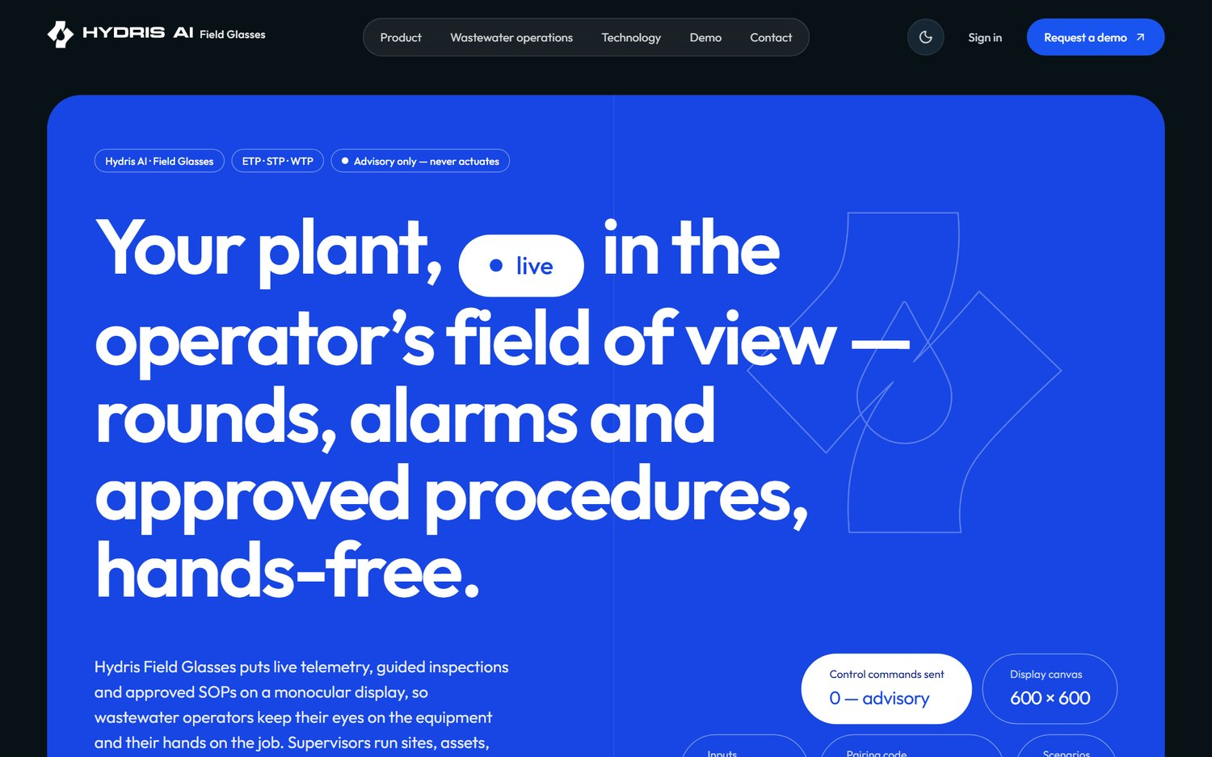
Figure 11. The public website home page

2.4 Key flows

From visitor to signed-in guest
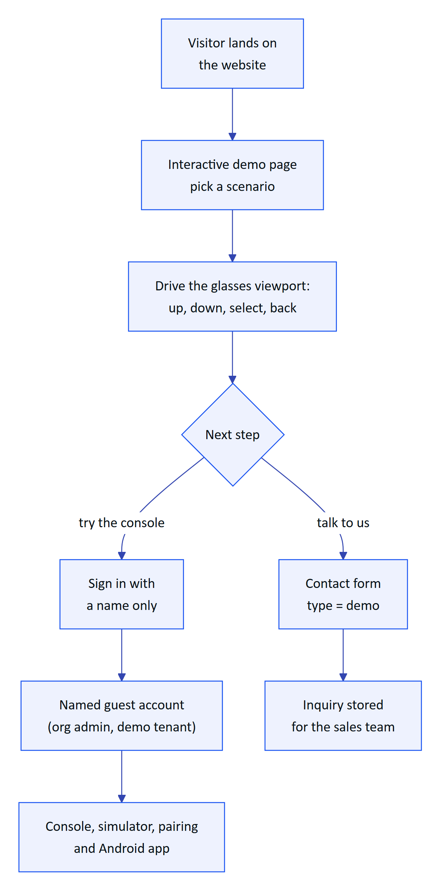
Figure 12. The prospect's path from the website to a named demo account
The /demo page runs the production glasses UI in a browser frame against a deterministic simulator of the reference plant, with no API calls. The ten scenarios cover normal operations, pump vibration, tank high level, abnormal pH, a scheduled inspection, equipment offline, glasses network loss, a high-priority alert, a maintenance checklist and device reassignment. Each replays identically, which makes it useful for training. From there a visitor books a guided demo or signs in by name.

One-click named demo account
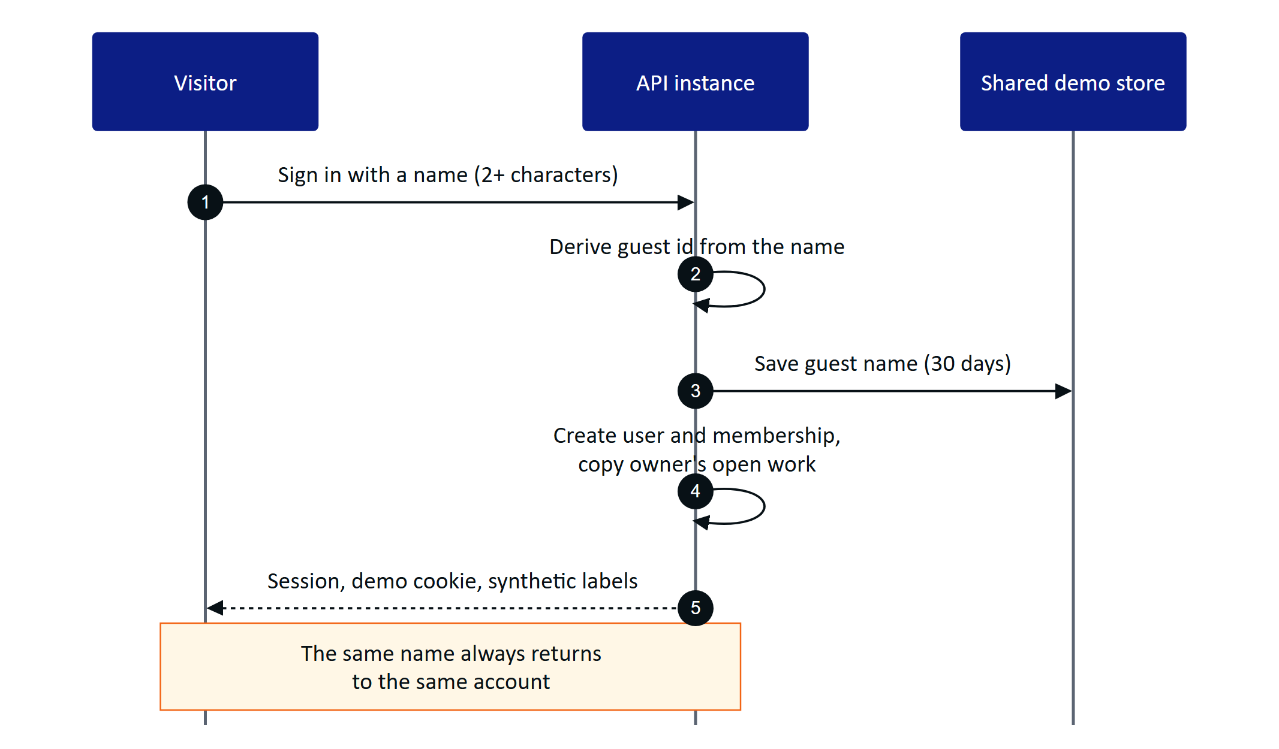
Figure 13. Demo sign-in creates or reuses a named guest and starts a normal session
A guest is an organization administrator of the demo tenant with access to all sites. The account id is derived deterministically from the normalized name, so returning with the same name restores the same account. Each guest gets personal copies of the demo owner's scheduled inspections and open maintenance tasks, so two guests acting at once never disturb each other's work.

Cross-instance demo state
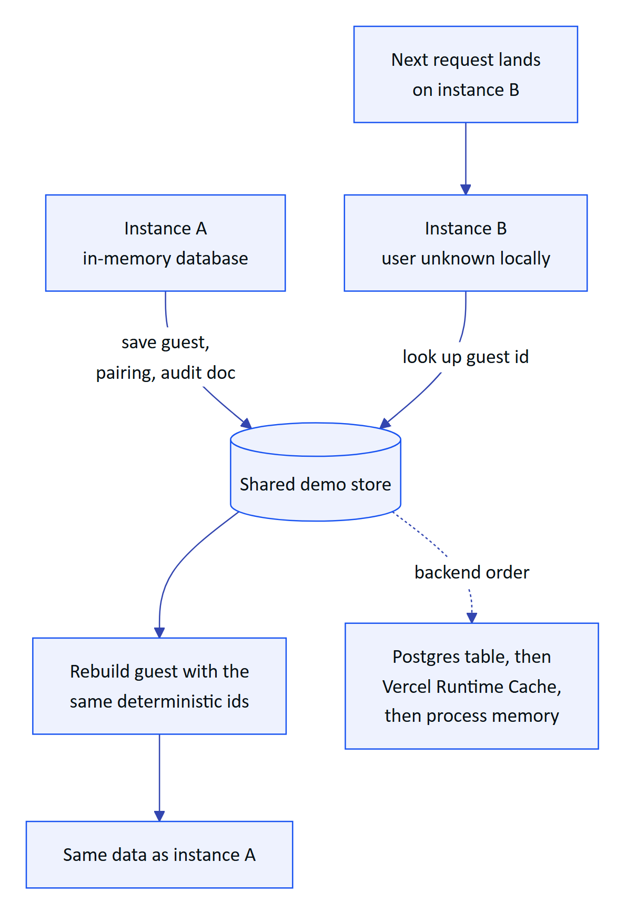
Figure 14. A guest created on one serverless instance is rebuilt on another from the shared store
Demo mode turns on automatically on Vercel when no database is configured. Every serverless instance seeds the same deterministic tenant in memory, so only a little state must travel between instances: named guests, pairing challenges and their approvals, and audit documents (snapshotted after each write). A resilient wrapper falls back to memory on any store error, so the demo never fails because of the store. Demo device refresh tokens are signed and self-contained, so any instance can rebuild a paired device.

2.5 Requirements
Table 9. Website and demo requirements
ID | Requirement | Priority | Status
FR-100 | Marketing website with seven pages and a privacy page, phone and desktop, light and dark | Must | Built
FR-101 | Contact and demo-request form, rate limited to 5 per 10 minutes per client | Must | Built
FR-102 | Live glasses demo from the website, fully client-side, plus the browser simulator | Must | Built
FR-103 | Named demo guests with personal copies of scheduled inspections and open tasks | Must | Built
FR-083 | Zero-configuration synthetic demo tenant, named guests, cross-instance pairing | Must | Built
FR-084 | Ten deterministic simulation scenarios, refused outside demo tenants | Must | Built
FR-091 | Demo sign-in with a name in the Android app | Must | Built
FR-029 | Synthetic data labelled everywhere and refused for customer tenants | Must | Built

2.6 Experience notes
- Simulator. /simulator renders the 600 by 600 heads-up display with a simulated camera that films a sample A4 sheet, so the whole scan pipeline can be shown without hardware. The website may embed /glasses and /simulator; every other page refuses framing.
- Pairing in the demo. A guest can pair the simulator or the phone layout by QR or typed code on /pair, and the pairing works even when the steps land on different instances.
- Honest labelling. The demo page shows a synthetic-data notice, and every value and voice answer in the demo tenant says it is synthetic demonstration data.
- Limits. Demo sign-in is limited to 20 per minute per client; the inquiry form to 5 per 10 minutes. The client IP on inquiries is stored hashed.
CAUTION
Demo mode relaxes security on purpose: public signing secrets, 12-hour access tokens instead of 15 minutes, self-contained device refresh tokens, acceptance of tokens whose session family the instance has never seen, and self-approval of audit documents. It is acceptable only because demo data is synthetic and flagged; production sets DEMO_MODE=false and SIMULATOR_ENABLED=false.

2.7 Success metrics
Table 10. Website and demo metrics (targets)
Metric | Target
Time from landing to a signed-in demo account | Minutes, with no sales contact (target, J9)
Demo availability on a zero-configuration deployment | Works with no environment variables (acceptance criterion of FR-083)
Guest isolation | Zero cases of one guest's personal work changing another's (target)
Demo requests converted to guided demos | Tracked from inquiries once the pilot pipeline opens (target to be set)

2.8 Status, gaps and next steps
The website and demo are Built and live. Open items:
- Inquiries are stored but no notification email is sent, because email delivery (FR-086) is Planned for hardening in Q4 2026.
- The Vercel Runtime Cache backend is per region and best effort; a Postgres shared store is preferred where available.
- The live demo mimics glasses input with on-screen buttons; a native device adapter for display glasses is Planned (see the roadmap part).

3 Operator console
The operator console is the web application at /console where supervisors, managers, auditors and administrators run the plant record. Field operators produce data with the glasses and the Android app; the console is where that data is dispatched, triaged, reviewed, approved and reported. It is one Next.js surface (apps/web/src/console) over the same API that serves every other client, so a value acknowledged on the glasses is the same record a manager sees on the overview a second later.
16  Navigation destinations  `Shell.tsx` |  | 6  Roles  38 permissions, `roles.ts` |  | 5  Alarm lifecycle states  resolve needs a note |  | 2 s  Realtime alarm target  NFR-002, not yet measured

3.1 Purpose, users and information architecture

Purpose and problem
Water and wastewater plants still run on paper log sheets, phone calls and spreadsheets. The supervisor cannot see which rounds are late, the manager cannot prove to a regulator who saw an alarm and when, and the auditor receives evidence that cannot be traced to a person. The console replaces that patchwork with one tenant-isolated, site-scoped workspace where every state change is attributed, timestamped and written to an append-only audit trail.

Users and jobs
Table 11. Console users and their main jobs
User | Role in code | Main jobs in the console
Shift supervisor | supervisor | Triage and assign alarms, dispatch rounds, review inspections, verify scanned documents, pair glasses
Plant manager | factory_manager | KPIs and reports, alarm rules, plant model, approve audit documents, devices and people
Compliance auditor | viewer plus report.read | Read the trail, approved documents and reports; export evidence
Organization admin | org_admin | Members, invitations, sites, glasses UI profiles, organization settings
Platform admin | users.is_platform_admin | Create and suspend customer organizations at /console/platform

Field operators and maintenance engineers can sign in to the console too, but their primary surfaces are the glasses and the Android app.

Information architecture
The navigation in apps/web/src/console/Shell.tsx groups destinations by intent. Each item declares the permission it needs; items the current role lacks are hidden rather than greyed out, and the API enforces the same check.
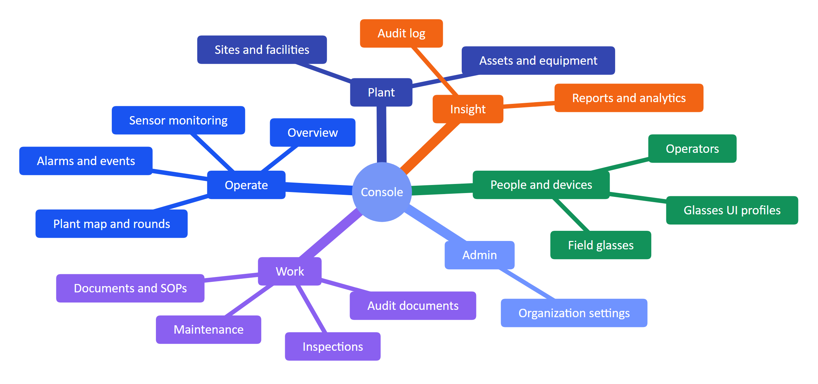
Figure 15. Console navigation groups and destinations (Shell.tsx)
A command palette (CommandPalette.tsx) gives keyboard access to every destination and to global search across assets, sensors, documents and work (FR-088). The console supports system, light and dark themes.

Role access summary
Permissions come from one fixed matrix (packages/domain/src/roles.ts, FR-012): can(role, permission) is the only check, and every role except org_admin is additionally scoped to its sites (FR-007). Row-level security in Postgres keeps tenants apart (FR-008).
Table 12. What each role can do in the console (summary of roles.ts)
Capability | Admin | Manager | Supervisor | Engineer | Operator | Viewer
Read plant, telemetry, alarms, work | Yes | Yes | Yes | Yes | Yes | Yes
Manage sites, assets, sensors, gateways | Yes | Yes | No | No | No | No
Manage alarm rules | Yes | Yes | No | No | No | No
Acknowledge alarms | Yes | Yes | Yes | Yes | Yes | No
Resolve alarms / close alarms | Yes / Yes | Yes / Yes | Yes / Yes | Yes / No | No / No | No / No
Manage and review inspections | Yes | Yes | Yes | No | No | No
Manage maintenance | Yes | Yes | Yes | No | No | No
Pair glasses / manage devices and profiles | Yes / Yes | Yes / Yes | Yes / No | Yes / No | Yes / No | No / No
Manage documents and SOPs | Yes | Yes | No | No | No | No
Verify / approve audit documents | Yes / Yes | Yes / Yes | Yes / No | No / No | No / No | No / No
Reports, audit log | Yes | Yes | Reports | No | No | Reports
Members and invitations / org settings | Yes / Yes | Yes / No | Read / No | No | No | No

NOTE
The auditor persona maps to viewer, which today holds read access plus report.read but not audit.read. Giving auditors the audit log page needs either a role change or a dedicated auditor role; this is an open product decision.

3.2 Overview dashboard

Purpose and scope
The overview is the first screen after sign-in. It answers "is anything wrong right now, and where?" in one glance: KPI tiles, open alarms by severity, asset health, live measurements with freshness, and recent activity. It is served by GET /overview (FR-089), the same endpoint that feeds the Android home screen (FR-092), so the console and the phone never disagree.
In scope: KPIs, open alarms, health roll-up, live values with freshness and synthetic labels, recent activity, realtime refresh. Out of scope: user-configurable widgets and cross-site benchmarking.
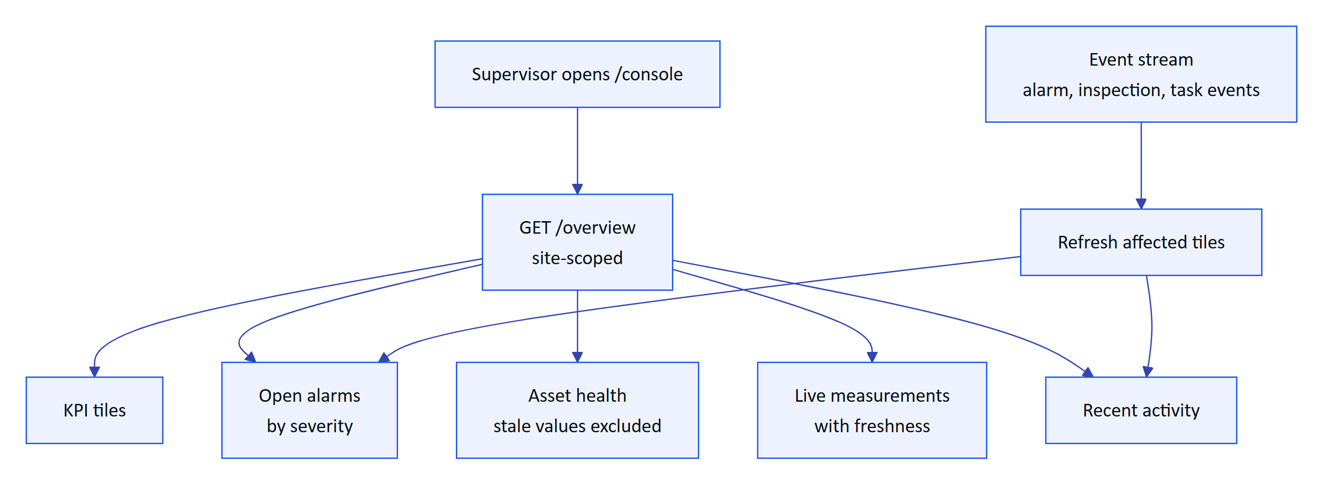
Figure 16. How the overview is assembled and kept current
Freshness is computed per sensor from its expected interval, and stale values are excluded from health roll-ups (packages/domain/src/freshness.ts). Synthetic demo values carry a visible label wherever they appear (FR-029).
Figure 17. Overview dashboard in the console
Table 13. Overview requirements
ID | Requirement | Pri | Status
FR-089 | Overview with KPIs, open alarms, health and live measurements | M | Built
FR-026 | Freshness states shown; missing data never shown as a value | M | Built
FR-085 | In-app notifications in realtime, mark as read | M | Built
FR-088 | Global search across assets, sensors, documents and work | S | Built

Status: Built. Next step: per-user default site and a compliance tile once FR-120 lands.

3.3 Plant model: sites, assets, sensors and the plant map

Purpose and scope
Everything in Hydris hangs off the plant model: alarms, rounds, documents and devices are all scoped to a site and usually an asset. The plant model lets managers describe their plant once (site, facility, process area, asset, sensor) and place it on a map, so that operators walking the plant see the right asset and the right values.
In scope: hierarchy with map positions, archive and restore (FR-020), sensors for 16 measurands with unit normalization (FR-021), gateways with hgw_ API keys, the plant map with rounds overlay. Out of scope: digital twins, P&ID import, write paths to equipment (Hydris is read-only towards the plant).
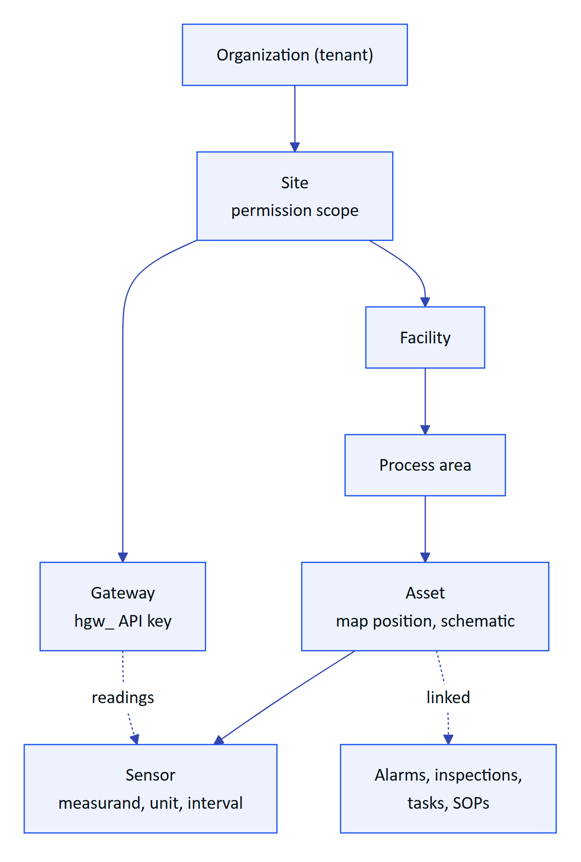
Figure 18. Plant hierarchy and what attaches at each level
The site level is the permission boundary: a site-scoped supervisor sees nothing from other sites. Archiving an asset removes it from glasses screens and assistant answers while keeping its history.

Plant map and rounds
The plant map (/console/map, apps/web/src/console/plant/map) places assets on the site layout and overlays route stops, so a supervisor can see where a round goes and where open alarms sit. The hierarchy navigator and asset schematic (HierarchyNavigator.tsx, AssetSchematic.tsx) give the same model as a tree and as a per-asset view of its sensors.
Table 14. Plant model requirements
ID | Requirement | Pri | Status
FR-020 | Site, facility, area and asset hierarchy with map positions, archive and restore | M | Built
FR-021 | Sensors for 16 measurands with unit normalization | M | Built
FR-007 | Site-scoped permissions | M | Built
FR-088 | Search by asset tag finds the asset and its open work | S | Built

Status: Built. Gaps: no bulk import of the asset register; map layout is drawn per site rather than imported from drawings.

3.4 Telemetry and sensor monitoring

Purpose and scope
Sensor monitoring shows what the plant measures, how fresh each value is, and where a value came from. The core promise is honesty: a missing reading is shown as "No data", never as zero, and every value carries its source (gateway, manual, lab or synthetic) and its time.
In scope: HTTPS gateway ingestion (FR-022), manual and lab entry with provenance (FR-023), append-only corrections (FR-024), history and CSV export (FR-025), freshness states (FR-026). Out of scope today: MQTT and OPC UA adapters (FR-027) and read-only historian connectors (FR-028), both Planned.

Ingestion flow
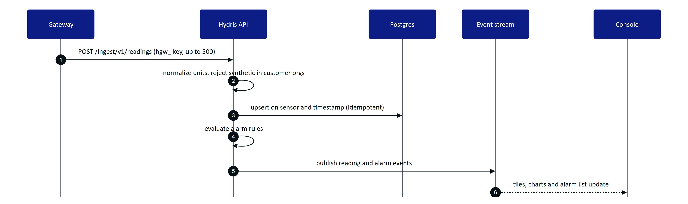
Figure 19. From a gateway reading to the console (telemetry.ts, alarms.ts, realtime.ts)
Replaying the same batch never creates duplicates because readings are keyed on sensor and timestamp. Synthetic readings sent into a customer organization are refused (FR-029).

Freshness
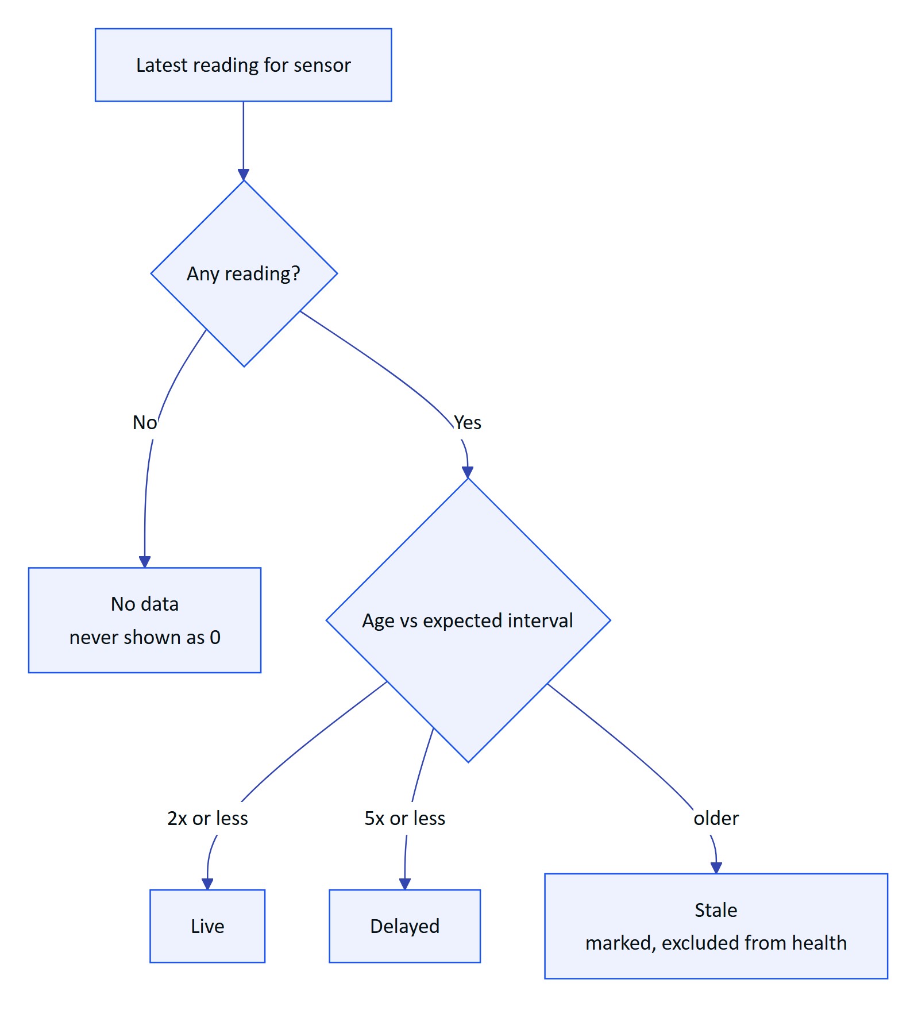
Figure 20. Freshness state of a sensor value (freshness.ts)

Corrections and history
A supervisor who finds a wrong value does not edit it. They add a correction or invalidate the reading; the original stays visible next to the correction with its author and reason (FR-024). Manual and lab entries (ManualEntryDialog.tsx) carry their provenance everywhere they appear. The sensor detail shows raw readings and history, and exports CSV with formula injection escaped (FR-025).
Table 15. Telemetry requirements
ID | Requirement | Pri | Status
FR-022 | Gateway ingestion, 500 per call, idempotent | M | Built
FR-023 | Manual and lab entry with provenance | M | Built
FR-024 | Append-only corrections (correct or invalidate) | M | Built
FR-025 | History, raw readings, CSV export | S | Built
FR-026 | Freshness live, delayed, stale, no data | M | Built
FR-029 | Synthetic data labelled, refused for customers | M | Built
FR-027 | MQTT and OPC UA adapters | S | Planned
FR-028 | Read-only SCADA and historian connectors | C | Planned

Status: Built for HTTPS. Next: MQTT and OPC UA adapters so pilots can connect existing gateways without custom code.

3.5 Alarms

Purpose and scope
Alarms turn readings into attributed work. The console is where alarm rules are defined, where supervisors triage and assign, and where the evidence of who saw what and when is kept. Acknowledging records that a person has seen the alarm; it never changes the process.
In scope: threshold and stale rules with deadband and on-delay (FR-030), the five-state lifecycle (FR-031), assignment, notes, history and linked SOP (FR-032, FR-112), realtime push (FR-033). Planned: escalation (FR-037), shelving (FR-038), push notifications when the app is closed (FR-034).

Rule evaluation
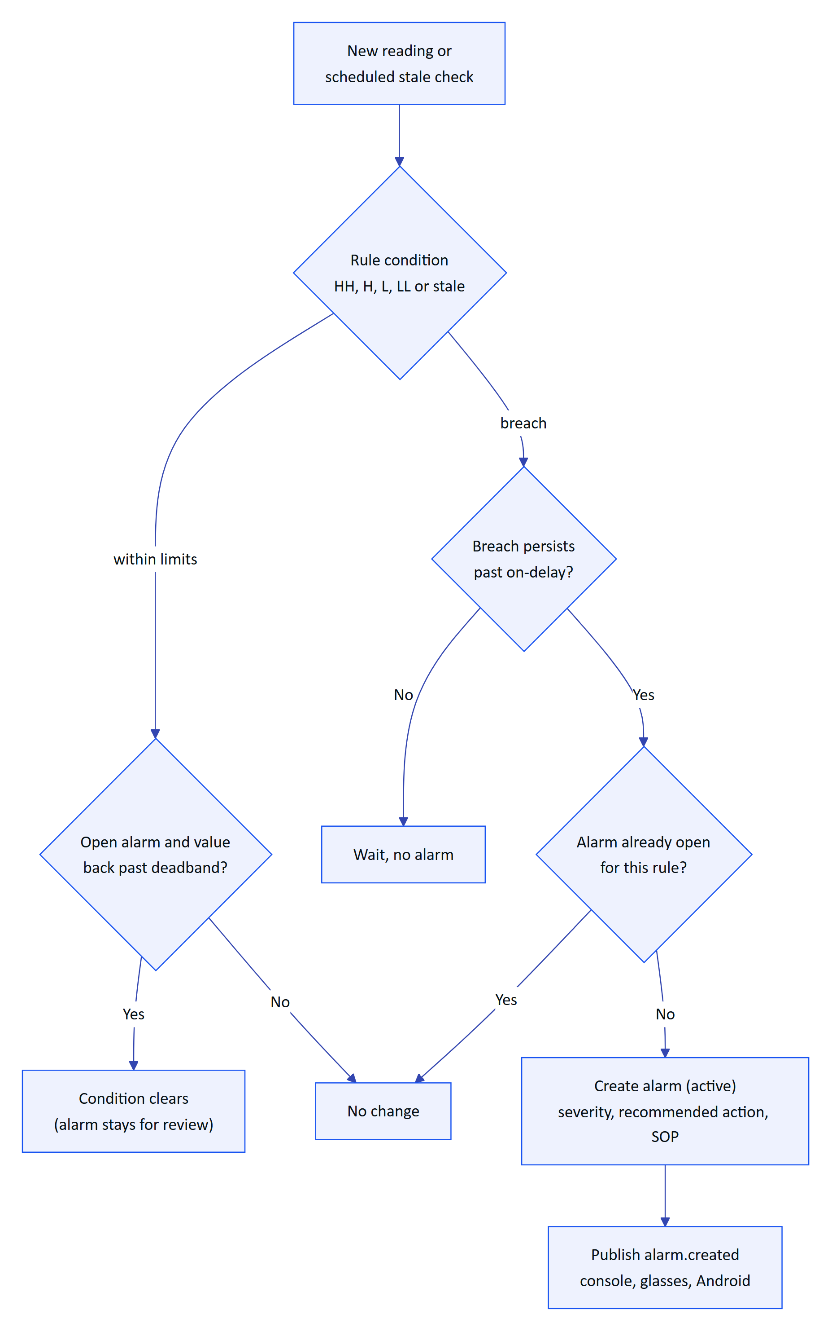
Figure 21. How a rule turns readings into an alarm (alarms.ts)
The deadband stops a value oscillating around a limit from raising and clearing repeatedly, and the on-delay ignores short spikes. Stale rules run on a schedule: every 30 s on a long-running server, but only once a day on the current Vercel cron (FR-035, Partial).

Lifecycle and permissions
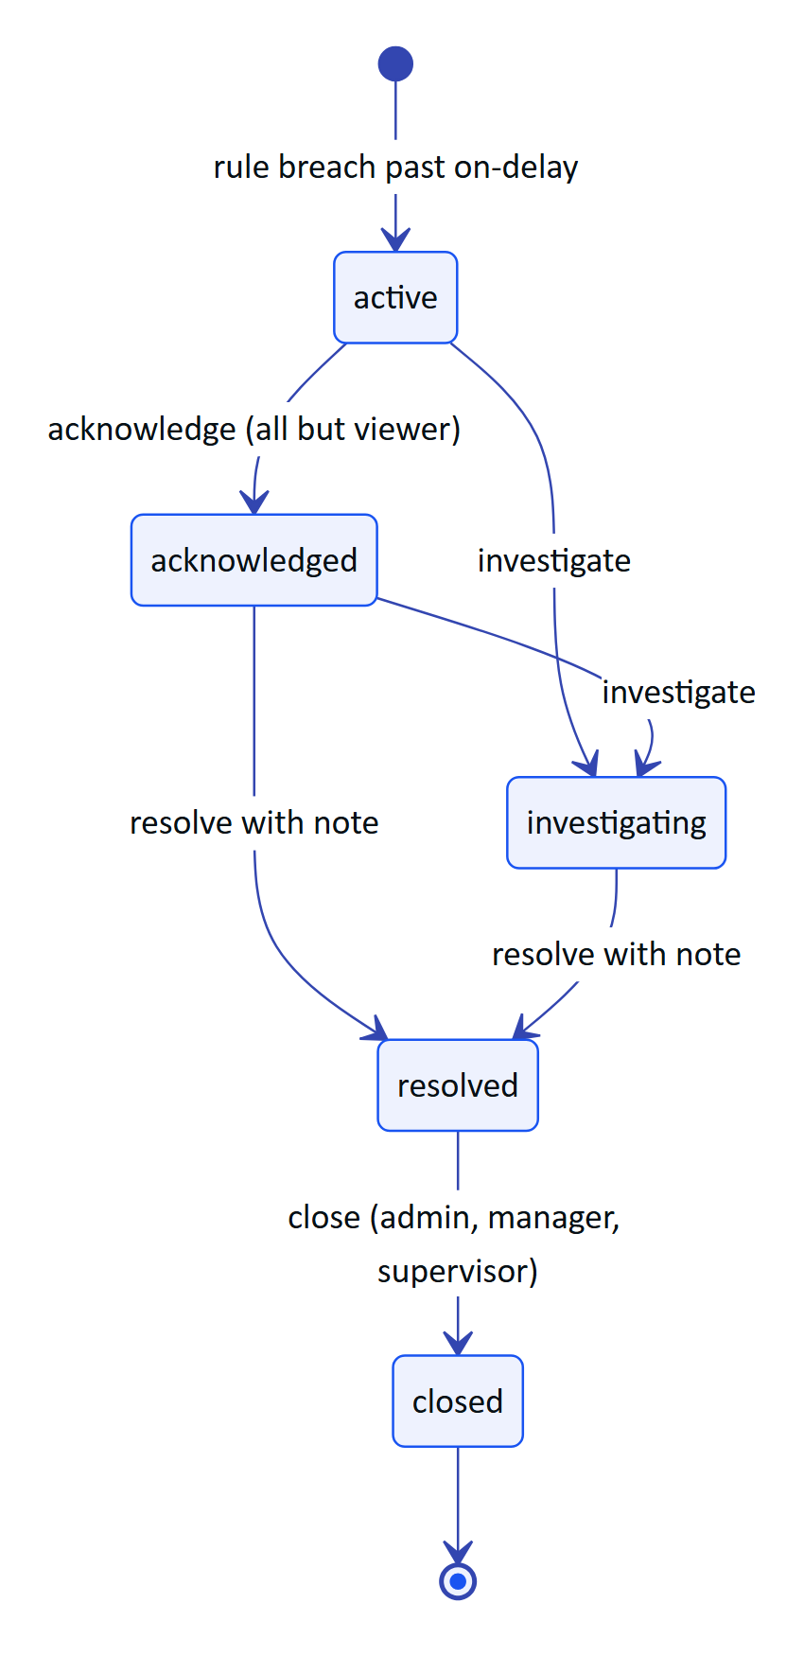
Figure 22. Alarm lifecycle with the permission each step needs (packages/domain/src/alarms.ts)
There is no path from active straight to resolved: someone must first see the alarm. Resolving requires a note, and the API rejects a resolve without one. Investigate and resolve are held by admins, managers, supervisors and maintenance engineers. Every transition writes a history row and an audit event.
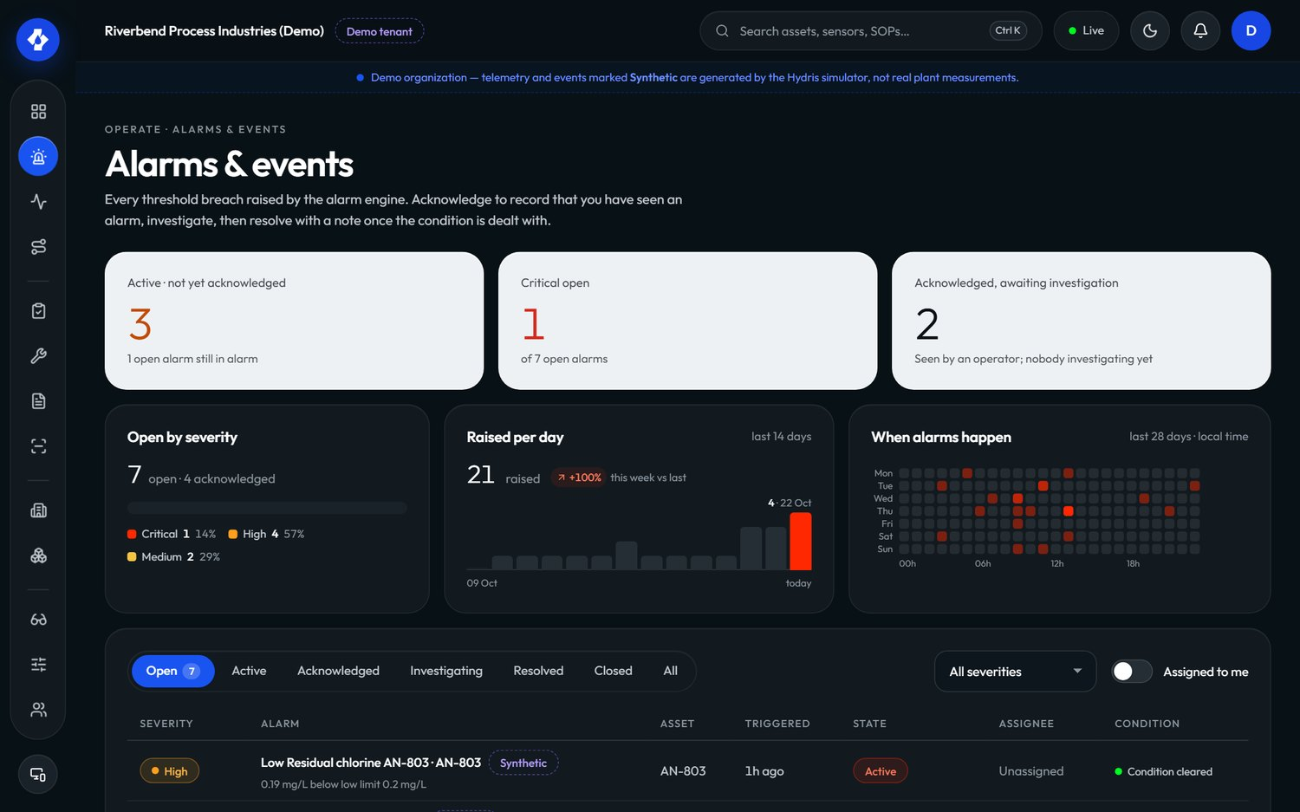
Figure 23. Alarms and events in the console

Escalation
Escalation is Planned for the pilot (FR-037): an unacknowledged critical alarm will notify the site supervisor after a configurable number of minutes, and the escalation will appear in the alarm history. Until then, supervisors rely on the realtime alarm list, the Android notification for critical and high alarms while the app runs (FR-097), and the median time to acknowledge in the alarm report.
Table 16. Alarm requirements
ID | Requirement | Pri | Status
FR-030 | Threshold rules with deadband and on-delay | M | Built
FR-031 | Five-state lifecycle, no resolve from active, note required | M | Built
FR-032 | Assignment, notes, history, recommended action, SOP | M | Built
FR-033 | Realtime push to console, glasses, Android | M | Built
FR-112 | Rule links a procedure shown with the alarm | M | Built
FR-035 | Stale-data alarms on a schedule | M | Partial
FR-037 | Escalation when unacknowledged | S | Planned
FR-038 | Shelving with reason and expiry | C | Planned
FR-034 | Push notifications when the app is closed | S | Planned

Status: core lifecycle Built. Gaps: stale evaluation cadence on serverless, escalation and shelving. Next: escalation first, because time to acknowledge is the headline alarm metric.

3.6 Inspections and maintenance

Purpose and scope
Rounds and maintenance are the daily work of the plant. The console lets a supervisor design what must be checked, send it to the right operator, and review the result; and lets anyone turn an alarm or an abnormal reading into a tracked task. Execution happens on the glasses (FR-041) and, for checklists, on the phone (FR-046).
In scope: versioned templates with five step kinds and routes with dispatch (FR-040), review with approve or return (FR-042), maintenance tasks with checklists and follow-ups (FR-043). Planned: recurring schedules (FR-047) and inspection execution on Android (FR-044).

Templates, routes and dispatch
A template is built in the console (TemplateBuilder.tsx) from steps: check, reading with expected range, choice with abnormal options, text and photo. Editing creates a new version, so inspections already dispatched keep the version they started with. Routes order templates along a walk and are dispatched to an operator. On the glasses, a reading outside its range, a failed check or an abnormal choice marks the step abnormal automatically.
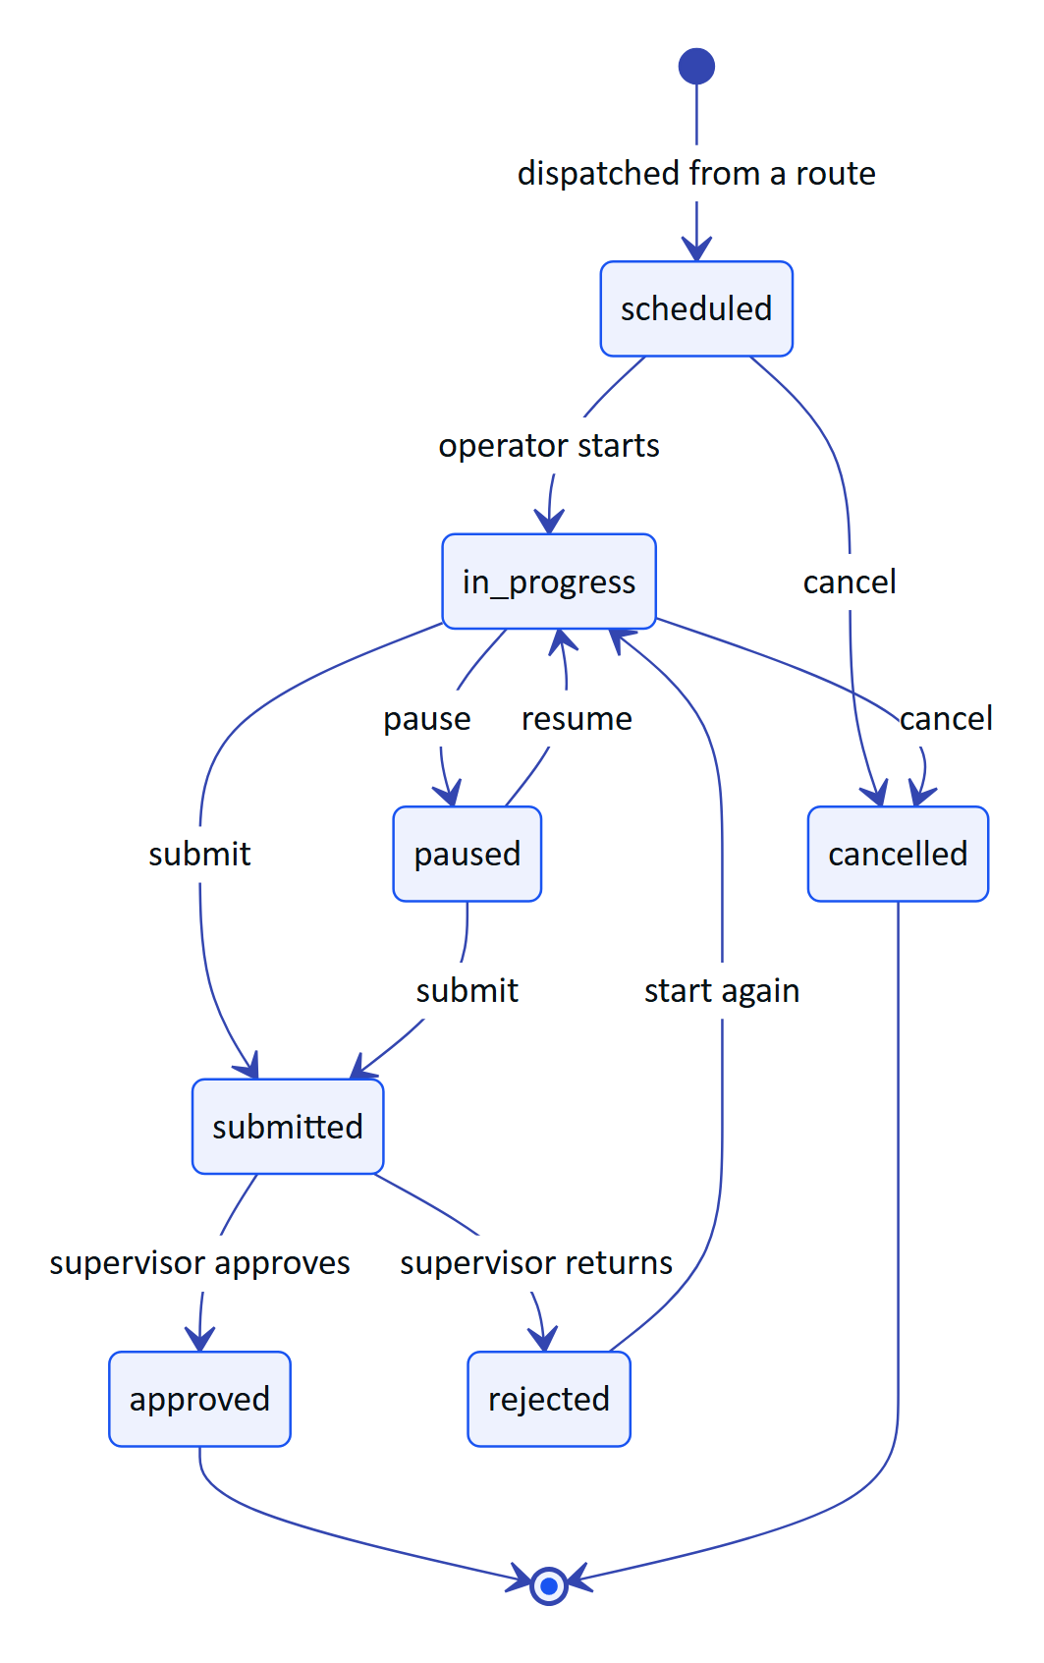
Figure 24. Inspection lifecycle as the supervisor sees it (workflows.ts)
Review is the console's job. The supervisor opens a submitted inspection, sees each step with abnormal ones highlighted and any photos, and either approves it or returns it with a reason. A returned inspection can be restarted and resubmitted, and history shows both submissions. Offline responses from the glasses are replayed idempotently, so the reviewer never sees duplicates.

Maintenance
Maintenance tasks are corrective, preventive, inspection follow-ups or alarm follow-ups, with a priority from low to urgent, a checklist and an activity log. A follow-up created from an alarm or inspection links back to its source.
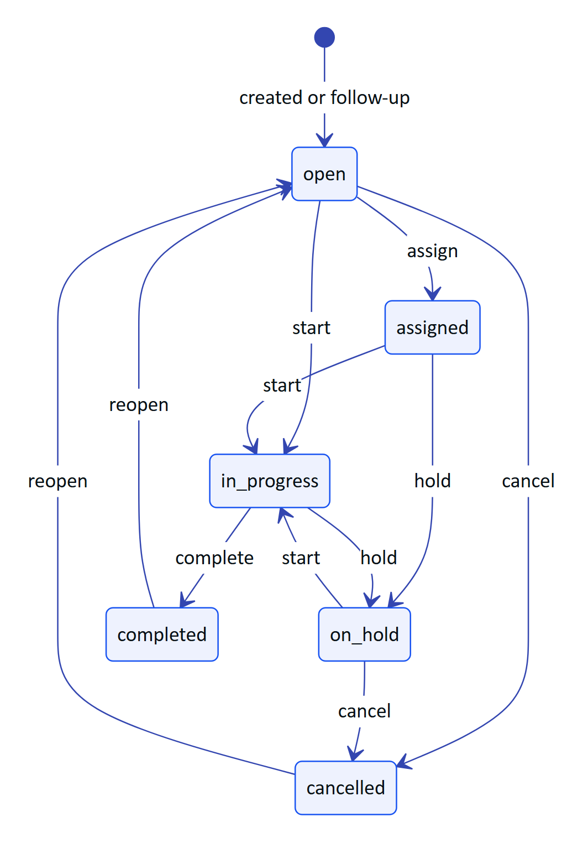
Figure 25. Maintenance task lifecycle (MAINTENANCE_TRANSITIONS in workflows.ts)
Table 17. Inspection and maintenance requirements
ID | Requirement | Pri | Status
FR-040 | Versioned templates, five step kinds, routes, dispatch | M | Built
FR-041 | Glasses execution with offline queue | M | Built
FR-042 | Submit, review, approve or return | M | Built
FR-043 | Maintenance tasks, checklists, follow-ups | M | Built
FR-046 | Tick checklist items from Android | M | Built
FR-045 | Photo steps from glasses or phone camera | S | Partial
FR-044 | Inspection execution in the Android app | S | Planned
FR-047 | Recurring schedules (calendar or runtime) | S | Planned

Status: Built for manual dispatch and review. Gap: every round is dispatched by hand. Next: recurring schedules, which also make on-time completion meaningful as a KPI.

3.7 Documents and SOPs

Purpose and scope
Operators need the right procedure at the asset, and only an approved one. The document library (/console/documents) holds SOPs, manuals, datasheets, safety notices and troubleshooting guides, each with versions and a scope of site, asset or asset type (FR-110). Only approved documents reach the glasses, the assistant and grounded retrieval (FR-111).
Lifecycle: draft, approved, archived. Managers and admins hold document.manage; everyone else reads. Alarm rules link a procedure that is shown with the alarm (FR-112). The library page also exposes grounded SOP retrieval (/assist): a question returns passages from approved documents with a safety notice (FR-070), so a supervisor can check what an operator will be told before it happens.
Table 18. Documents requirements
ID | Requirement | Pri | Status
FR-110 | Library with draft, approved, archived; versions; scope | M | Built
FR-111 | Only approved documents reach glasses and assistant | M | Built
FR-112 | Alarm rules link a procedure | M | Built
FR-070 | Grounded SOP retrieval with safety notice | M | Built
FR-113 | SOPs cached on glasses for offline reading | S | Built
FR-114 | Upload PDF manuals with text extraction | C | Planned

Status: Built for authored documents. Gap: existing PDF manuals cannot yet be uploaded and searched (FR-114).

3.8 Field glasses fleet

Purpose and scope
Glasses are shared, often unattended devices. The console makes them a managed fleet: pair a new pair to a site and an operator, see which are connected, suspend or revoke one that is lost, and control what each pair shows through UI profiles. The glasses never hold a user password; they hold a device credential that the console can end.
In scope: pairing approval (FR-050), device tokens and revocation (FR-051, FR-052), the device permission ceiling (FR-053), UI profiles (FR-054). The camera, capture button and Android registration are covered in the glasses part of this book.

Pairing from the console
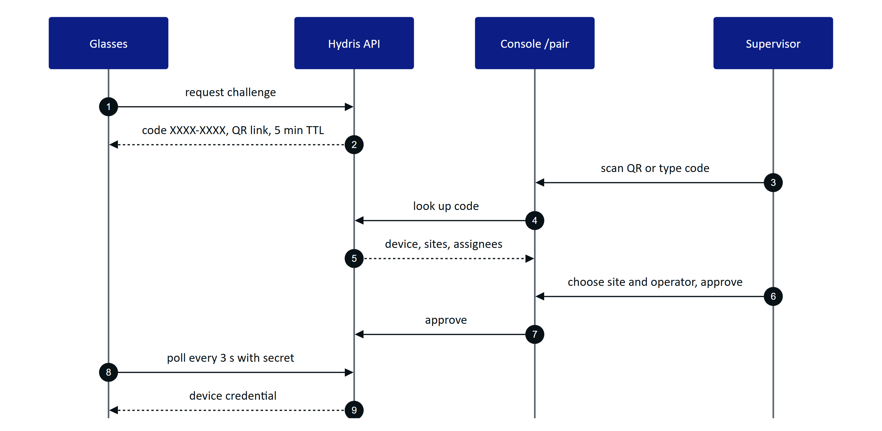
Figure 26. Approving a pairing from the console (devices.ts)
The code avoids confusable characters (no 0, O, 1, I, L, U), wrong-code lookups are rate limited, and the QR link never carries a credential. The approver needs device.pair, which every role except viewer holds.

Device states
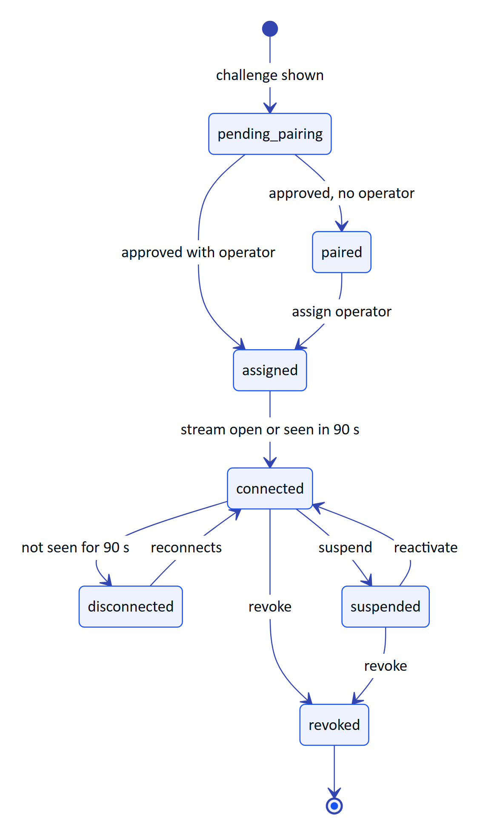
Figure 27. Device states shown in the fleet list (deriveDeviceState in devices.ts)
Revocation takes effect on the next request and closes an open event stream within 30 s (FR-052). Device access tokens last 15 minutes and refresh tokens rotate with reuse detection. Whatever role the assigned operator has, a device can never exceed the device permission ceiling: glasses paired to an admin still cannot manage members (FR-053).
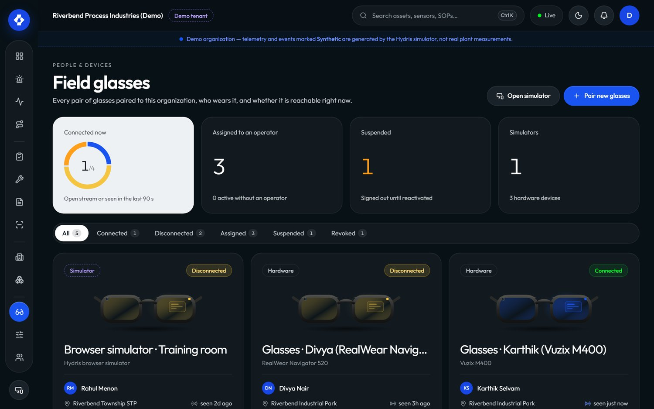
Figure 28. Field glasses fleet in the console

UI profiles
A UI profile controls what the glasses show (/console/glasses-profiles, ui-profiles.ts). Profiles are edited as drafts, published, and can be rolled back. Assignment can be made to a device, a user, a role or the whole organization; the most specific assignment with a published version wins. Publishing pushes the change live, so the glasses screens change without a restart. Managing profiles needs device.manage (admins and managers).
Table 19. Fleet requirements
ID | Requirement | Pri | Status
FR-050 | Pairing code, QR, 5 min TTL, 3 s polling, approval | M | Built
FR-051 | Device tokens, rotation, reuse detection | M | Built
FR-052 | Suspend, reactivate, revoke, reassign | M | Built
FR-053 | Device permission ceiling | M | Built
FR-054 | UI profiles: draft, publish, rollback, precedence, live push | S | Built
FR-058 | Log out and unpair from the glasses menu | M | Built

Status: Built. Next: fleet health signals (battery, app version) once the glasses bridge reports them.

3.9 Audit documents: review and approval

Purpose and scope
Paper log sheets scanned in the field become evidence only after a person has checked them and a second person has approved them. The console side (/console/audit-docs, work/auditdocs.tsx) is that review desk. Capture, page detection and OCR are covered in the scanning part of this book.
In scope: field review (confirm, correct, flag, reset) with the original value kept (FR-064), bulk-confirm where engines agree (FR-069), four-eyes approval (FR-065), the evidence PDF (FR-066). Planned: electronic signature with re-authentication (FR-068).
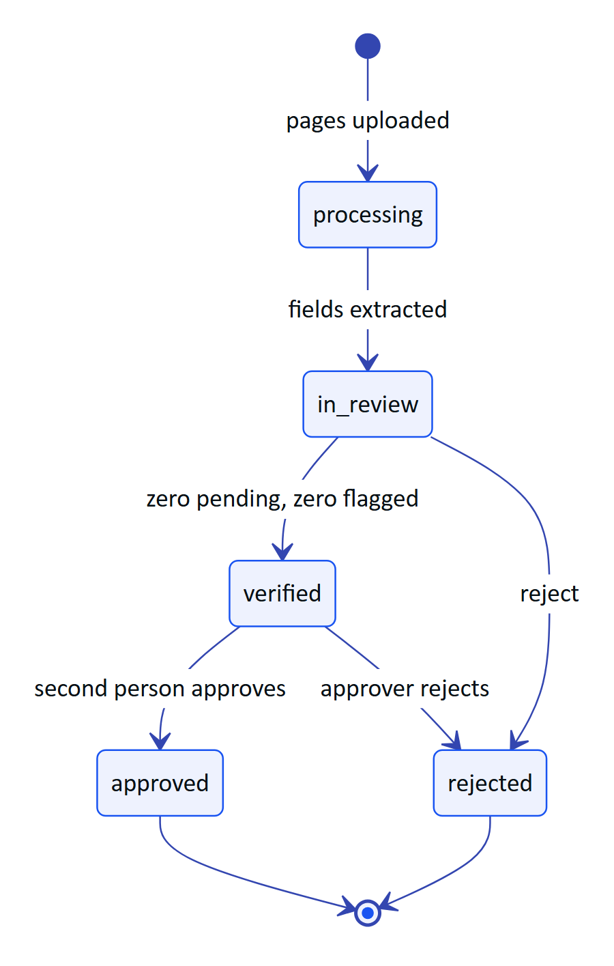
Figure 29. Audit document states on the console side (AuditDocStatus in auditdoc.ts)
The reviewer sees each extracted value beside its crop of the page, with the engines that read it and their agreement. Values where at least two independent engines match with confidence of 0.8 or more can be confirmed in bulk; everything else is confirmed, corrected or flagged one by one, and the original reading is always kept. Verify is blocked while any item is pending or flagged. Approval needs auditdoc.approve (admins and managers) and must come from someone other than the verifier, except in demo tenants where self-approval is allowed and recorded as such. The approved PDF carries the verification trail, the searchable original and a reconstructed page.
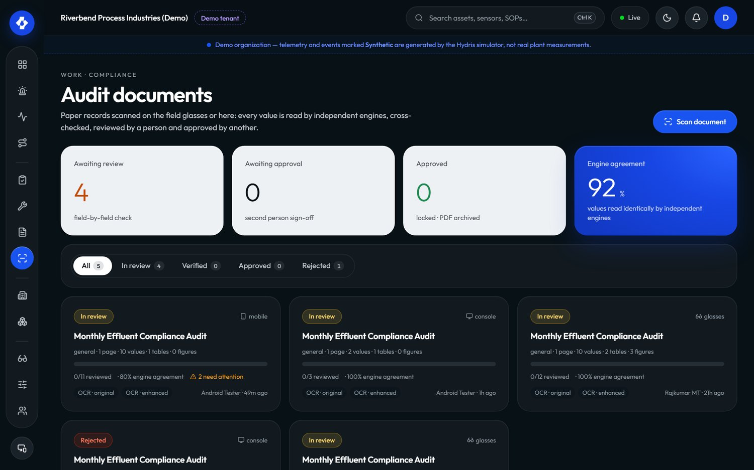
Figure 30. Audit documents review in the console
Table 20. Audit review requirements
ID | Requirement | Pri | Status
FR-064 | Confirm, correct, flag, reset; verify gate | M | Built
FR-069 | Bulk-confirm agreed multi-engine values | S | Built
FR-065 | Independent approval (four eyes) | M | Built
FR-066 | PDF with trail, searchable original, reconstruction | M | Built
FR-068 | Electronic signature with re-authentication | S | Planned

Status: Built. Next: electronic signature, which regulated customers will ask for before audit documents replace paper.

3.10 Reports, insights and the assistant

Purpose and scope
Managers and auditors need numbers they can defend. Reports (/console/reports, insights.ts) cover inspections, alarms, maintenance, devices and operators, in JSON for the page and CSV for export (FR-081). The alarm report includes median minutes to acknowledge; the inspection report includes on-time rate and the share submitted via glasses. Those fields are the data sources for most of the pilot KPIs below.
The assistant is grounded and read-only. In the console it appears as SOP retrieval on the documents page (FR-070); the voice assistant (/assistant/ask) answers only from tenant data through read tools and has no write tools (FR-072, FR-078). Its full design is in the assistant part of this book.
Table 21. Reports and insights requirements
ID | Requirement | Pri | Status
FR-081 | Reports for five areas in JSON and CSV | M | Built
FR-080 | Realtime events with replay | M | Built
FR-084 | Simulation scenarios in demo tenants only | M | Built
FR-120 | Compliance summary per discharge point | S | Planned
FR-121 | Scheduled report delivery by email | C | Planned
FR-122 | Grounded shift handover summary | C | Planned

Status: operational reports Built. Gap: no compliance summary against consent limits, which is the report regulators actually ask for. Next: FR-120 for the pilot.

3.11 Organization admin

Purpose and scope
Admins set up who can do what. The admin area covers operators (members), roles, invitations, sessions, organization settings, the audit log and, for Hydris staff, platform administration. Its rule is no escalation: nobody can grant a role above their own (assignableRoles).
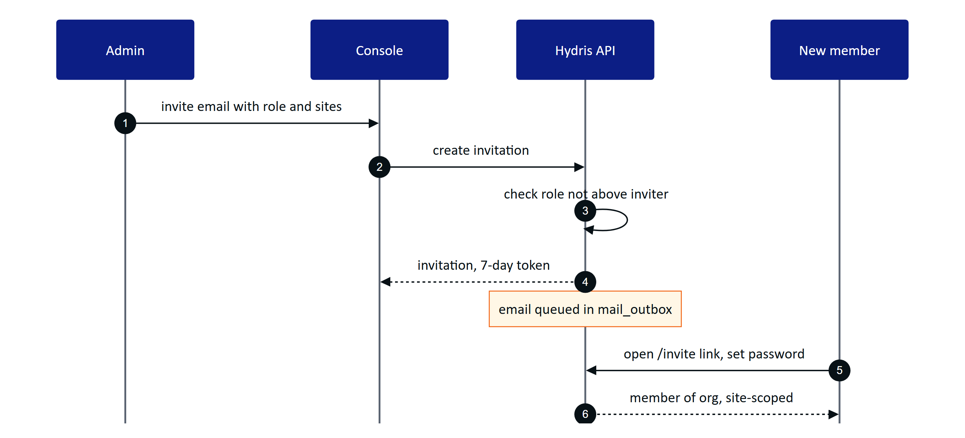
Figure 31. Inviting a member (org.ts, auth.ts)
Invitation emails are written to mail_outbox but not yet sent; until email delivery lands (FR-086), the admin shares the link. Members can belong to several organizations and switch between them (FR-006); sessions can be listed and revoked (FR-009); TOTP MFA is available (FR-002). Organization settings need org.manage, held only by org_admin.
The audit log page (/console/audit, FR-087) filters the append-only trail by action and entity and shows actor, time and IP; no API path updates or deletes an audit event (FR-082). Platform admins create and suspend customer organizations at /console/platform (FR-010); members of a suspended organization cannot sign in to it.
Table 22. Organization admin requirements
ID | Requirement | Pri | Status
FR-004 | Invitations, 7-day token, no escalation | M | Built
FR-006 | Multi-organization membership and switch | S | Built
FR-009 | Session listing and revocation | S | Built
FR-012 | Fixed role matrix | M | Built
FR-082 | Append-only audit trail | M | Built
FR-087 | Audit log page with filters | M | Built
FR-010 | Platform organization create and suspend | M | Built
FR-005 | Password reset email | M | Partial
FR-086 | Email delivery (SMTP, SES or Resend) | M | Planned
FR-011 | SSO with SAML 2.0 and OIDC | S | Planned

Status: Built apart from email delivery and SSO. Next: email delivery before the pilot, SSO for general availability.

3.12 Console success metrics and gaps

Success metrics
The console is measured by whether supervisors and managers act on field records quickly and trust them. All values below are pilot targets from the PRD, not measured results.
Table 23. Console metrics (pilot targets)
Area | Metric | Source | Target
Alarms | Median time to acknowledge, critical and high | Alarm report | Under 5 minutes
Alarms | Acknowledged but unresolved older than 24 h | Alarm list | Visible daily, trending down
Rounds | On-time completion | Inspection report onTimeRate | 95 % or more
Rounds | Share submitted via glasses | Inspection report viaGlasses | 50 % or more
Evidence | Approval cycle, capture to approval | Audit documents | Under 24 hours
Evidence | Reviewer edits per reviewed field | Audit documents | Under 5 %
Security | Device revocation to stream end | Event stream | 30 s or less
Security | Cross-tenant incidents | Security review | 0

< 5 min  Time to acknowledge  target, critical and high |  | 95 %  On-time rounds  target |  | < 24 h  Evidence approval  target |  | 0  Cross-tenant incidents  target

Gaps and next steps
Table 24. Console gaps in priority order
Gap | Requirement | Effect today | Next step
No email delivery | FR-086, FR-005 | Admin shares invite links by hand | Wire SMTP, SES or Resend with retries
No escalation | FR-037 | Unacknowledged alarms rely on someone watching | Configurable escalation to site supervisor
Stale checks daily on Vercel | FR-035 | Stale alarms late on serverless | Higher-frequency scheduler
No recurring schedules | FR-047 | Rounds dispatched by hand | Calendar and runtime schedules
No compliance summary | FR-120 | Regulator reports built outside Hydris | Daily min, max, average against consent
No SSO | FR-011 | Local passwords only | SAML and OIDC per organization
No electronic signature | FR-068 | Approval not Part 11-style | Re-authentication on approve
Auditor cannot open audit log | roles.ts | viewer lacks audit.read | Decide on an auditor role
Performance not measured | NFR-001, NFR-002 | Targets unproven | Load and latency tests before pilot

IMPORTANT
The console is functionally complete for a supervised pilot. The items that block an unsupervised pilot are email delivery, alarm escalation and a reliable stale-data schedule.

4 Glasses app (heads-up and phone)

4.1 Purpose and problem
Field operators walk rounds with gloves on, a radio in one hand and a log sheet in the other. They need the next inspection, the live reading at the asset in front of them, the alarm near them and the right procedure, without stopping to unlock a phone or walk back to the control room. The Hydris glasses app is one web viewport (apps/web/src/glasses/*, served at /glasses) that puts this work in front of the operator's eyes on display glasses, inside the phone bridge for Ray-Ban Meta, and in a browser simulator for demos and testing.
12  Screens  gated by the UI profile |  | 6  Input keys  up, down, left, right, select, back |  | 600 x 600  HUD canvas  additive display |  | 0  Lost offline steps  queue plus idempotent replay

Hands-free principles
The app follows a small set of rules that come from the design system and are enforced in hud.tsx:
- One primary action per screen, one lime focus ring, and every action reachable with six directional keys or voice (NFR-021).
- Glanceable. Body type at 20 px or more, light strokes on black, no large filled areas, because pure black is transparent on an additive display (NFR-020).
- Records only. Hydris never operates equipment. Acknowledge carries the hint "does not change equipment", and the task screen says "Records only".
- Honest data. Cached data is labelled as cached with its age, never as live (NFR-026). Demo data is labelled as synthetic.
- Administered, not configured on the device. What a pair of glasses shows is decided in the console through UI profiles, with no app update (FR-054).

4.2 Users and jobs
Table 25. Who uses the glasses app and why
User | Job on the glasses | Requirements
Field operator | Walk the assigned round, record readings, acknowledge nearby alarms, open the SOP | FR-041, FR-059, FR-112
Field operator | Capture a paper log once and send it for verification | FR-060, FR-061
Field operator, hands busy | Ask "Hey Hydris" and hear a short grounded answer | FR-071, FR-072
Shift supervisor | Pair a pair of glasses to an operator and site from a phone | FR-050
Plant manager or admin | Decide what each role sees, roll back a bad change | FR-054
Prospect and sales | Try the full app in the browser simulator | FR-059

4.3 Scope
Table 26. Scope of the glasses app
In scope (Built) | Out of scope or Planned
HUD layout for display glasses, phone layout for the bridge, browser simulator | Rendering on a real glasses display (Planned)
Device pairing by code and QR, device tokens, log out and unpair | Native Vuzix or RealWear hosts (Planned)
Home, alerts, inspections with offline queue, tasks, measurements, assets, plant map | Camera capture into inspection photo steps (FR-045 Partial)
SOP library and reader with offline cache | Hardware gestures such as a neural band or temple touchpad (Planned)
Audit scan entry, Hey Hydris voice entry | Multi-language voice (FR-073 Planned)

4.4 Runtimes
The same React viewport runs in three places. useViewportLayout in hud.tsx picks the layout: phone mode when the page runs inside the bridge (HydrisNative is present), when ?mode=phone is set, or on a narrow portrait screen; HUD mode otherwise.
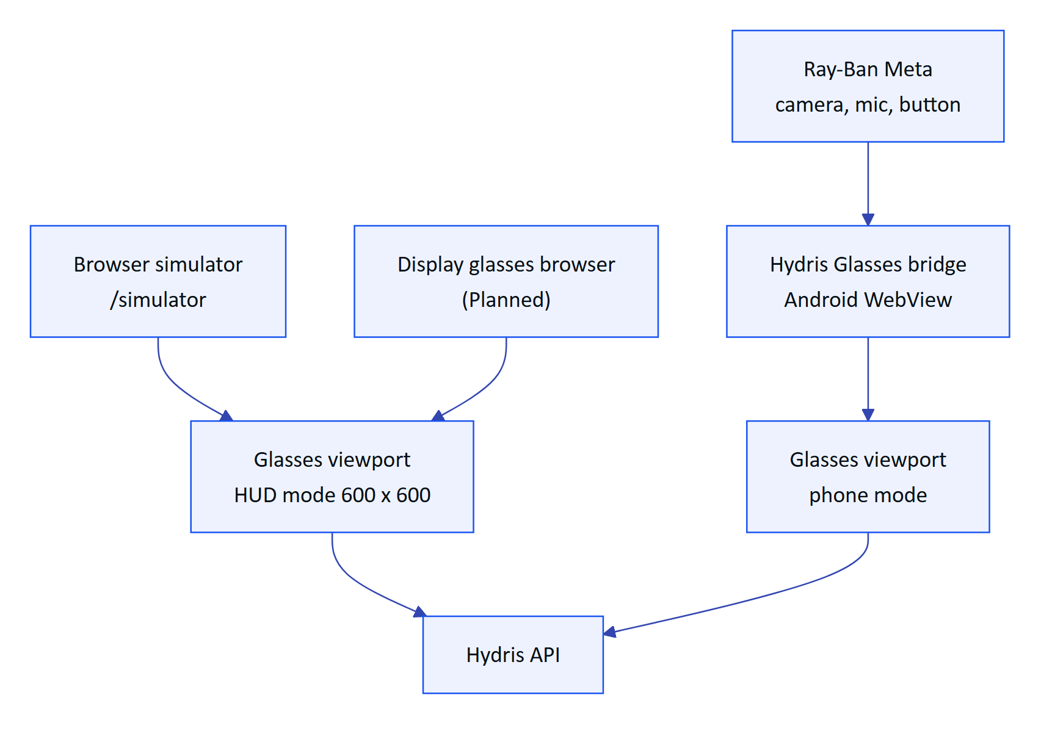
Figure 32. One viewport, three runtimes, one backend
The HUD scales a 600 x 600 canvas to the window and is driven by directional keys, swipes or the simulator's on-screen pad. Phone mode uses a 540-unit-wide layout at full height with safe-area insets and a bottom tab bar: Home or Back, Scan, Hey Hydris, Alerts. The simulator also offers 640 x 480 and 480 x 480 viewports, a network switch for simulating loss, and an event log.
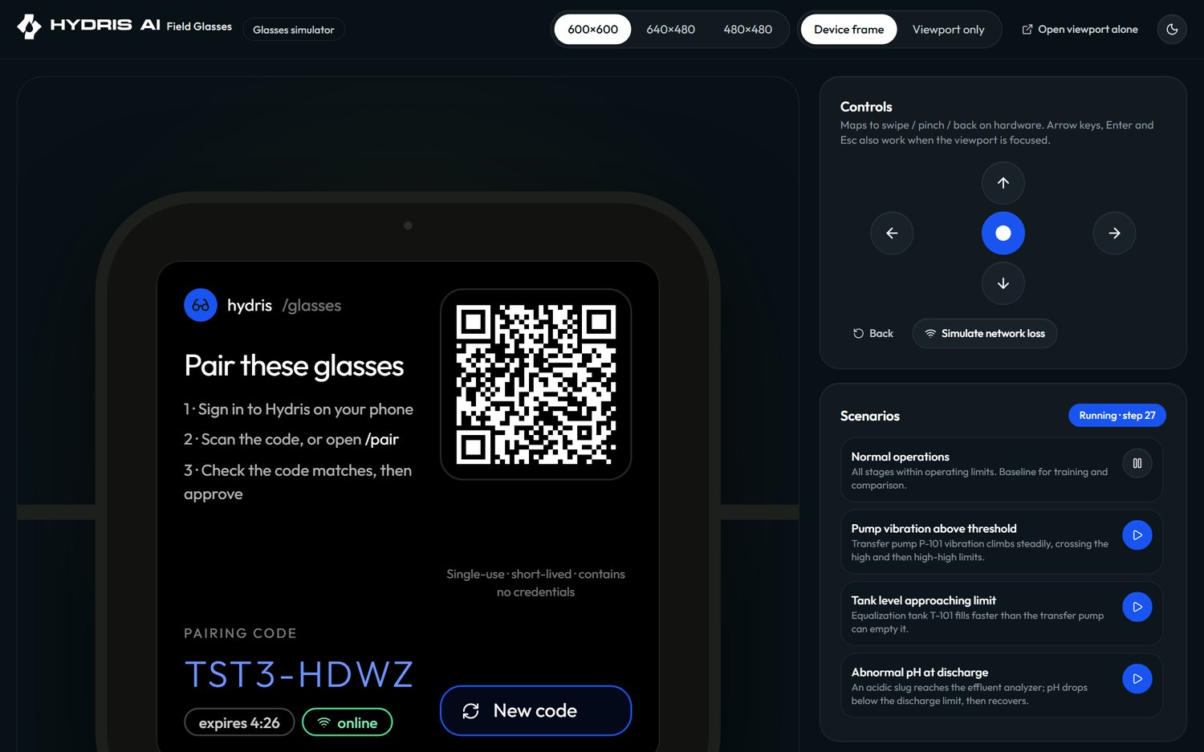
Figure 33. The browser simulator running the HUD
Table 27. HUD and phone mode compared
Aspect | HUD mode | Phone mode
Target | Display glasses, simulator | Bridge app on the phone paired with Ray-Ban Meta
Navigation | Six keys, swipes, hydris:input from the simulator | Bottom tab bar plus touch
Camera | Simulated or device camera | Glasses camera through the bridge
Voice | Browser speech | Glasses microphone through the bridge, browser fallback

4.5 Screen map and navigation
The app has twelve top-level screens (FR-059) plus detail screens for an alert, an inspection, a task, an asset and an SOP. Home is the menu: its item order and visibility come from the UI profile, and Home and Status (device and log out) can never be switched off.
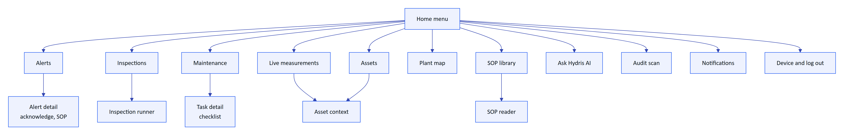
Figure 34. Screen map (GlassesApp.tsx)
Navigation is a stack. Every push also writes a browser history entry, so the hardware or browser back button walks back through glasses screens and never leaves the app; at the bottom of the stack it returns to Home. In HUD mode, up and down move the focus, select activates it, left or back pops the stack.
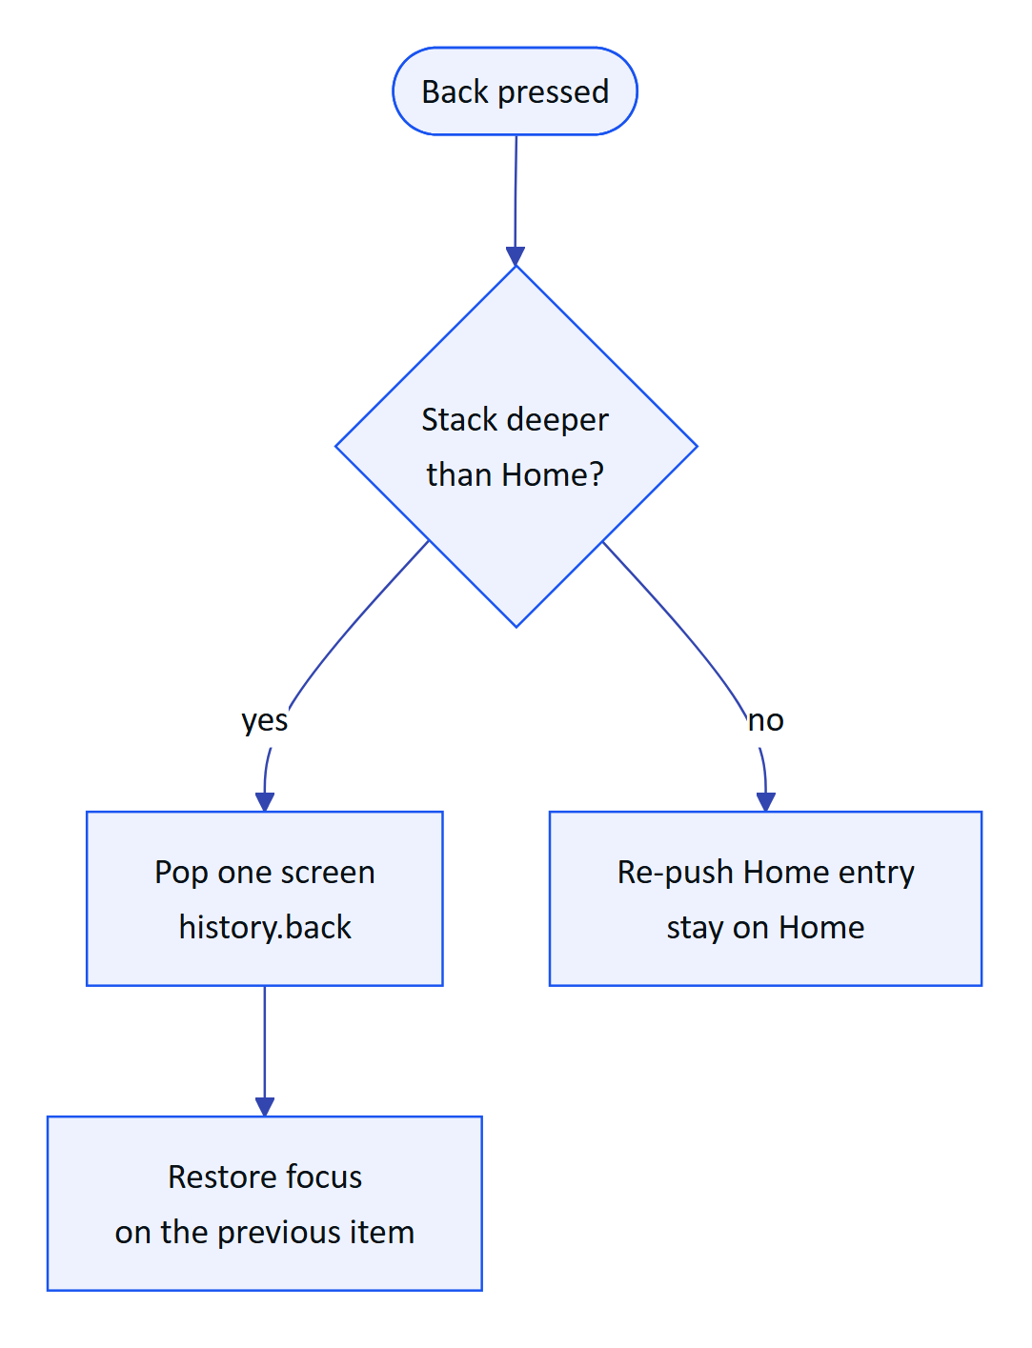
Figure 35. Back navigation never leaves the app

4.6 Lifecycle and pairing
The viewport moves through phases before the operator reaches Home. On boot it looks for a device credential; without one it shows the pairing screen. If the server reports the device as revoked, suspended or unassigned, the app shows that state plainly instead of failing silently.
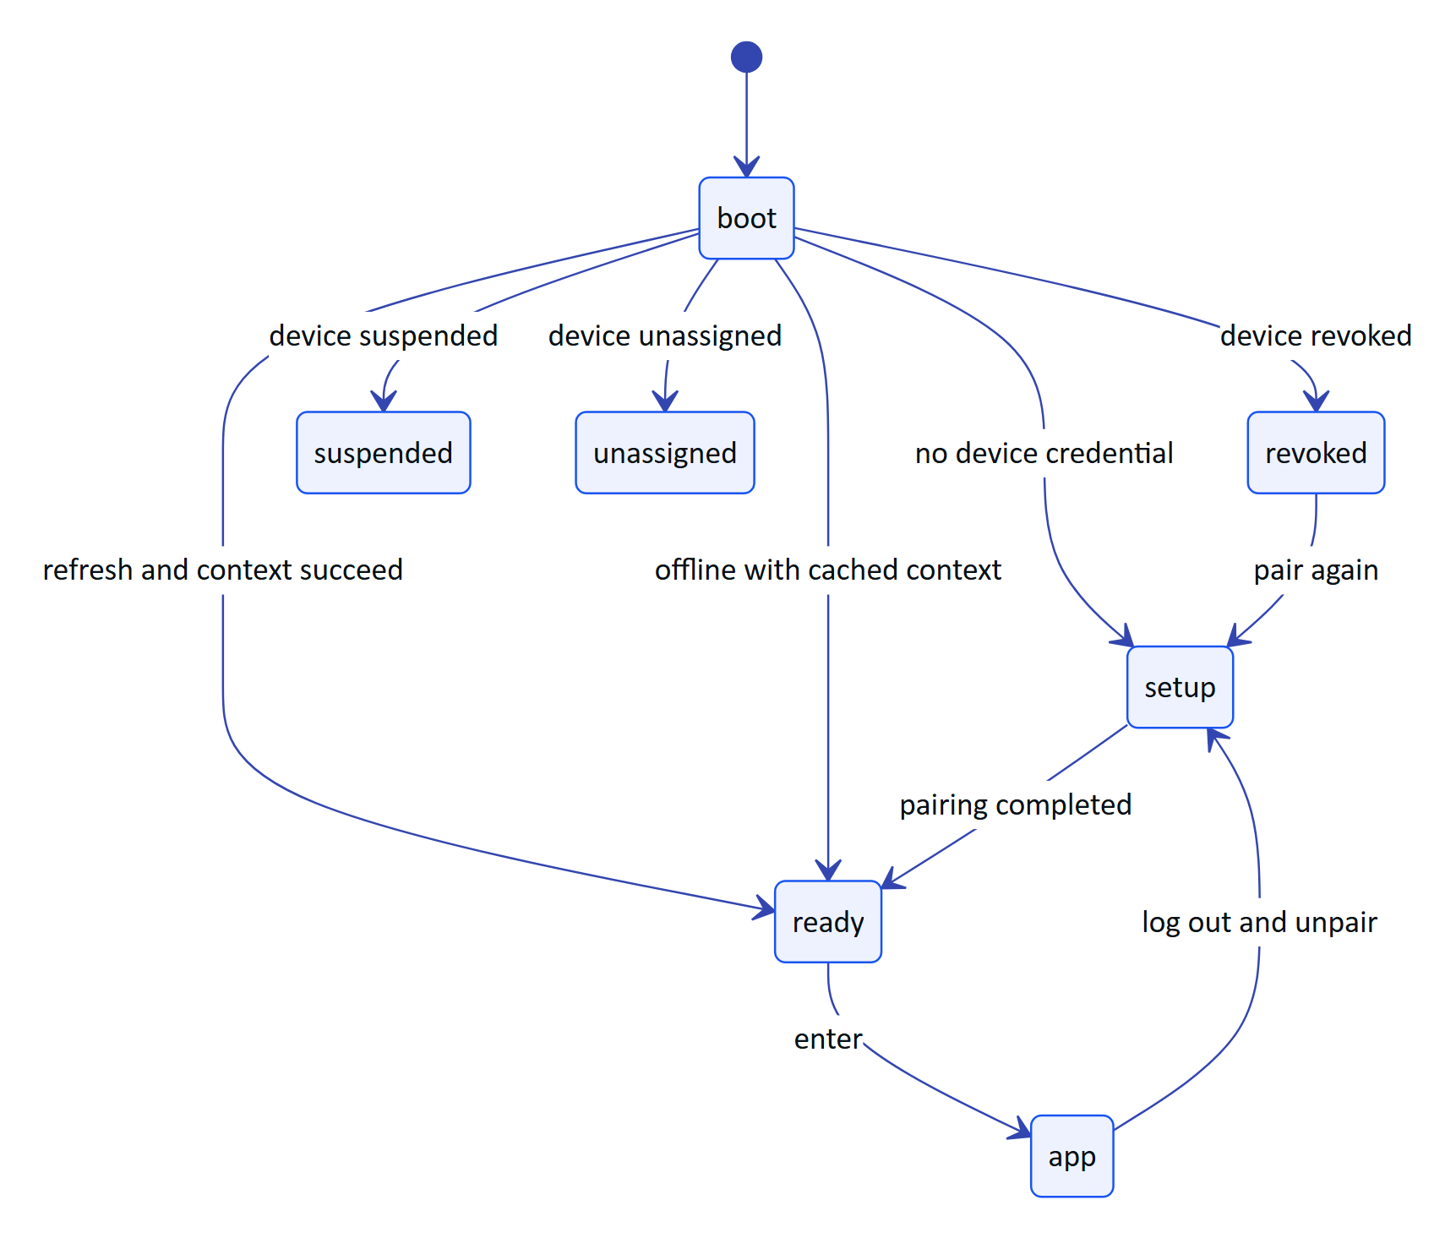
Figure 36. Viewport phases from boot to the app
Pairing follows the shape of the OAuth device authorization grant (RFC 8628). The glasses never type a password: they show a short code and a QR link, a signed-in supervisor approves on any phone or browser, and the glasses claim their own credential with a secret that is never displayed.
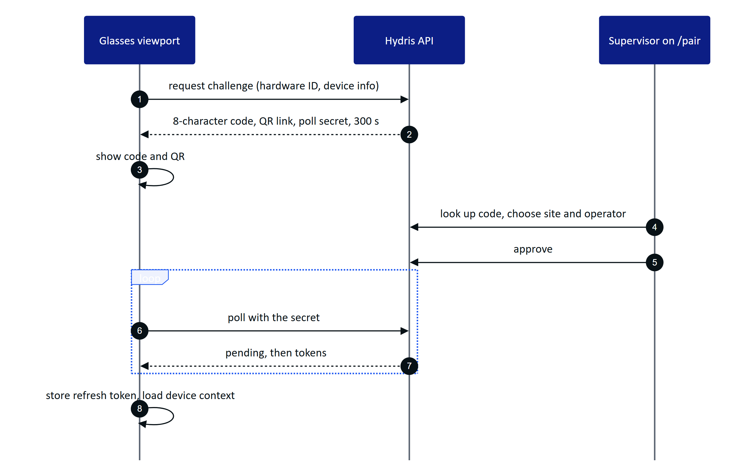
Figure 37. Pairing from the glasses side
The code uses 8 characters from an alphabet without 0, O, 1, I, L or U. Polling faster than 3 s returns slow_down; an expired code cannot be approved. After pairing the device holds a 15-minute access token and a 30-day rotating refresh token with reuse detection (FR-051). The viewport keeps its hardware ID (hg- plus a random UUID) and refresh token in local storage, which the code marks as the boundary for a hardware-backed store.
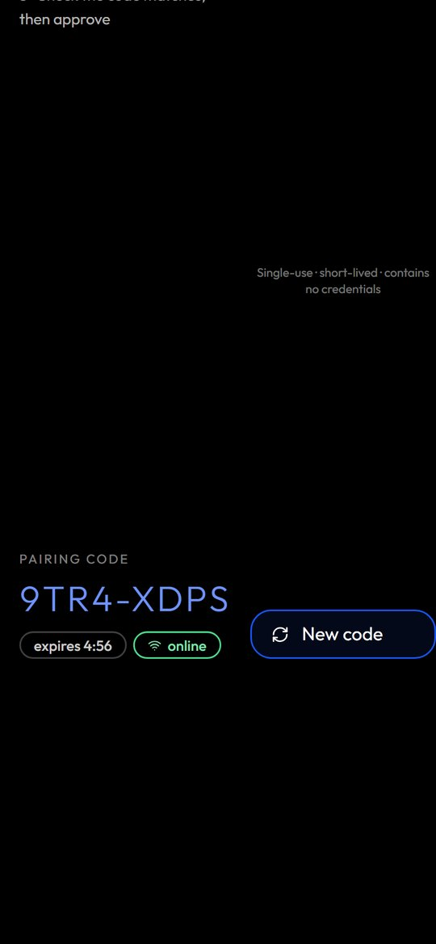
Figure 38. Pairing code and QR in phone mode
Log out and unpair lives on the Device screen behind a confirmation ("Log out and unpair these glasses?"). It ends the device's server sessions, after which the refresh token is rejected and anyone can pair the glasses again (FR-058). Revocation from the console takes effect on the next request and within 30 s on the live event stream (FR-052).

4.7 Core experience

Home
Home greets the operator by first name ("...'s shift") with the site name, then shows profile-controlled widgets: the next inspection card, a critical alarm badge, three measurements at a glance and checklist progress. Below is the menu, each item with a live count (open alerts and critical count, inspections assigned, sensors on site). Values outside their threshold are tinted.

Alarms
Alerts lists open alarms by severity. The detail shows the value, the rule, the recommended action and the linked SOP (FR-112). Acknowledge is the single primary action; it needs a connection, says so when offline, and confirms with "Acknowledged. The equipment state is unchanged."

Inspections with an offline queue
The inspection runner walks the operator one step at a time through check, reading, choice and text steps. A reading outside its expected range, a failed check or an abnormal choice marks the step abnormal automatically. Photo steps show "attach from console" today (FR-045 Partial).
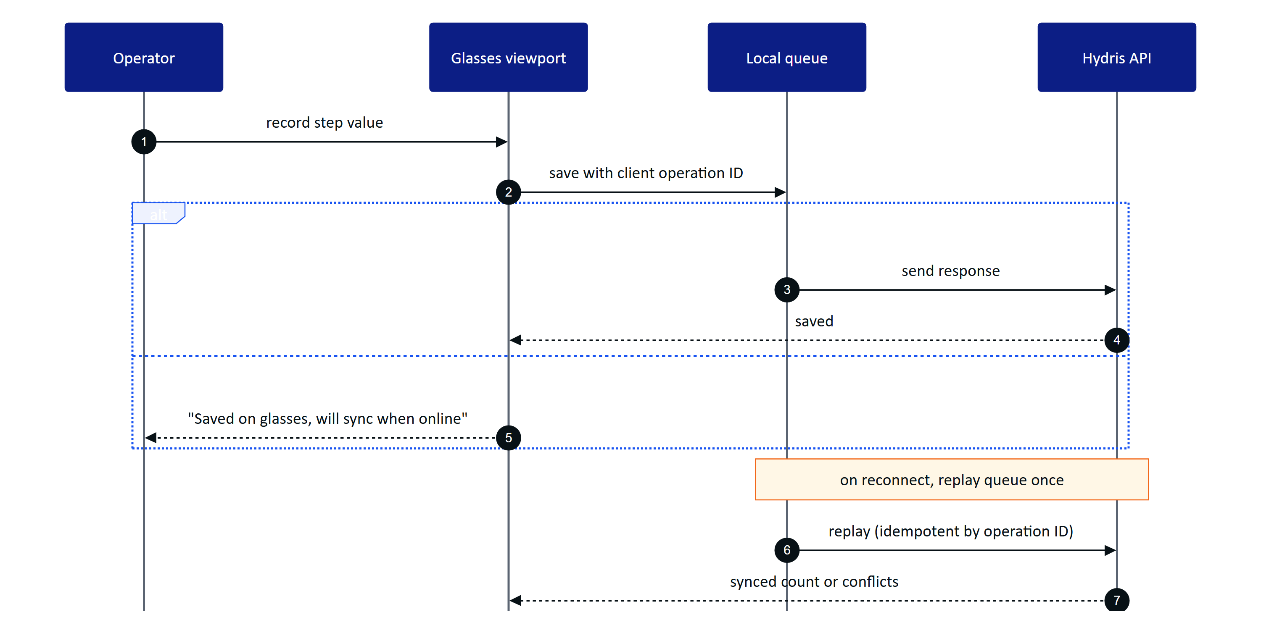
Figure 39. Recording a step online or offline (data.ts)
Every response is queued first and then flushed, so the same path serves online and offline work (FR-041, NFR-025). The status bar shows "N queued" and an offline strip states the age of cached data. On reconnect the app reports "Back online, N queued steps synced", or names the first conflict if the server rejected a step. Submitting an inspection needs a connection and stays disabled until every required step is complete.

SOPs and assets
The SOP library lists only approved documents (FR-111); a draft never reaches the glasses. An SOP opened once is cached and opens again with no network (FR-113). Asset context shows the asset's live readings with freshness and a short trend from the last 30 values, and links to Assist for grounded procedure passages with a safety notice (FR-070).

Audit scan entry point
Audit scan turns a paper log into a verified record. On the glasses it opens a guided A4 capture: live page detection, auto-capture when the page is aligned, steady and sharp, perspective correction, two on-device OCR passes, review of up to six pages, then upload for verification in the console (FR-060, FR-061, FR-067). In the bridge the glasses camera feeds the guidance and the capture button takes the photo; in the simulator a simulated camera walks a sample sheet through too close, too far, tilted and square. The full pipeline is described in the audit scan part of this book.

4.8 UI profiles
A UI profile is a versioned description of what a pair of glasses may show and do: enabled screens and their order, home widgets, allowed actions, a measurement filter and a text scale (0.9, 1, 1.15 or 1.3, NFR-019). Profiles are drafted, published and rolled back in the console. Assignment resolves with precedence device, then user, then role, then organization; the most specific published profile wins entirely and is never merged.
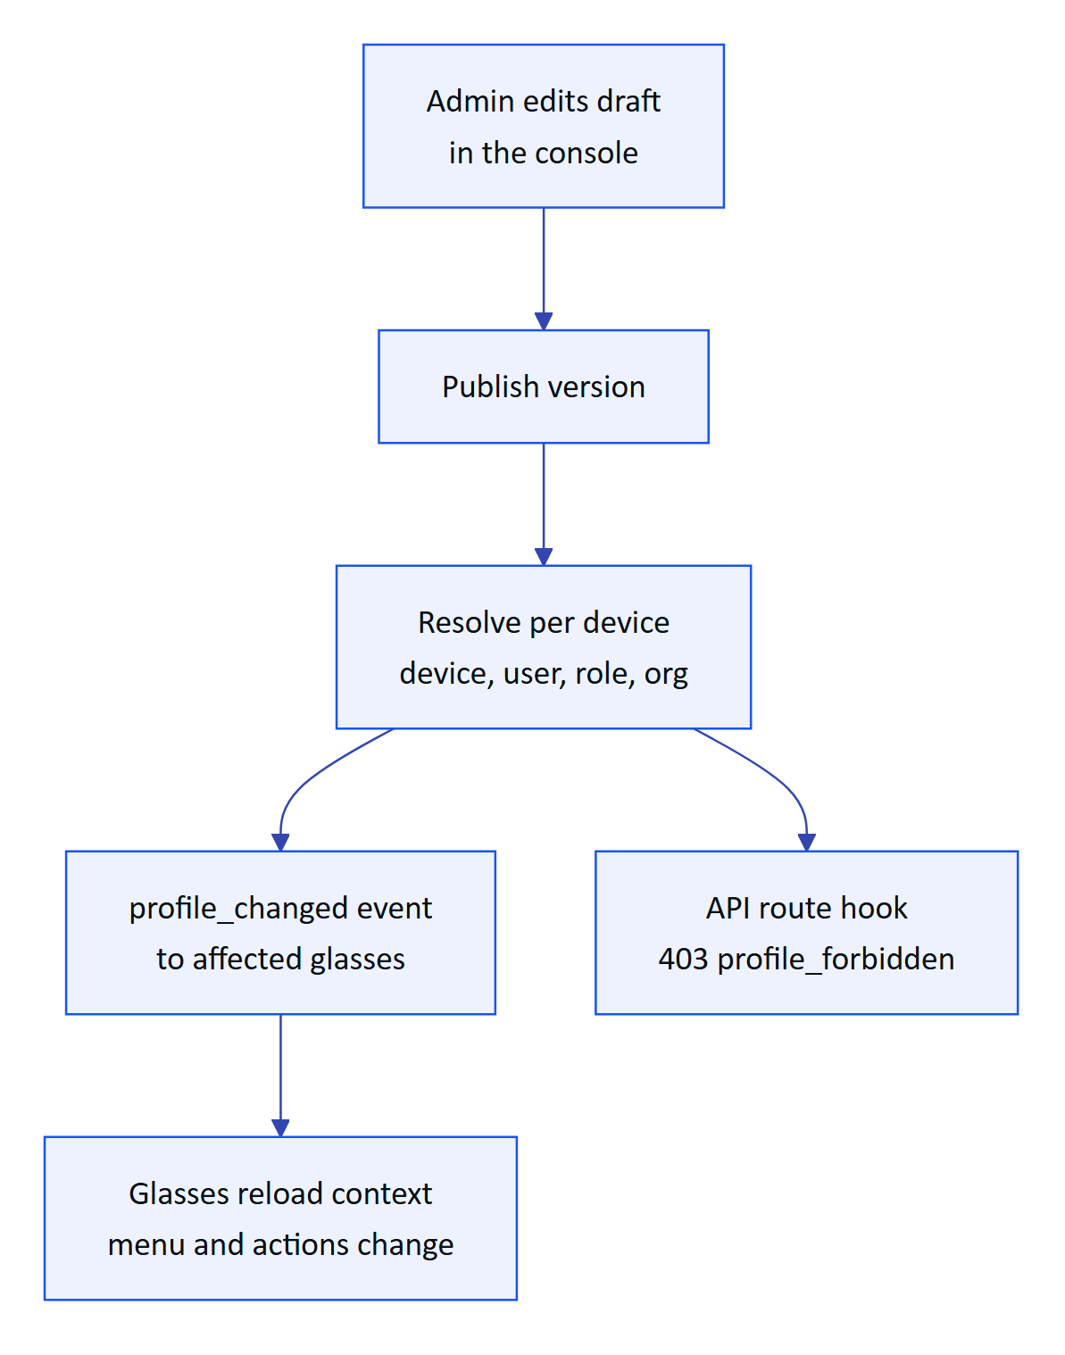
Figure 40. How a profile reaches the glasses and is enforced
The server enforces the same profile it sends: a device whose profile hides alarms gets 403 profile_forbidden from the alarms API even if the operator's role allows it. On the glasses, a blocked action shows a dashed "not permitted by your profile" note rather than disappearing silently. The console can also push a draft into a live preview of the viewport before publishing.
Table 28. What a profile controls
Control | Options
Screens | 12 screens; Home and Device are always on
Widgets | Next inspection, critical alarm badge, measurements at a glance, checklist progress
Actions | Acknowledge alarms, record and submit inspections, tick checklists, ask AI, open SOPs, view map, mark notifications read
Measurements | Allowed measurands, order by asset type
Text scale | 0.9, 1, 1.15, 1.3

4.9 Voice entry point
"Hey Hydris" opens the voice assistant from any screen, and so does the Hey Hydris tab in phone mode or a "Hey Meta, start Hydris" invocation in the bridge (FR-077 Partial). The engine order is the glasses microphone through the bridge, then the browser Web Speech API, then typed questions. Answers are one or two sentences, spoken, and shown with the facts behind them (FR-071, FR-075, NFR-022).
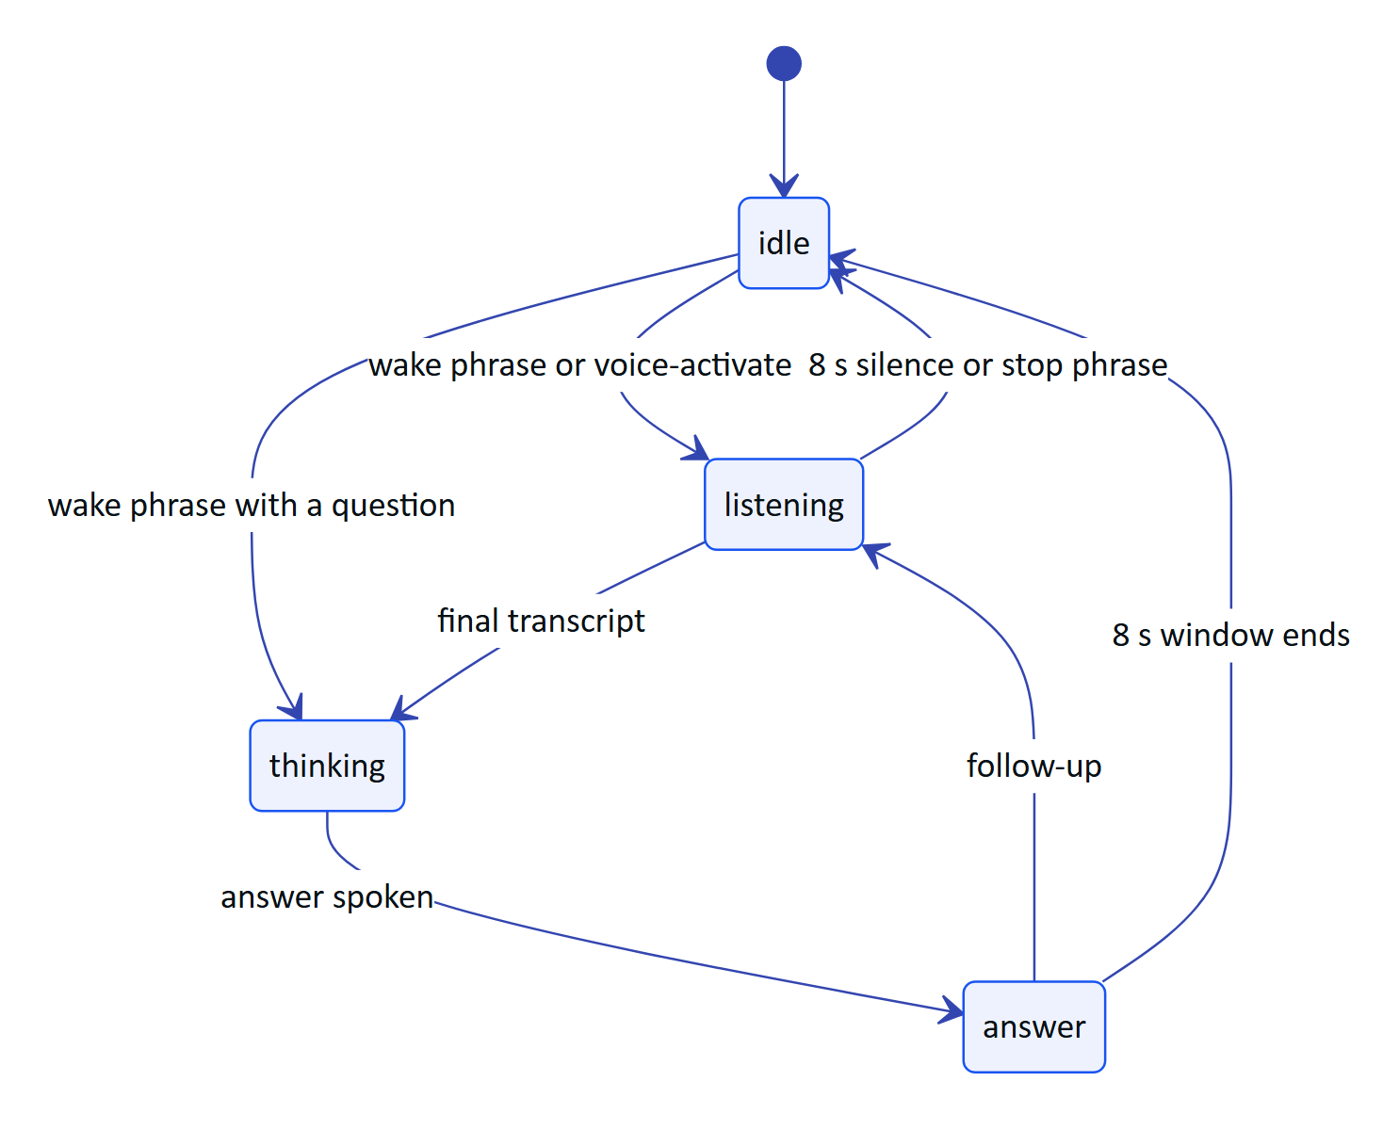
Figure 41. Voice assistant states (VoiceAssistant.tsx)
Offline, demo and cached answers come from the same rules engine the API uses, so the assistant never guesses: an unknown question returns "unknown" (FR-072). The assistant has no write tools (FR-078).

4.10 Requirements
Table 29. Glasses app requirements (IDs from the PRD)
ID | Requirement | Pri | Status
FR-059 | Heads-up app, 12 screens, six-key input, phone layout | M | Built
FR-050 | Pairing by 8-character code and QR, 300 s TTL, 3 s polling | M | Built
FR-051 | Device tokens: 15-minute access, 30-day rotating refresh | M | Built
FR-052 | Suspend, revoke, reassign; effective within 30 s on the stream | M | Built
FR-058 | Log out and unpair from the glasses menu | M | Built
FR-054 | UI profiles: draft, publish, rollback, live push | S | Built
FR-041 | Inspection execution with offline queue and idempotent replay | M | Built
FR-042 | Submit inspections; returned ones can be restarted | M | Built
FR-045 | Photo steps captured with the glasses camera | S | Partial
FR-112 | Alarm detail shows and opens the linked SOP | M | Built
FR-111 | Only approved documents reach the glasses | M | Built
FR-113 | Opened SOPs cached for offline reading | S | Built
FR-060 | Guided A4 capture with auto-capture | M | Built
FR-071 | Hey Hydris wake phrase and short spoken answers | M | Built
FR-077 | "Hey Meta, start Hydris" opens the assistant | C | Partial (bridge only)
NFR-019 | Text scale per profile | M | Built
NFR-020 | Additive-display friendly design | M | Built, to verify on hardware
NFR-025 | Inspection responses survive connectivity loss | M | Built
NFR-026 | Cached context shown as cached, never as live | S | Built

4.11 Success metrics
Table 30. Glasses app metrics (targets, not measured results)
Metric | Target | Source
Home ready after wake | 2 s from cached context, fresh data within 5 s | NFR-005 (target)
Queued steps lost after reconnect | Zero | NFR-025 (Playwright journey passes today)
Voice answer time, end of speech to spoken answer | 3 s rules engine, 8 s model engine | NFR-003 (target)
Profile change visible on glasses | Without a reload | FR-054 acceptance
Rounds completed on the glasses in pilot | To be set with the pilot customer | Pilot plan

4.12 Status, gaps and next steps
The web viewport is Built and runs today in the simulator and inside the bridge. It has not yet run on a real glasses display.
WARNING
Hardware gestures (neural band, temple touchpad) are not delivered to the web runtime yet; input.ts keeps a placeholder. The viewport's refresh token sits in local storage until a hardware-backed store exists.

- ☐ Run the HUD on display glasses (Vuzix M400, RealWear Navigator 520, Meta Ray-Ban Display), Planned.
- ☐ Wire glasses camera capture into inspection photo steps (FR-045).
- ☐ Hardware-backed credential storage for the viewport.
- ☐ Inspection execution in the Android app with the same offline guarantees (FR-044, Planned for pilot).
- ☐ Measure NFR-003 and NFR-005 on hardware during the first pilot.

5 Hydris Field Android app

5.1 Purpose and problem
Operators in effluent and sewage treatment plants walk rounds with a phone in their pocket and, increasingly, Ray-Ban Meta glasses on their face. Until now the only app that talked to those glasses was Meta AI, a consumer assistant that knows nothing about the plant. Hydris Field is the native Android companion that takes over the working day: one Hydris account, the plant dashboard, alarms and work, audit scanning, the "Hey Hydris" assistant and the glasses link, all in one app (apps/android, Kotlin and Jetpack Compose).
IMPORTANT
Hydris Field does not replace the Meta AI app, and cannot. Meta's Wearables Device Access Toolkit (DAT) requires Meta AI for Bluetooth pairing, firmware updates, Developer Mode and the approval prompts for camera and microphone. Meta AI stays installed as the connection broker; after a one-time setup the operator opens only Hydris Field.

5  Bottom tabs  Home, Work, Scan, Hydris, Glasses |  | 7  Navigation routes  `Root.kt` NavHost |  | 2  OCR passes per page  on the phone, before upload |  | 12  Minimum Android version  `minSdk` 31

5.2 Users and jobs
Table 31. Who uses the app and for what
User | Job the app does for them
Field operator | See what needs attention on my sites, act on alarms where I stand, scan paper logs, ask questions hands-free
Maintenance engineer | See open work orders and tick checklist items in the field
Shift supervisor | Keep plant status, alarm trend and asset health in my pocket
Prospect or partner | Try the full product in minutes with a named demo account

All of them already hold a Hydris console account. The app adds no new account type and the server needed no mobile-specific authentication.

5.3 Scope
Table 32. In scope and out of scope for this release
In scope | Out of scope
Sign-in, demo mode, session restore | Administration of members, roles, sites and rules (console)
Home dashboard, Work tabs, alarm and sensor detail | Reviewing and approving audit documents (console)
Audit scan from glasses, phone camera or import | Equipment control of any kind
Hey Hydris assistant | A heads-up display on Ray-Ban Meta (they have none)
Glasses connect, test and register | iOS native app
Realtime alarm notifications while the app runs | Replacing the Meta AI app

5.4 Navigation
The app is one activity with a bottom navigation bar. Root.kt first decides between restoring a session, Login and the signed-in shell; each tab keeps its scroll position when the user switches away and back.
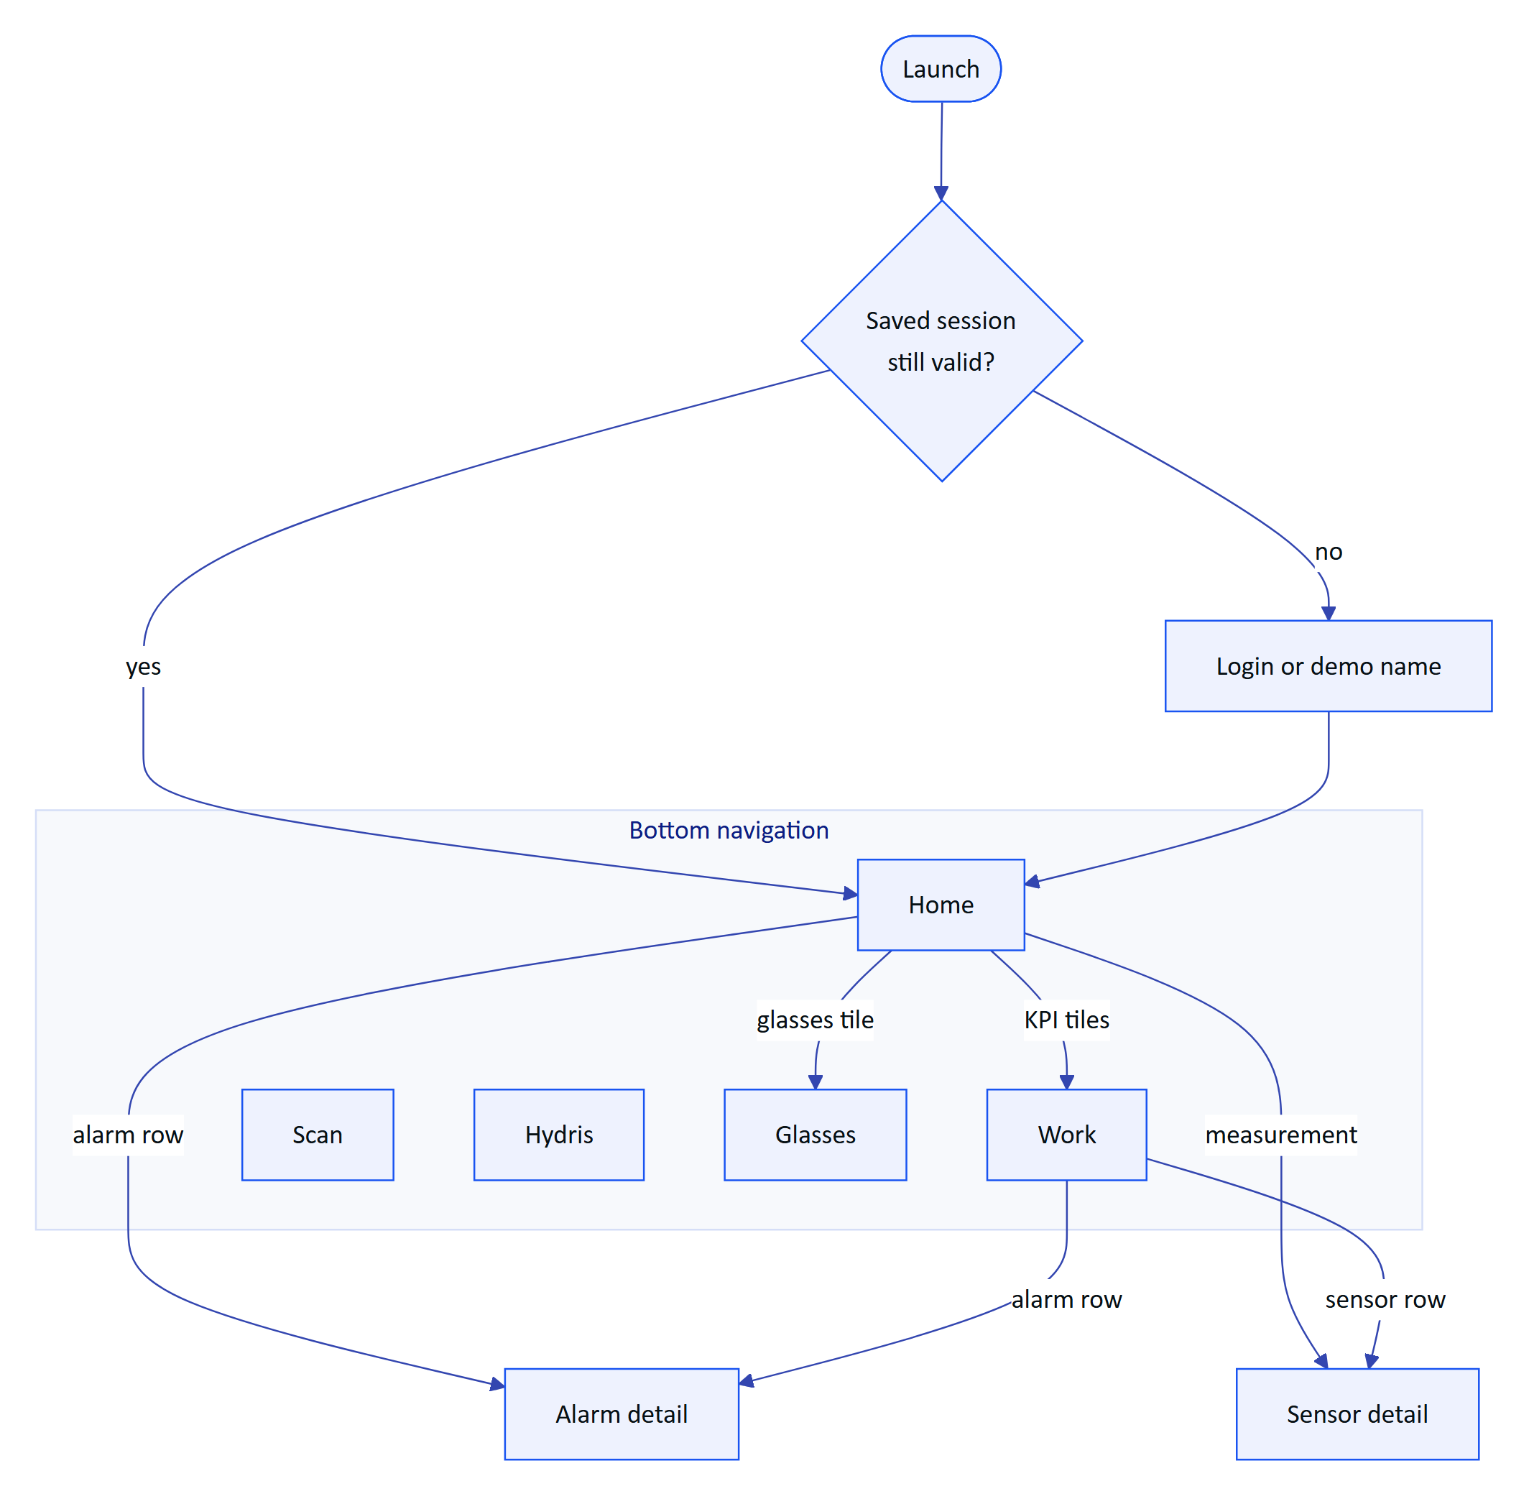
Figure 42. Navigation map of the five tabs and the two detail screens
Table 33. What each tab is for
Tab | What the user does there | Part of this book
Home | Reads the plant status at a glance | This part
Work | Works alarms, inspections, maintenance, sensors, audit documents | This part
Scan | Turns a paper record into a document for verification | Audit document scanning
Hydris | Asks questions by voice or text | Hey Hydris voice assistant
Glasses | Connects, tests and registers Ray-Ban Meta glasses | Ray-Ban Meta glasses

5.5 Session and sync

Sign-in and restore
The operator signs in with the console email and password, or taps "Enter demo mode" and types a name of two or more characters to get a personal synthetic account. The short-lived access token lives in memory only; the rotating refresh cookie is stored encrypted with AES-256-GCM under a non-exportable Android Keystore key (SecureStore.kt). Killing and reopening the app restores the session without a password.
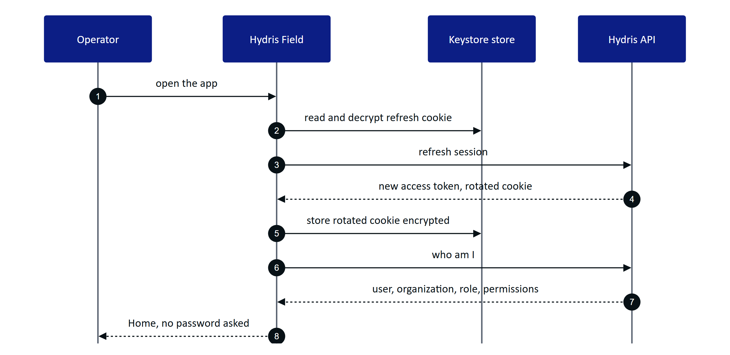
Figure 43. Session restore when the app starts
If the cookie is missing or refused, the operator lands on Login. Later, any 401 triggers one refresh; refreshes are serialized by a lock so parallel screens never present an old cookie, which the server would treat as reuse and revoke. If refresh fails the user sees "Session ended. Please sign in again."
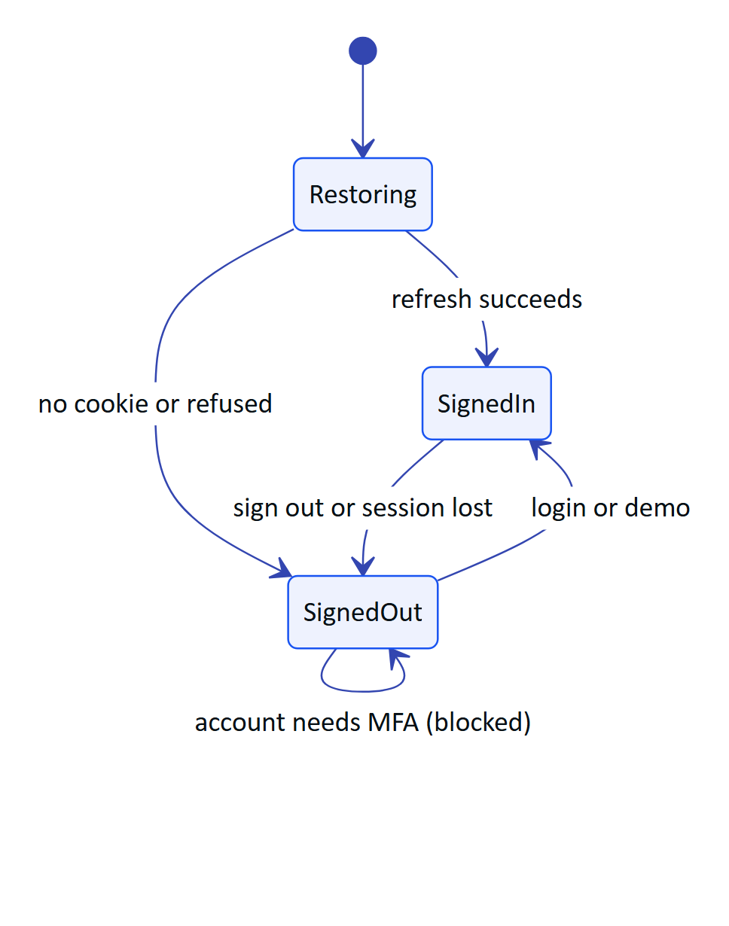
Figure 44. Session states in Root.kt

Keeping screens live
Two mechanisms keep data current without a local database. Screens poll while visible (Home and alarms every 15 s, sensors every 10 s, audit documents every 20 s), and a server-sent event stream pushes alarm events. The stream resumes with Last-Event-ID, so events missed during a network drop are replayed.
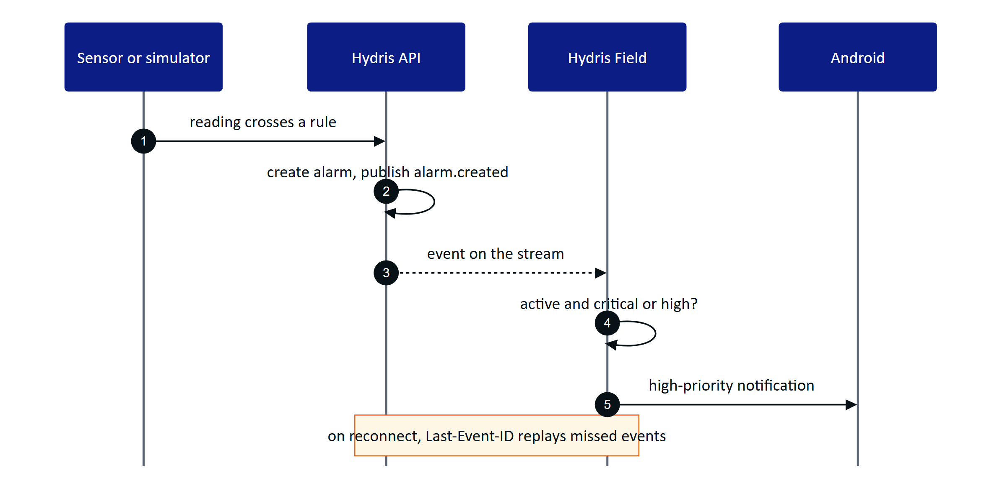
Figure 45. Realtime alarm notification from reading to phone
DECISION
Polling plus the event stream is deliberate for the pilot. Every screen stays correct after a network drop without an offline cache. The cost is extra requests while a screen is visible; the Planned offline outbox and cache will change this.

5.6 Home dashboard
Figure 46. Home: status line, KPI tiles, alarm trend and asset health
Home answers "what needs me now?" from one call to the same overview endpoint the console uses (FR-089). Top to bottom: a greeting with the operator's first name and a "Demo" chip for demo tenants; a status line ("2 critical alarms need attention." or "All quiet on your sites."); four KPI tiles (open alarms, inspections due and overdue, maintenance, field glasses connected); a 14-day alarm trend; an asset-health donut; live measurements with a freshness dot, age and a "synthetic" label for simulator data; recent alarms; and the last eight activity events. Tiles and rows are shortcuts into Work, Alarm detail, Sensor detail and Glasses.
A failed refresh keeps the last overview on screen. Missing data shows "No data", never zero, and stale values carry their state.

5.7 Work
Work holds everything open in five tabs, each filtered by the operator's site scope on the server.
Table 34. Work tabs
Tab | What the operator sees | What the operator can do | Status
Alarms | Severity, title, state, age, assignee; critical alarms outlined in orange | Open alarm detail and act | Built
Inspections | Title, status, site, overdue marker, step progress | Read only | Partial: running an inspection on the phone is Planned (FR-044)
Maintenance | Priority, status, checks done; expands to the checklist | Tick checklist items | Built; start, hold and complete Planned
Sensors | Name, tag, freshness, age, open alarms, value | Open sensor detail with 6 h, 24 h, 7 d chart | Built
Audit docs | Status, values, engine agreement, review progress | Read only (review is in the console) | Built

Working an alarm
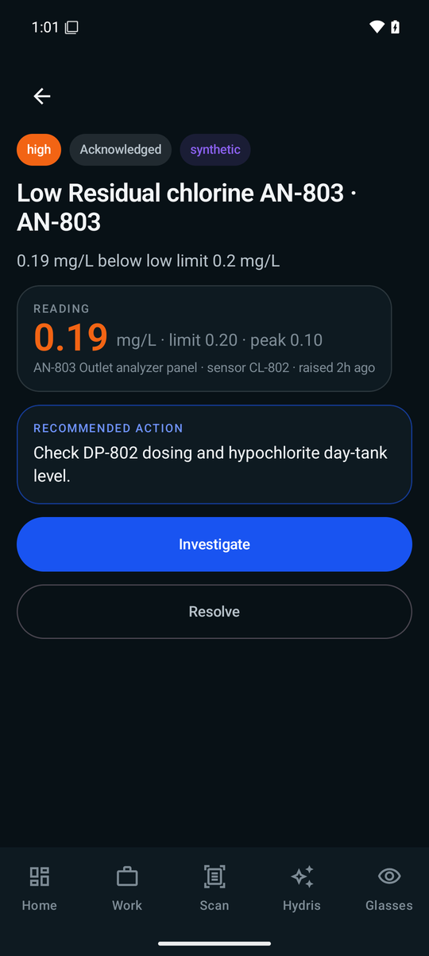
Figure 47. Alarm detail: reading against limit, recommended action and the next step
Alarm detail shows the trigger value in the severity colour against its limit and peak, the asset and sensor, a recommended action, and buttons for the next lifecycle step. Resolve asks for a note ("What was done"), because the API refuses a resolution without one (FR-031); the button stays disabled until the note is filled.
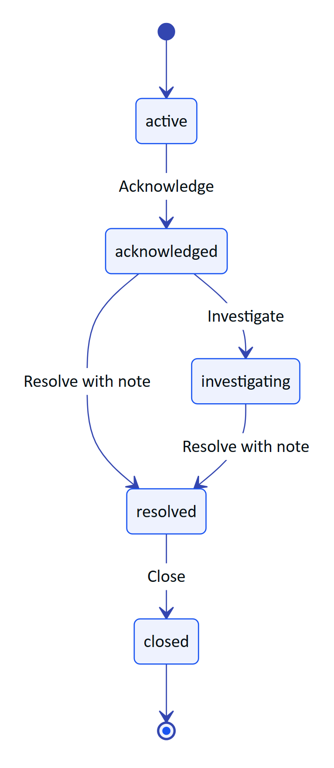
Figure 48. Alarm lifecycle as the operator moves it on the phone
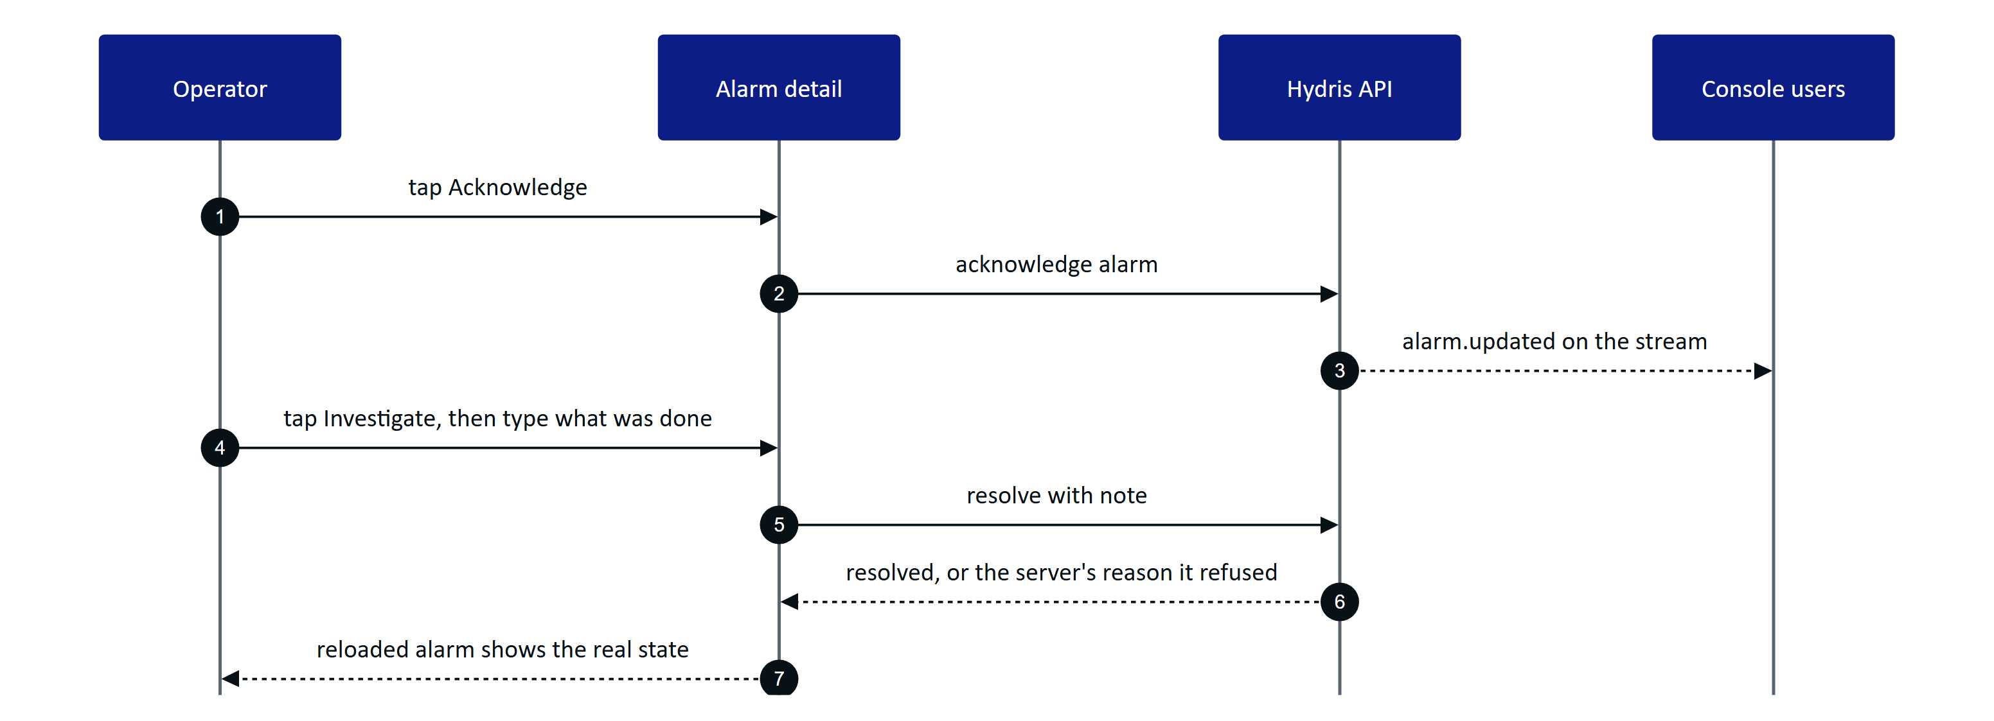
Figure 49. Acknowledge, investigate and resolve from the field
Server rules always win: if the operator lacks the permission, or a colleague moved the alarm first, the server's message is shown and the screen reloads the true state.
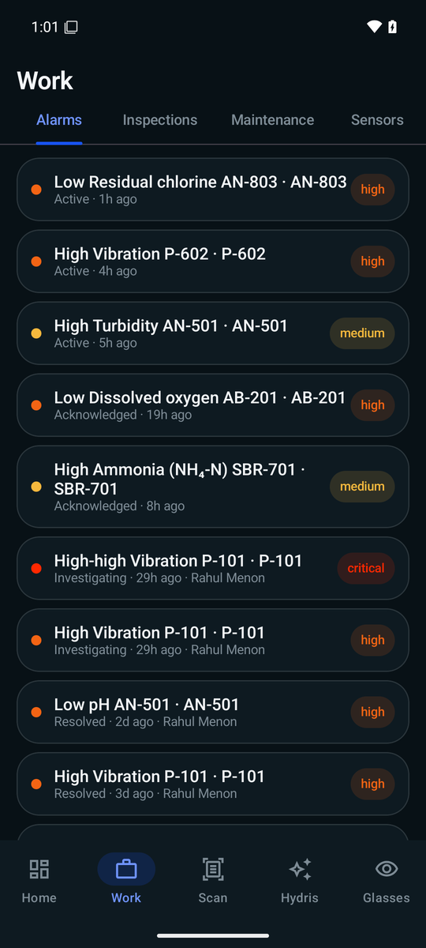
Figure 50. Work on the Alarms tab

5.8 Glasses tab
The Glasses tab is the one place to link Ray-Ban Meta glasses through the Meta AI app, test the camera and microphone, and register the glasses as a Hydris device so scans are attributed. If Meta AI is not installed, "Connect glasses" stops early and says so. The full flows are in the Ray-Ban Meta glasses part. Every glasses feature has a phone fallback: phone camera, phone microphone, phone speaker.

5.9 Permissions
The app asks for each permission in context and keeps working when one is denied.
Table 35. Permissions and what happens if denied
Permission | Asked when | If denied
Nearby devices (Bluetooth connect) | App start | Glasses unavailable; phone features work
Notifications | App start | No alarm notifications
Camera | "Scan with phone camera" | Import a photo still works
Microphone | Turning Hey Hydris on | Typing still works
Glasses camera (in Meta AI) | First glasses preview or photo | Clear message; phone camera works
Glasses microphone (in Meta AI) | First glasses listening | Falls back to the phone microphone

WARNING
Bluetooth and notification permissions are requested on every app start, so a user who denies them is asked again each time. Asking once and explaining in Settings is Planned.

5.10 Performance and native principles
- Native, not a wrapped website. Kotlin, Compose and Material 3, dark only, in the shared Hydris palette; charts are drawn directly on a canvas with no chart library.
- Work on the device first. Page detection and both OCR passes run on the phone; no image leaves it until "Send for verification".
- Fail fast, wait when it matters. 15 s connect timeout; 90 s read timeout for scan uploads; the event stream has no read timeout and relies on server heartbeats.
- Tolerant of server change. Unknown JSON fields are ignored, so new API fields do not break older builds.
- Glanceable for gloves and glare. Large KPI numbers, 52 to 54 dp primary buttons, explicit empty states ("No open alarms.").
- One app-wide set of engines. Session, glasses link and voice live in singletons created once at start; ViewModels, Hilt and Room are Planned.

5.11 Requirements
Table 36. Android app requirements (FR-090 block)
ID | Requirement | Pri | Status
FR-090 | Console sign-in; session restored from a Keystore-encrypted refresh cookie | M | Built
FR-091 | Demo sign-in with a name | M | Built
FR-092 | Home: greeting, 14-day trend, asset health, live measurements with freshness | M | Built
FR-093 | Work tabs scoped to the user's sites | M | Built
FR-094 | Alarm detail with lifecycle actions | M | Partial: resolve note added; buttons not yet driven by the API's allowed actions
FR-095 | Sensor detail with 144-point history and typical range | S | Built
FR-096 | Audit scan from glasses, phone or import | M | Built (phone); glasses path Partial
FR-097 | Realtime notifications for critical and high alarms while the app runs | M | Built
FR-098 | Offline outbox with idempotent replay | S | Planned (GA)
FR-099 | Complete MFA sign-in in the app | S | Planned (Pilot)
FR-089 | Home and console overview from the same endpoint | M | Built

5.12 Success metrics
Table 37. Android success measures (targets, not measured results)
Measure | Target
Opening Scan to "Sent" for one A4 page | Under 60 s on a mid-range phone
Scans that auto-capture without "Capture now" | Above 70 %
Critical alarm to phone notification | Under 5 s while the app runs
Spoken answer after the question ends | Under 3 s on 4G
Crash-free sessions in pilot | Above 99.5 %

The app was verified manually on an emulated Pixel 7 (API 35): login, demo mode, home, assistant, alarm acknowledgement, and a scan import that extracted 10 values including pH 7.3 correctly.

5.13 Status, gaps and next steps
Table 38. Gaps to close before and during the pilot
Gap | Effect today | Plan
No MFA step (FR-099) | Accounts with TOTP must sign in on the web | Code entry screen, Pilot
No offline outbox (FR-098) | Actions need a network | Room cache and outbox, GA
Actions not driven by allowed actions (FR-094) | A button may be offered that the server refuses | Use the API's list, Hardening
No push service | Notifications only while the app runs | FCM, GA (FR-034)
Notification opens the app, not the alarm | Operator must find it | Deep link to the alarm
No automated tests | Regressions caught by hand | Unit and UI tests before pilot
Release builds signed with the debug key | Cannot be distributed outside the team | Release keystore, Play internal track
Glasses path not run on hardware | DAT flows proven only on the mock device | First hardware run, Q4 2026
Glasses registered to the first site | Multi-site users cannot choose | Site picker before multi-site pilots

RISK
Until release signing is in place, no build may leave the team. MFA, release signing and the first hardware run are the three items that gate a pilot handover.

6 Ray-Ban Meta integration

6.1 Purpose and problem
Ray-Ban Meta glasses are the lightest way to give an operator a camera, a microphone and speakers at eye and ear level, but they have no display. Hydris uses them as hands-free sensors for the phone: the glasses camera frames and shoots paper logs, the glasses microphone hears "Hey Hydris", the open-ear speakers play the answer, and the capture button takes the photo. The phone is the screen. The integration uses Meta's Wearables Device Access Toolkit (DAT) 1.0.1 with four modules: core, camera, speech and inputs.
IMPORTANT
No Hydris build has yet been run against physical Meta glasses. All DAT calls compile and are type-checked against DAT 1.0.1, and the page side of the bridge was tested with a stand-in bridge. Every hardware behaviour here is Built, not hardware-verified unless stated otherwise.

4  DAT modules  core, camera, speech, inputs |  | 0  Displays  the phone is the screen |  | 2  Integration routes  native app, WebView bridge |  | 15  Hardware acceptance tests  none run yet

6.2 Users and jobs
Table 39. Users and jobs
User | Job | Requirements
Field operator | Scan a paper log with the glasses camera without holding the phone | FR-055, FR-056
Field operator | Ask by voice and hear the answer on the open-ear speakers | FR-074, FR-077
Supervisor or admin | See the glasses as a managed, revocable device in the console | FR-057
Solutions engineer | Set up and troubleshoot a pilot kit | Setup and troubleshooting below

6.3 Scope
Table 40. Scope
In scope | Out of scope
Ray-Ban Meta Gen 1 and Gen 2 (primary target: Gen 2) | Video recording or upload
Camera preview for guided capture, full-resolution photo | Replacing the Meta AI app
Glasses microphone, phone TTS on the glasses speakers | Hydris UI on the Ray-Ban Meta (it has no display)
Capture button short press | Long press and other gestures
Registering the glasses as a Hydris device | Several pairs of glasses per phone

6.4 What the glasses can do
Table 41. Capability matrix by glasses family
Capability | Ray-Ban Meta | Oakley Meta (HSTN, Vanguard) | Meta Ray-Ban Display
Supported by DAT | Yes (Meta FAQ) | Yes (Meta FAQ) | Yes (Meta FAQ)
Camera stream and photo | Yes | Expected, unverified | Expected, unverified
Microphone through DAT Speech | Yes | Unverified | Unverified
Speakers | Phone TTS over Bluetooth | Phone TTS over Bluetooth | Phone TTS over Bluetooth
Capture button | DAT Inputs | Unverified | Unverified
Display | None | None | Yes; Hydris use Planned
Hydris status | Primary target, not yet on hardware | Untested | Phone path expected; display Planned

Every glasses feature has a phone fallback: phone camera, phone microphone and phone speaker. An operator without glasses loses nothing but the hands-free convenience.

6.5 The Meta AI app dependency
Meta's documentation is explicit that the Meta AI app must be used to pair the glasses. It pairs them to the phone, updates firmware, enables Developer Mode for unpublished apps, and approves each third-party app and each permission (camera, microphone). Hydris does not try to replace it.
DECISION
The Meta AI app must stay installed and signed in. Hydris checks for it (package com.facebook.stella) and, if missing, tells the operator to install it and pair the glasses there first. Hydris pairing is separate: it makes the glasses a managed device in the customer's organization.

6.6 DAT lifecycle
Both Hydris phone apps follow the same lifecycle. DAT is initialized only after Android grants the Bluetooth permissions; the app then watches registration state, connected devices and device names.

Registration and permissions
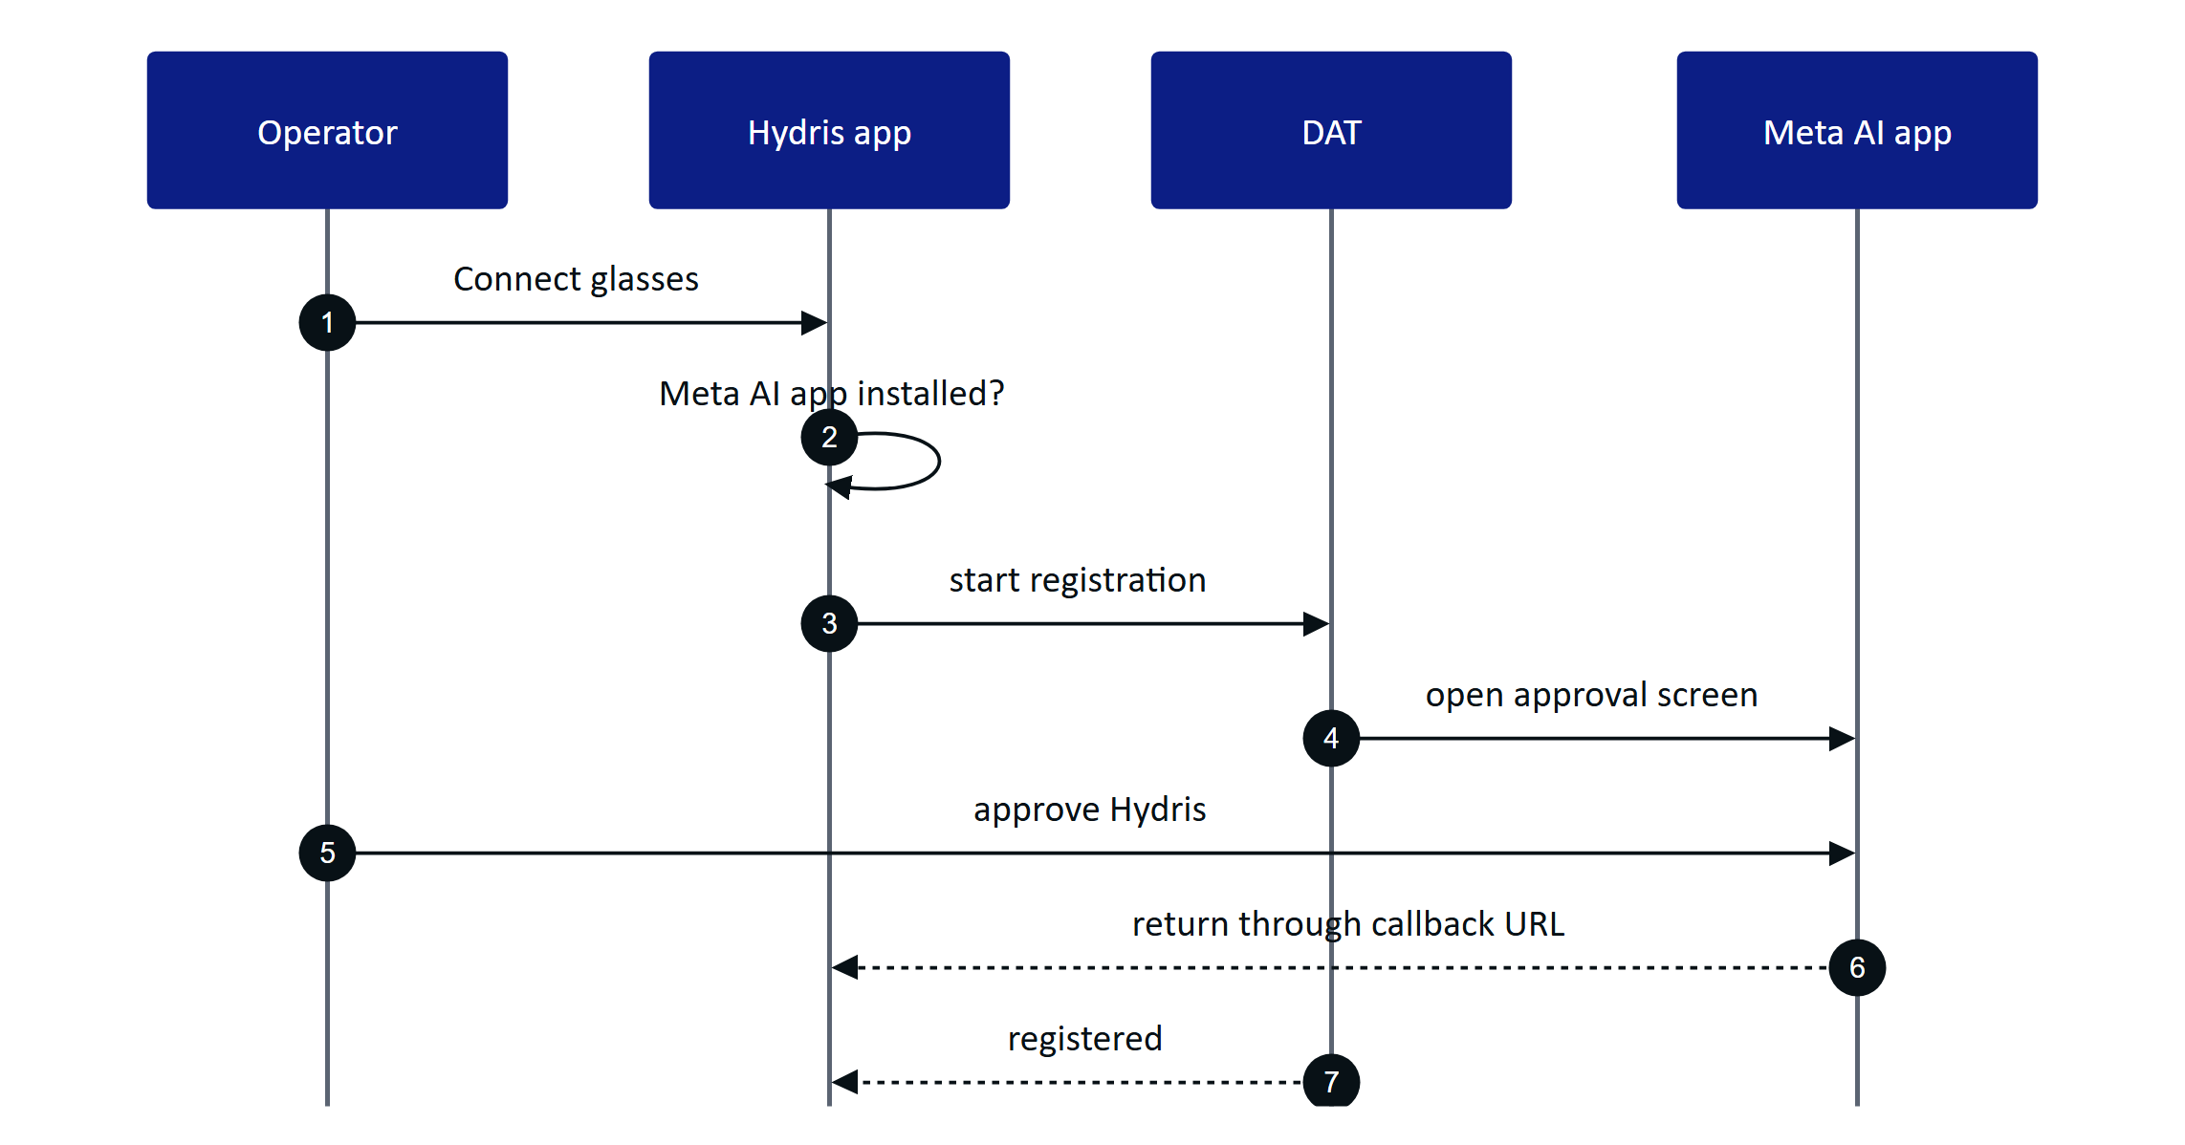
Figure 51. Registration hands off to the Meta AI app and returns
Camera and microphone access on the glasses are DAT permissions, separate from Android permissions, and are also approved in the Meta AI app. Hydris asks for one permission at a time, and a cancelled prompt counts as denied.

Session
One device session is shared by camera, speech and inputs. It is created the first time a capability is needed, reused while started, and rebuilt from scratch after it stops (for example when the glasses are switched off).
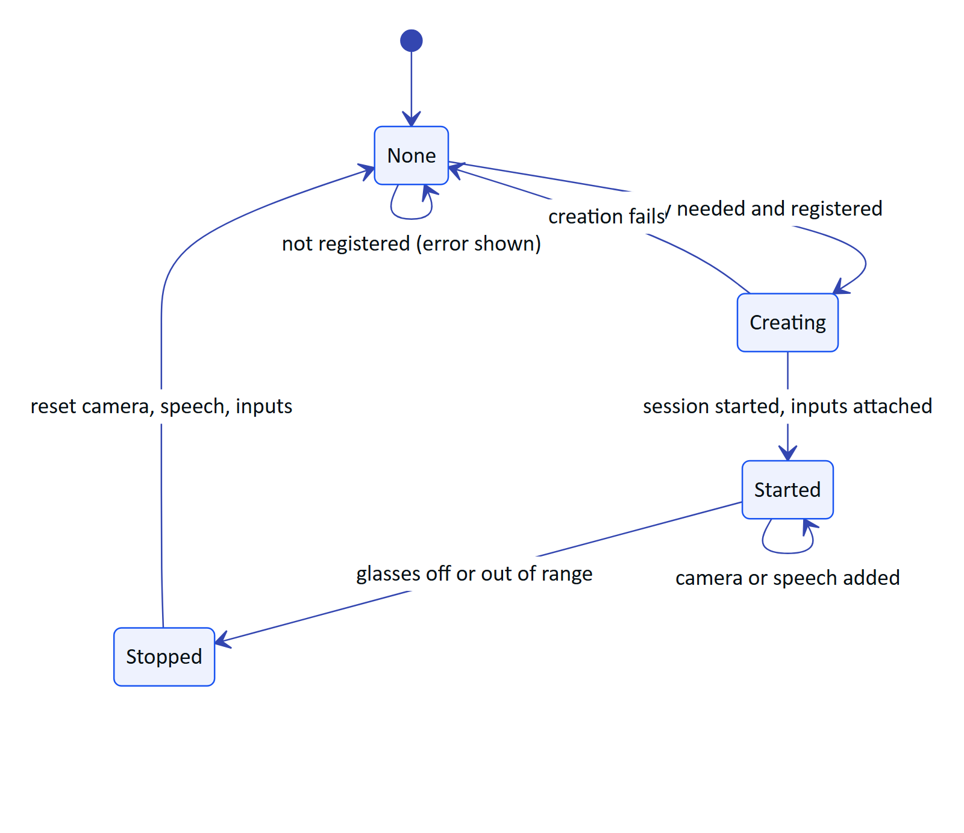
Figure 52. Device session lifecycle

Camera stream and photo
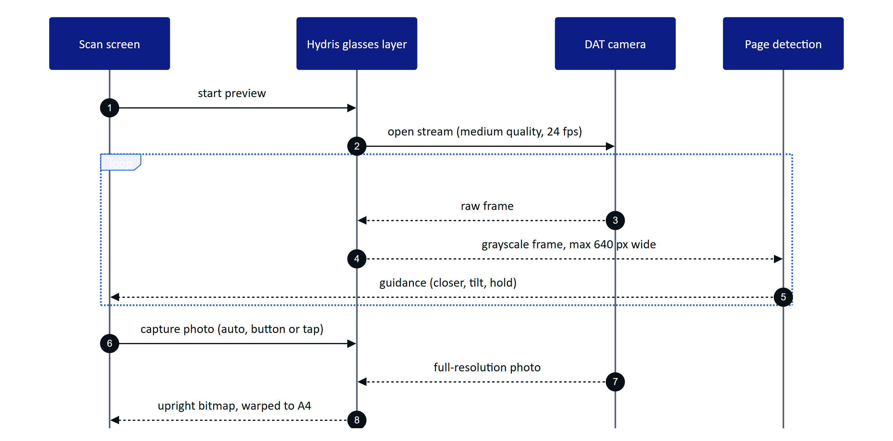
Figure 53. Guided capture from the glasses camera
Preview frames are processed in memory for framing only; Hydris reads the luma plane and never stores or uploads frames. The photo is taken only on an active stream, decoded (bitmap or HEIC), rotated upright from EXIF, then flattened to an A4 page of 1654 x 2339 pixels. Images leave the phone only when the operator taps "Send for verification".

Capture button and speech
A short press of the capture button starts a glasses scan from the Scan menu or review, and takes the photo while framing; elsewhere it is ignored. Speech is always on while wanted: transcripts arrive as text, Hydris restarts listening after silence and ignores transcripts while its own answer is playing. Answers are spoken by the phone's text-to-speech and play on the glasses when they are the Bluetooth audio output. Hydris receives transcripts, never audio, and sends only the question text to the assistant.

6.7 Two integration routes
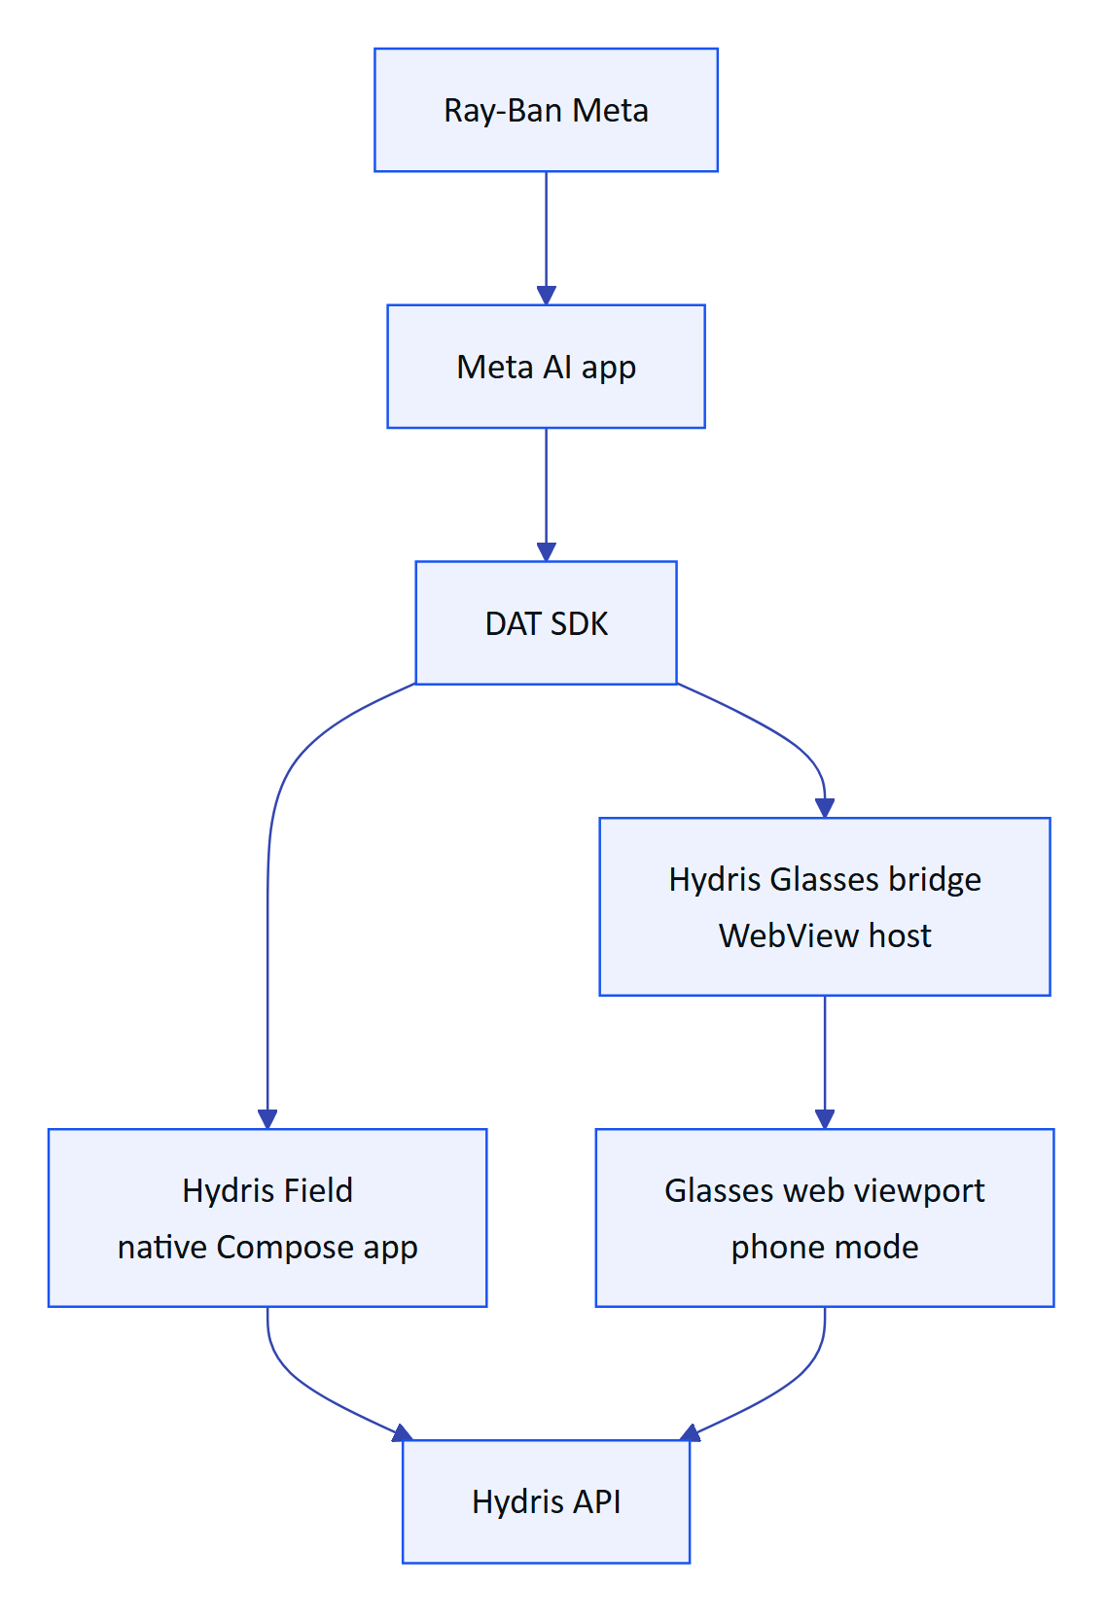
Figure 54. Native app and WebView bridge share DAT and the backend
Table 42. The two routes compared
Aspect | Hydris Field (native) | Glasses bridge (WebView)
UI | Native Compose screens | The /glasses web viewport in phone mode
How DAT reaches the UI | Kotlin state flows | HydrisNative JavaScript interface and page callbacks
Registration as a Hydris device | Self-approved by the signed-in user | Code and QR, approved by a supervisor
"Hey Meta, start Hydris" | Planned | Built
Intended use | Pilot runtime | Web viewport and development comparison; not for general distribution

The bridge forwards one JPEG preview frame per 120 ms and full photos at quality 92 to the page; the page gives up on a photo after 20 s. The same page also supports an injected promise API for iOS hosts and a postMessage protocol for any embedding host.
WARNING
Bridge hardening is Planned: the WebView grants every page permission request and does not restrict navigation away from the Hydris site. Restrict navigation to the Hydris origin before distributing the bridge outside the team.

6.8 Registering glasses as a Hydris device
The Meta AI app pairs the glasses to the phone; Hydris pairing makes them a managed device: assigned to a person and a site, visible to supervisors, revocable, and credited for the scans they capture (FR-057). In the native app the phone plays both roles of the device flow at once.
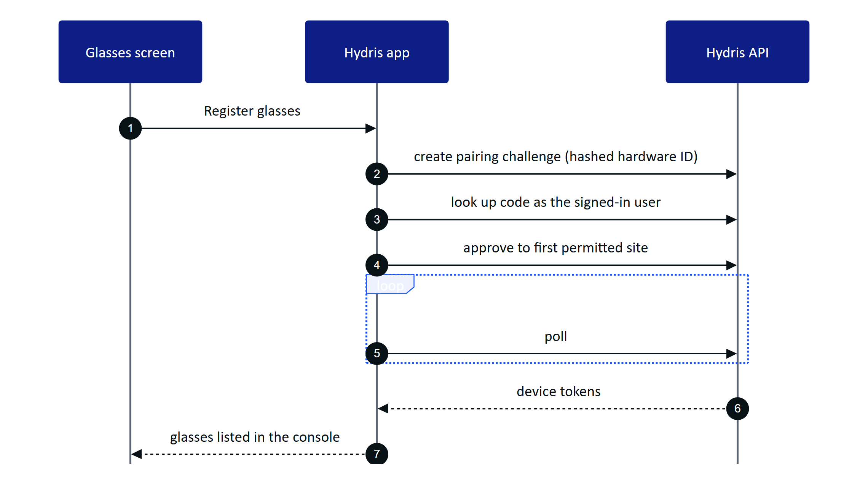
Figure 55. Self-approved registration in the native app
The hardware ID is rbm- plus a SHA-256 digest of the DAT device identifier, so the raw Meta identifier never leaves the phone and re-registering reuses the same console record. Glasses registered in another organization must be revoked there first (device_owned_elsewhere).
NOTE
The same glasses paired through both routes produce two device records, because the hardware IDs differ. Pilots should use one runtime per pair. The native app assigns the glasses to the first site the user can see; a site picker is Planned before multi-site pilots.

6.9 Setup guide
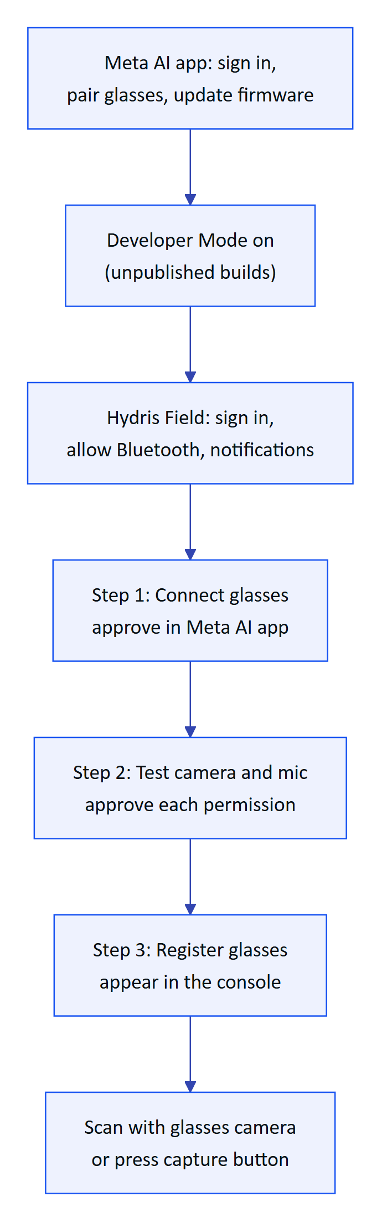
Figure 56. First-time setup for a pilot operator
Developer Mode is turned on in the Meta AI app under Settings, App Info, by tapping the app version five times. Speech, Inputs and Voice Invocations are experimental in DAT and must be enabled for the app in Meta's Wearables Developer Center; Hydris treats them as optional and keeps the phone fallbacks. Developer Mode builds use placeholder DAT credentials; production builds use the values issued by the Developer Center.

6.10 Troubleshooting
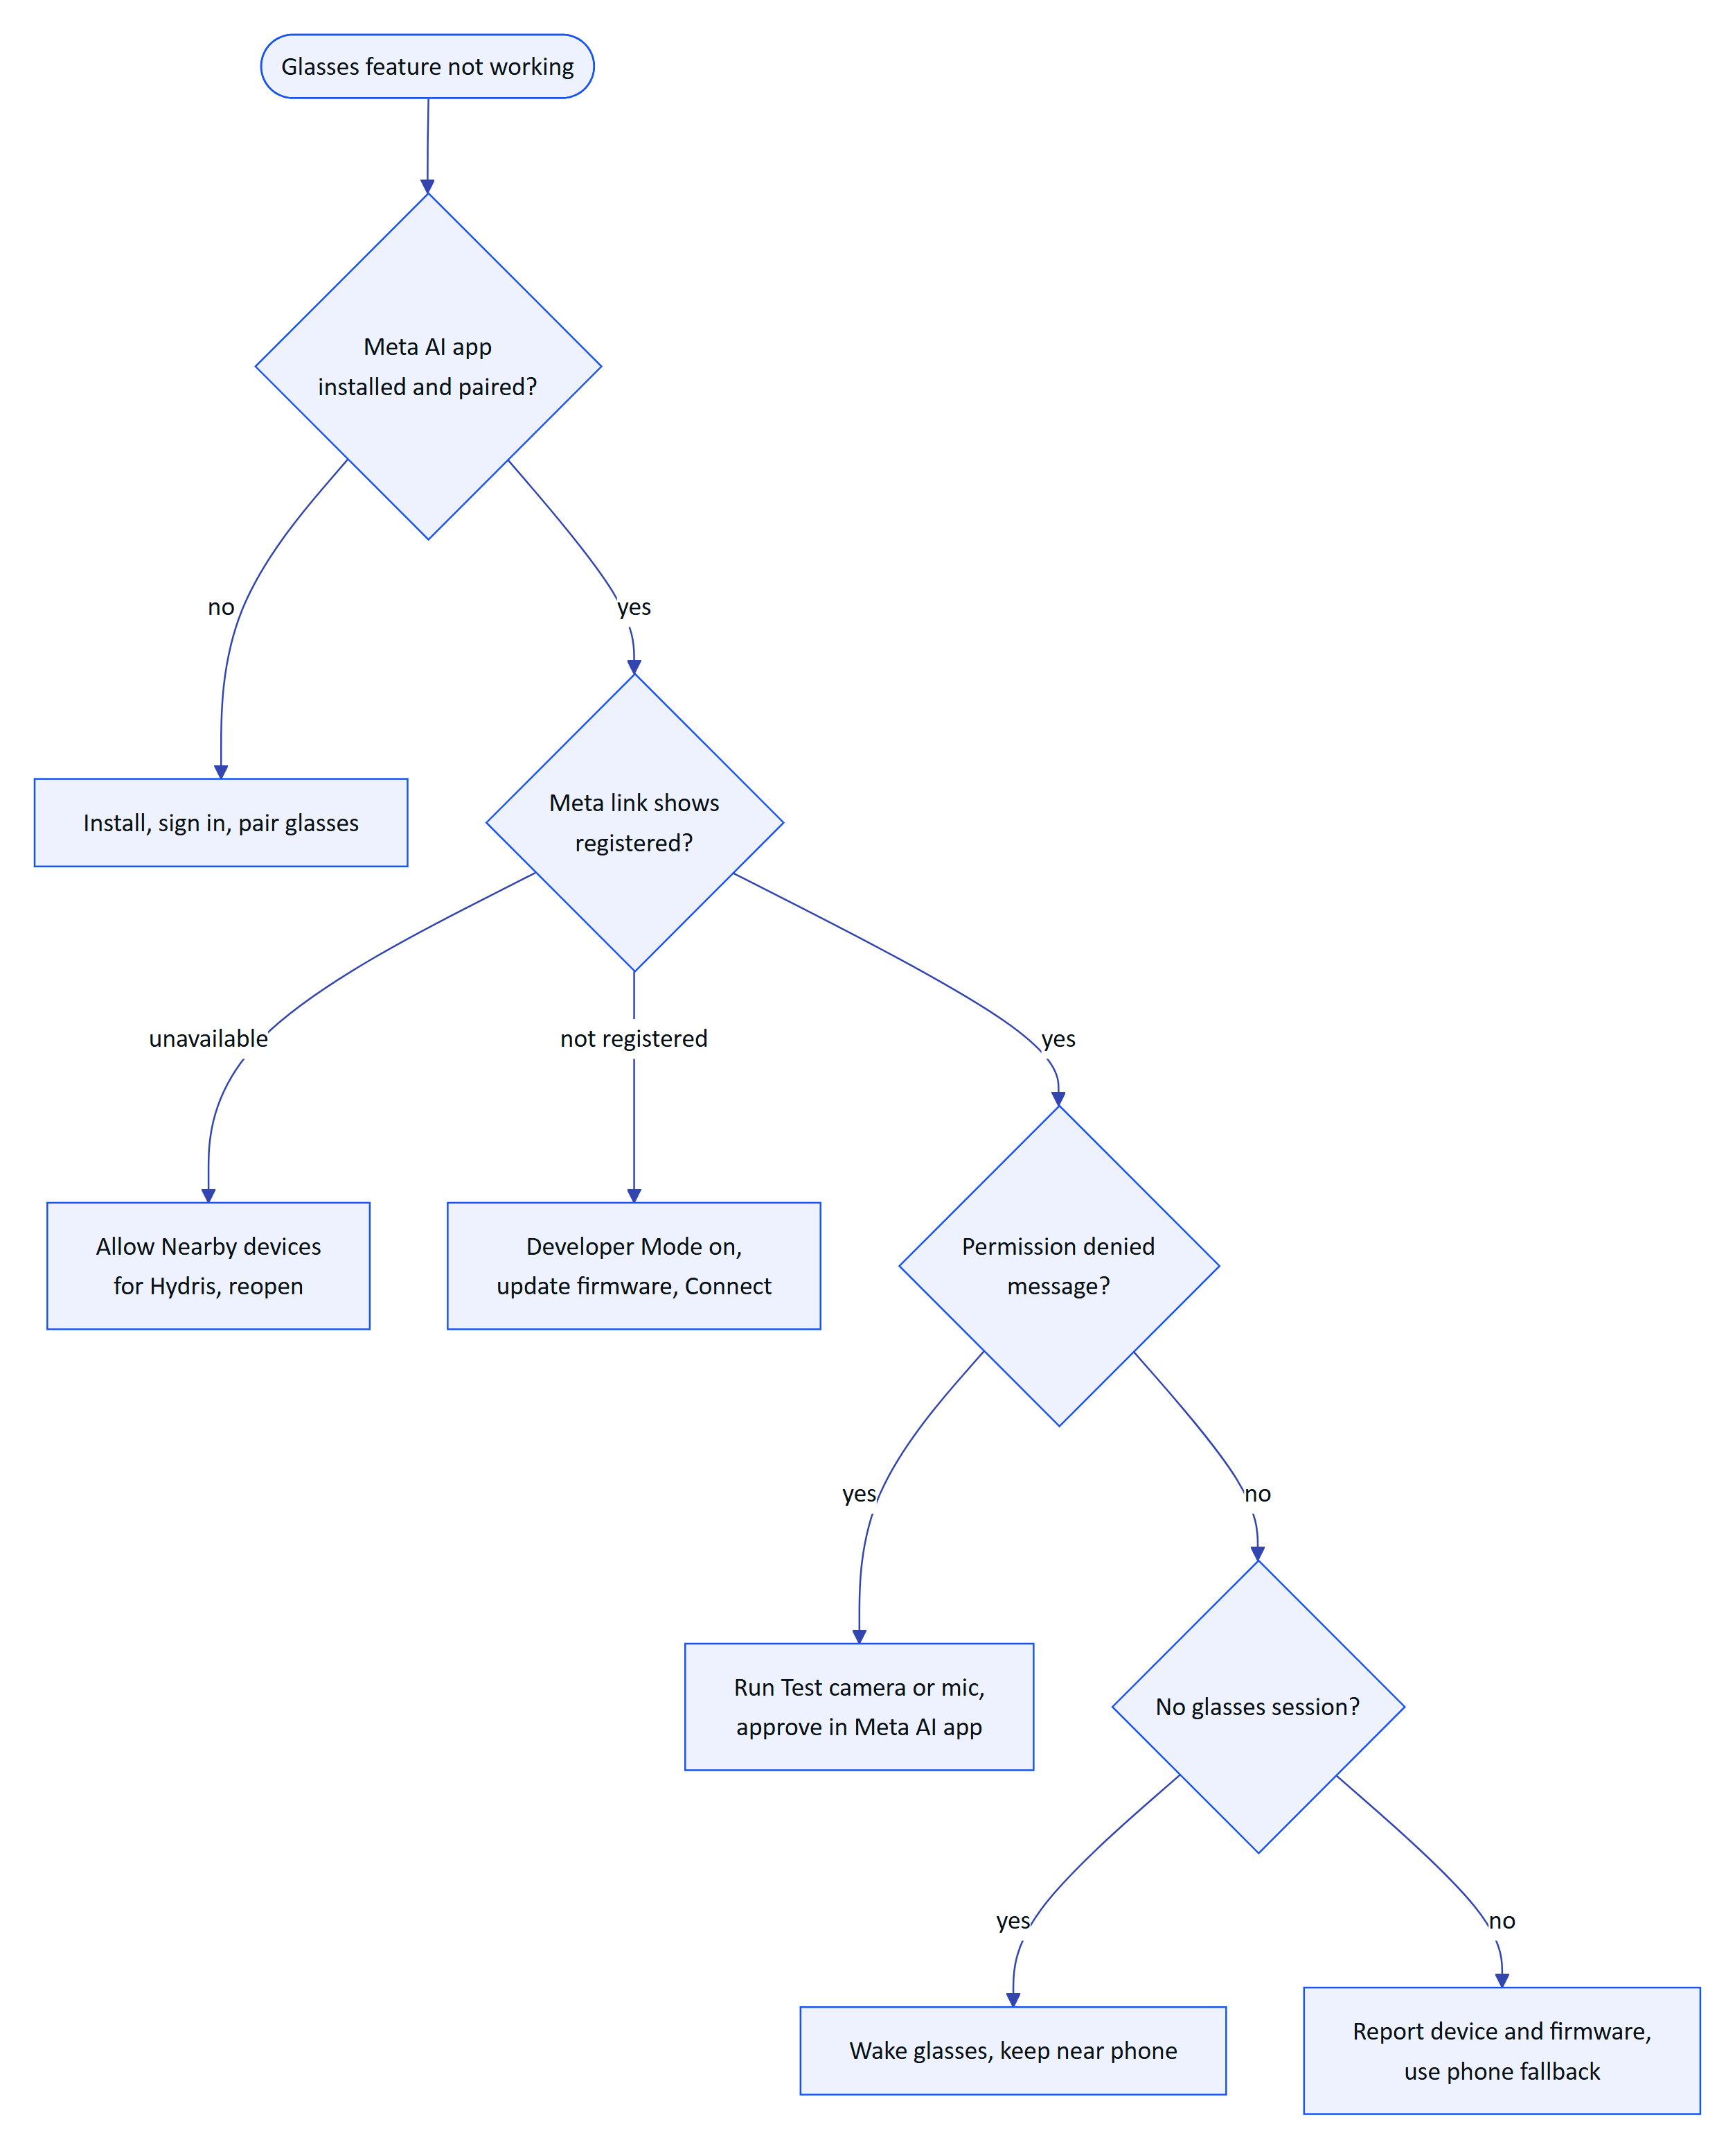
Figure 57. Troubleshooting decision tree
Table 43. Other common symptoms
Symptom | Fix
Capture button ignored | Enable Inputs in the Developer Center; open Scan
Answers play on the phone speaker | Reconnect audio to the glasses in Android Bluetooth settings
Preview black or garbled | Report device and firmware; use the phone camera meanwhile
"Your account has no site to assign the glasses to" | Ask an admin for site access
device_owned_elsewhere | Revoke the glasses in the other organization

6.11 Requirements
Table 44. Ray-Ban Meta requirements (IDs from the PRD)
ID | Requirement | Pri | Status
FR-055 | Glasses camera through DAT: preview stream and full-resolution photo | M | Partial (not on hardware)
FR-056 | Capture button takes the photo or starts a scan | S | Partial (not on hardware)
FR-057 | Android app registers the glasses as a Hydris device | M | Partial (not on hardware)
FR-074 | Glasses microphone with phone fallback; answers on the speakers | M | Partial (phone path Built)
FR-077 | "Hey Meta, start Hydris" opens the assistant | C | Partial (bridge only)
NFR-015 | Camera only on explicit intent; no continuous recording | M | Built
NFR-028 | 4-hour shift on Ray-Ban Meta with up to 20 scans | S | Planned (measure)
NFR-029 | Android 12 or later | M | Built

6.12 Success metrics
Table 45. Timing targets for the first hardware run (targets, not measured)
Path | Target
First preview frame after opening the glasses scan | Under 3 s with an existing session
Preview rate reaching detection | 8 to 10 frames per second
Photo returned after capture | Under 4 s
Speech restart gap after silence | Under 1 s
Battery | 4-hour shift with up to 20 scans (NFR-028)

6.13 Limitations and publishing constraints
- Not yet run on hardware. Preview stride inference, capture press decoding and speech restart are unverified.
- The DAT camera stream is not stopped when the preview ends, only when the session ends; battery and capture LED impact to be checked.
- Low-resolution preview. Frames cross the wireless link, so detection runs on small frames; the photo is full resolution.
- Publishing. Public publishing of DAT apps is not open yet (Meta FAQ); pilots rely on Developer Mode and Developer Center release channels. Full Developer Center access is limited to countries where Meta AI glasses are supported.
- Testing. Hydris has no automated DAT tests yet, and Meta's Mock Device Kit does not support display glasses.
- Privacy. Meta glasses show a capture LED that Hydris cannot control; whether it is lit during preview streaming is to be confirmed. Pilot sites should brief staff and mark scan points.

6.14 Hardware acceptance status
Table 46. Hardware acceptance tests (none run yet)
ID | Test | Status
GLS-T01, T02 | Connect with and without Developer Mode | Not run
GLS-T03 to T06 | Camera permission, guided A4 scan, leaving scan, photo orientation | Not run
GLS-T07, T08 | Capture button short and long press | Not run
GLS-T09, T10 | Ten minutes of Hey Hydris, answers on the speakers | Not run
GLS-T11 to T13 | Register, revoke then upload, glasses off mid-session | Not run
GLS-T14 | Repeat camera and voice tests through the bridge | Not run
GLS-T15 | Battery over a simulated four-hour shift | Not run

Next steps, in order: the first run on Ray-Ban Meta Gen 2 with this checklist, stopping the DAT stream when the scan screen closes, and bridge hardening (Q4 2026); Oakley Meta validation, Voice Invocations in the native app and DAT mock-device tests (Q1 2027); a Developer Center release channel pilot and a site picker for registration (Q2 2027). Using the Meta Ray-Ban Display screen remains Planned and unverified.

7 Audit document scanning

7.1 Purpose and problem
Treatment plants still run on paper: shift logbooks, round sheets, lab reports, permits, calibration certificates. These records are the evidence a regulator or auditor asks for, yet they are hard to search, easy to lose, and slow to copy into a system by hand, where a moved decimal point turns pH 7.1 into 71. Audit scanning turns a paper record into a verified, searchable digital document. The design rule is dual verification: a machine cross-check of every value between independent readings, then a human review of every value and an independent approval by a second person.
2  OCR passes per page  original and enhanced, on device |  | 6  Pages per document  each under 900 KB |  | 4 eyes  Verify and approve  two different people |  | 10  Values from the demo sheet  pH 7.3 read correctly

7.2 Users and jobs
Table 47. Who takes part in a scan
User | Job
Field operator | Capture the paper record where it is, with glasses or phone, in under a minute
Shift supervisor (reviewer) | Confirm, correct or flag every value against the paper, then verify
Plant manager (approver) | Approve or reject a verified document; never the same person as the verifier
Compliance auditor | Download a searchable PDF with the full verification trail

7.3 Scope
Table 48. In scope and out of scope
In scope | Out of scope
Capture from glasses, phone camera, imported photo, console | Signing on the device: devices capture, people verify
Guided A4 framing, auto-capture, flattening | Electronic signature with re-authentication (Planned, FR-068)
Two OCR passes, structuring of fields, tables, figures | Handwriting-specific recognition models
Plausibility checks and optional vision engine | Bulk upload of existing PDF archives
Field review, verify, approve, PDF with trail | Writing values into plant records automatically

7.4 From paper to verified PDF
The whole journey has three halves that never mix: the device captures and reads, the server structures and cross-checks, and people verify and approve.
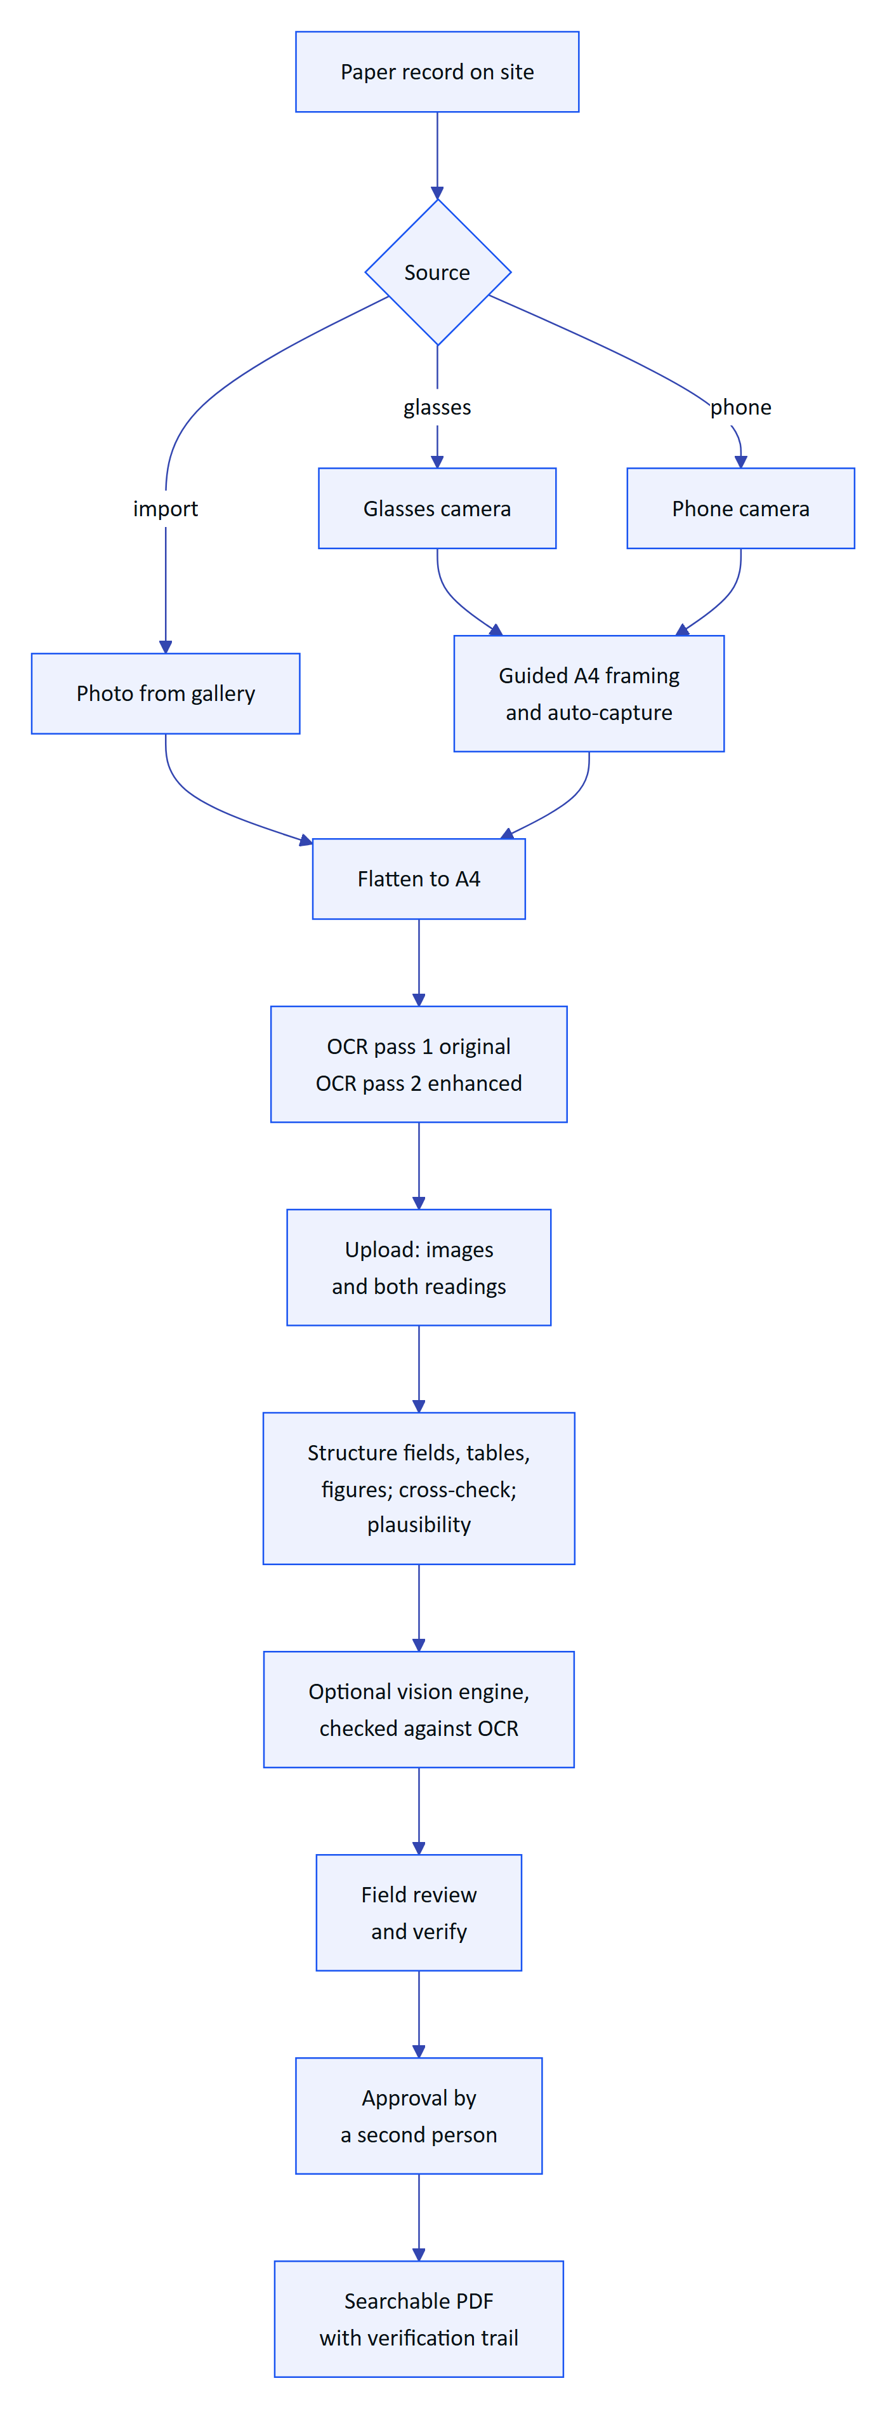
Figure 58. End-to-end flow from paper record to approved PDF
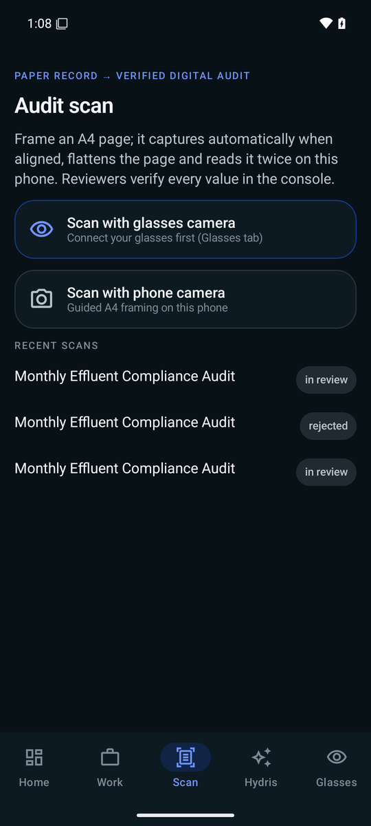
Figure 59. Scan menu: glasses camera, phone camera or import

Who does what
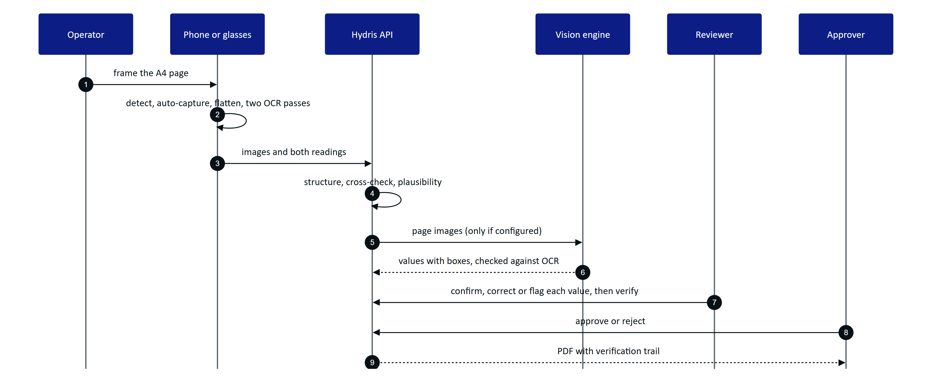
Figure 60. Capture, machine cross-check, review and approval
The operator sees "Sent · awaiting dual verification" with the detected title, value and table counts, and the engine agreement. Review and approval happen in the console.

7.5 Guided capture
Framing a sheet on glasses, with no display, is the hard part. The device checks each preview frame (at most every 90 ms) and speaks or shows one instruction at a time, in a fixed order: there is no point asking the wearer to straighten a page that is half out of frame. The phone, the glasses web viewport and the console use the same detection code and thresholds.
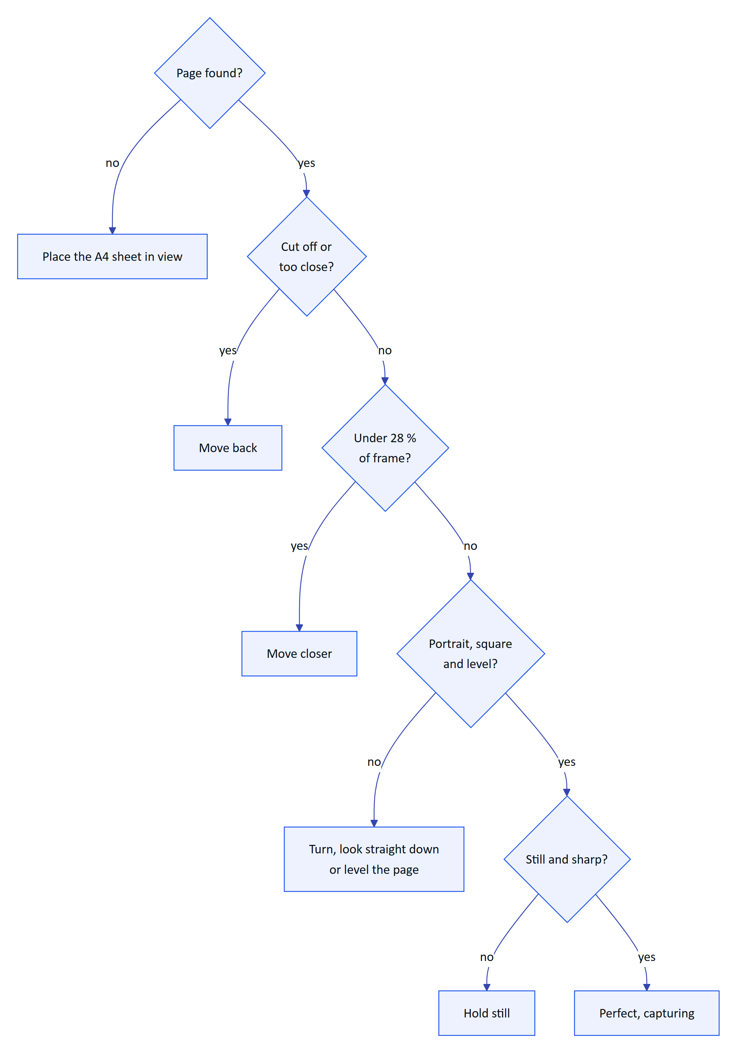
Figure 61. Guidance order: the first failing check sets the message
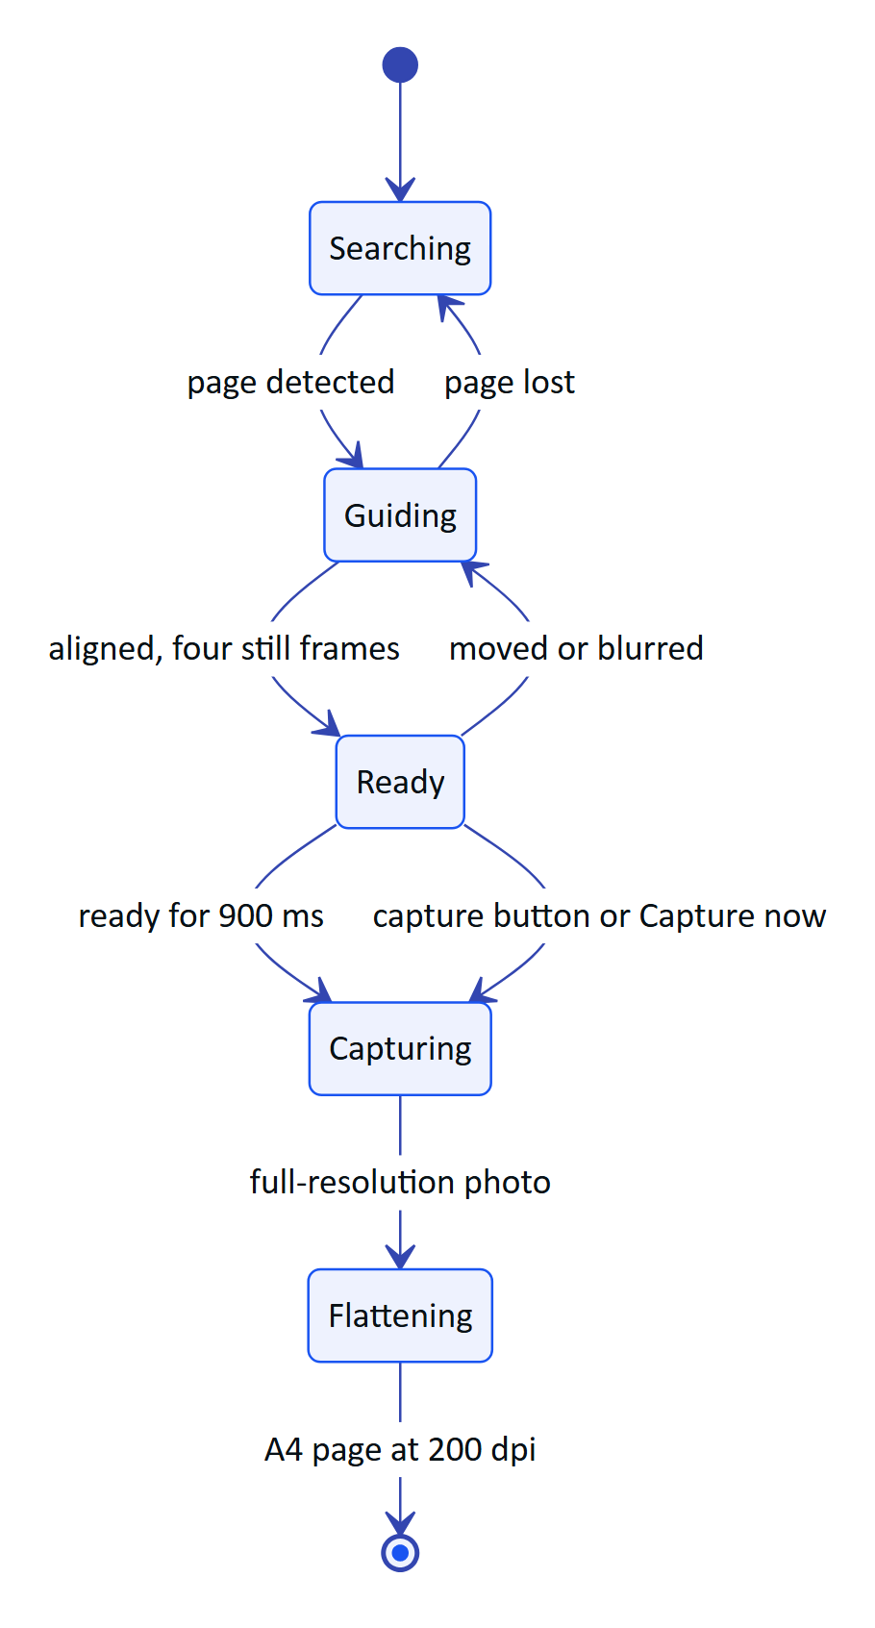
Figure 62. Guided capture state machine with auto-capture
On capture the device takes a full-resolution photo, finds the page again, and warps it to a flat A4 image (1654 x 2339 pixels, 200 dpi). A short press of the glasses capture button takes the photo during framing.
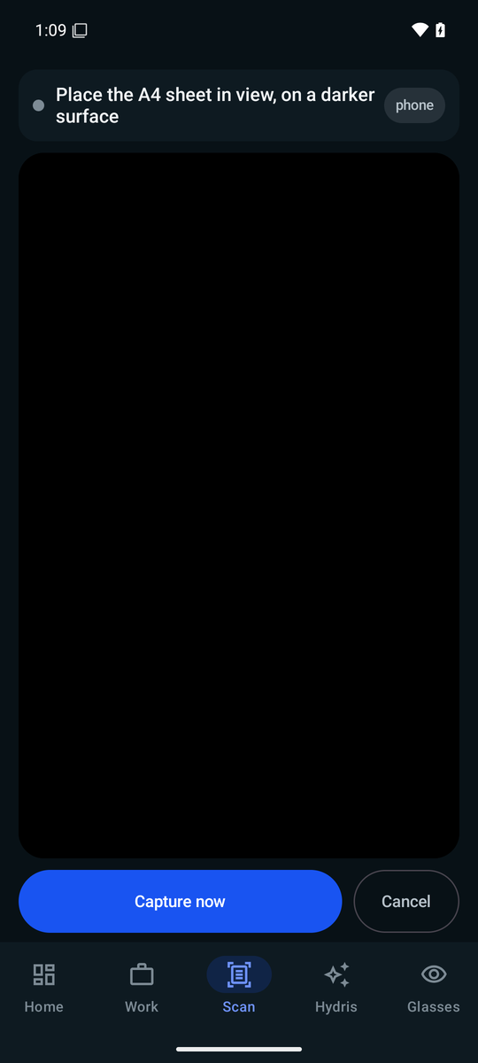
Figure 63. Guided capture waiting for an A4 sheet

7.6 Reading the page twice
Each page is read twice on the device before anything is sent. Pass 1 reads the page as captured. Pass 2 reads an enhanced copy: contrast stretched, adaptively thresholded, with table rulings removed so borders do not merge cells. Two independent readings let the server tell a confident value from a lucky one. Up to six pages make one document; the review screen shows each page's confidence and the label and value pairs found.
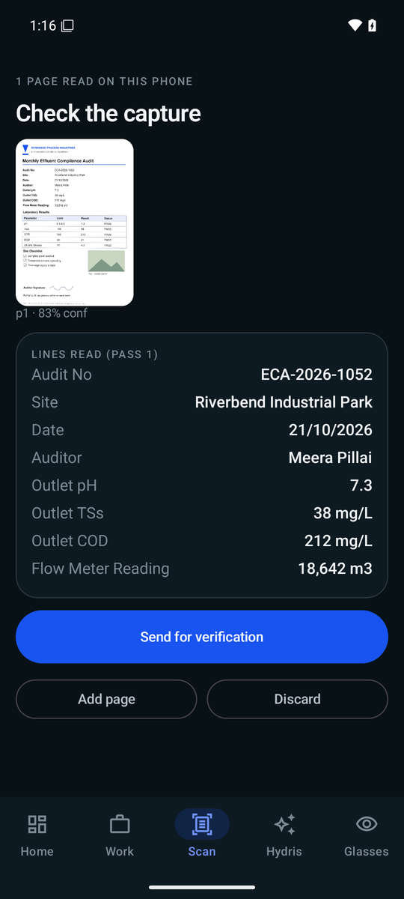
Figure 64. Review: confidence per page and the label and value pairs found

7.7 Structuring and cross-checking
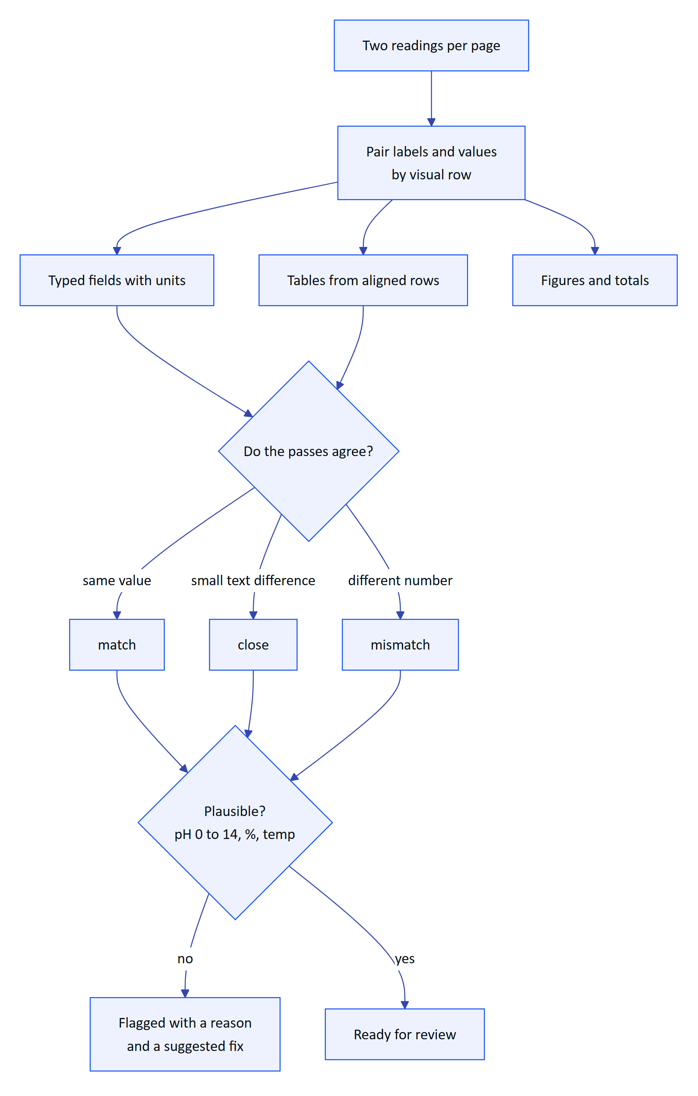
Figure 65. How the server turns two readings into reviewable items
Each value carries an agreement level and keeps its position on the page. Plausibility checks run even when both passes agree, because both can be wrong in the same way.

Optional vision enhancement
When an Anthropic credential is configured, the server sends the page images to a vision model that returns fields, tables and figures with boxes. Each vision value is then checked against the OCR text inside its own box; a value the OCR does not support is never marked as agreed. Without a key the OCR result stands and the document says vision is unavailable. The vision model adds reach; it never adds unchecked trust.

7.8 Accuracy design
DECISION
The primary quality metric is the silent error rate: a value marked as agreed and not flagged, but wrong. A system that is 85 % accurate and flags what it is unsure of is safer than one that is 95 % accurate and confidently wrong on the rest.

Table 49. How the design protects the numbers that matter
Risk | Safeguard
Decimal point dropped or moved | "7.4" against "74" is always a mismatch; thousands separators ("18,857" and "18857") are not
Both passes misread the same way | Range checks still flag pH 71 as implausible, and offer a matching labelled value as the fix
Letters and digits confused | O and 0 are folded inside numbers before comparison
Labels and values read as separate columns | Paired again by visual row (common with ML Kit)
Vision model invents a value | Checked against OCR text in the value's box
Reviewer overwrites the machine value | The first extracted value is always kept beside the correction

7.9 Review, verify and approve
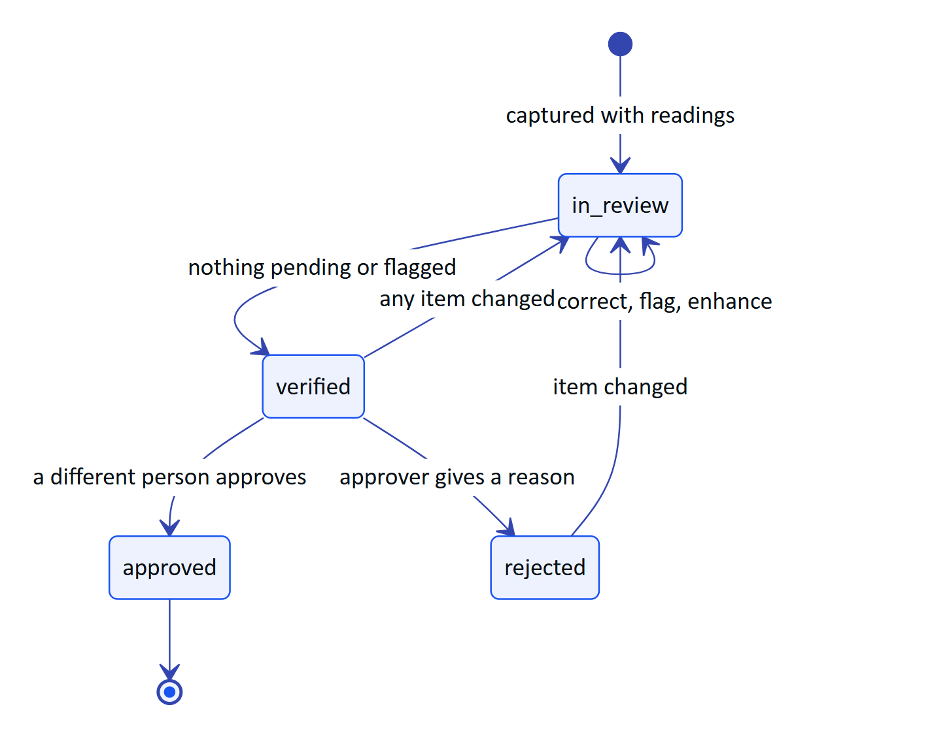
Figure 66. Audit document lifecycle and the four-eyes rule
The reviewer works field by field against the paper and can bulk-confirm values where at least two engines match with confidence of 0.8 or more. Verify is blocked while anything is pending or flagged. Approval must come from a different person in a customer organization; demo tenants allow self-approval and record it as such. Only a signed-in person in the console can verify or approve: a device never can.
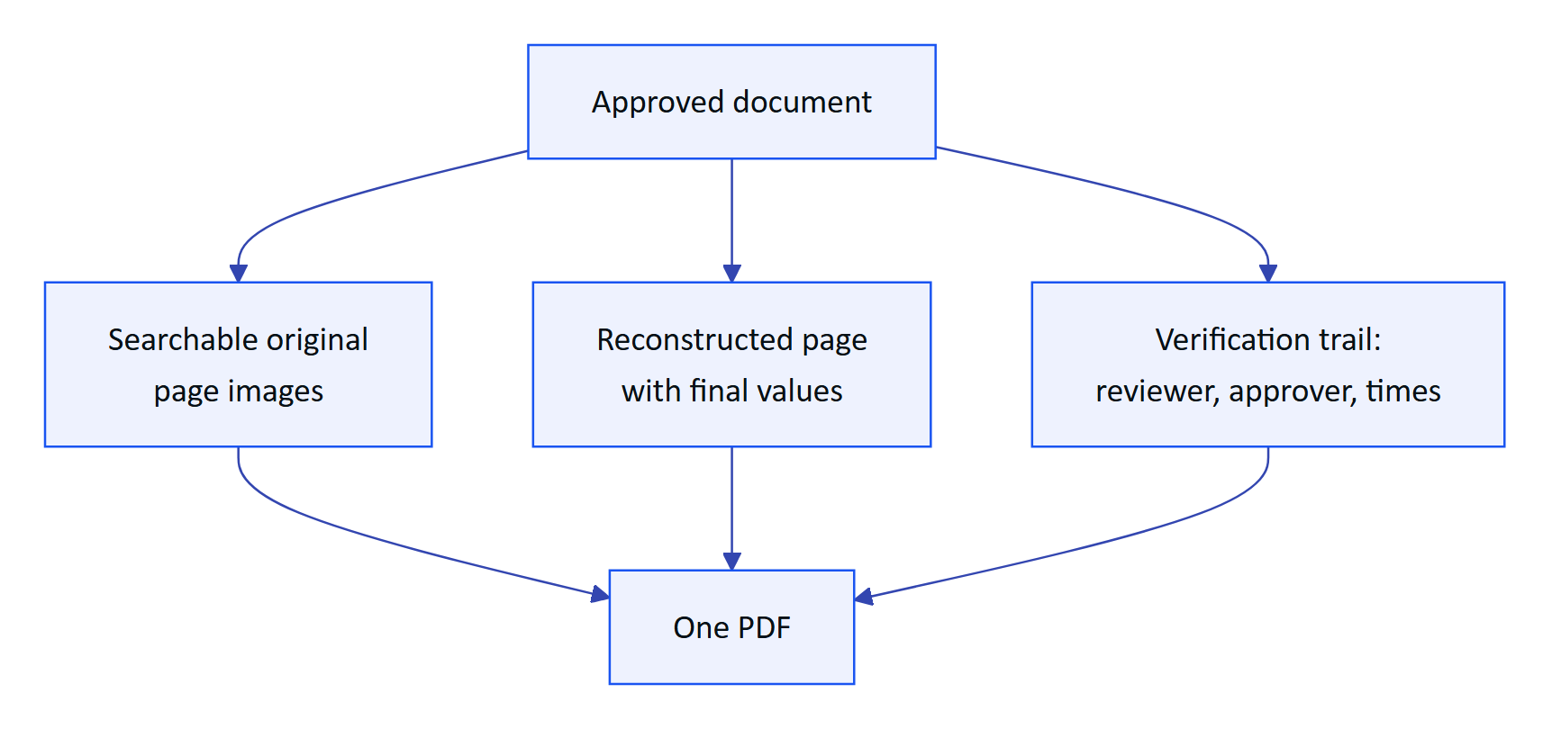
Figure 67. The approved output an auditor receives
Every review action is appended to the document's event history, and concurrent edits are rejected with a revision check, so two reviewers cannot silently overwrite each other.

7.10 Requirements
Table 50. Audit scanning requirements
ID | Requirement | Pri | Status
FR-060 | Guided A4 capture with live detection, auto-capture, perspective correction | M | Built (web and Android, same thresholds)
FR-061 | Dual-pass on-device OCR | M | Built
FR-062 | Fields, tables, figures with plausibility checks | M | Built
FR-063 | Optional vision engine cross-checked against OCR in each box | S | Built (needs a key)
FR-064 | Field review; original kept; verify needs zero pending and flagged | M | Built
FR-065 | Independent approval (four eyes) | M | Built
FR-066 | PDF with trail, searchable original, reconstructed page | M | Built
FR-067 | Up to 6 pages, each at most 900 KB, JPEG or PNG | M | Built
FR-068 | Electronic signature with re-authentication | S | Planned (Advanced)
FR-069 | Bulk-confirm values where two engines agree confidently | S | Built
FR-096 | Scan from glasses, phone or import in the Android app | M | Built (phone); glasses Partial
FR-055 | Glasses camera capture through DAT | M | Partial (not run on hardware)

7.11 Success metrics
Table 51. Scanning quality targets (targets, not measured results)
Metric | Pilot target
Fields where the engines agree, typed forms | 90 % or more
Fields a reviewer corrects | Under 5 %
Silent error rate | Under 0.5 %
Decimal correctness | 99 %
Planted implausible values flagged | 100 %
Capture to review-ready per page | 15 s or less
Capture to approval, median | Under 24 hours

EXAMPLE
Demo result (manual verification, emulated Pixel 7 with API 35): a printed lab sheet imported into the Android app was read correctly, including pH 7.3, and 10 values were extracted and uploaded for review. This is one sheet, not a benchmark.

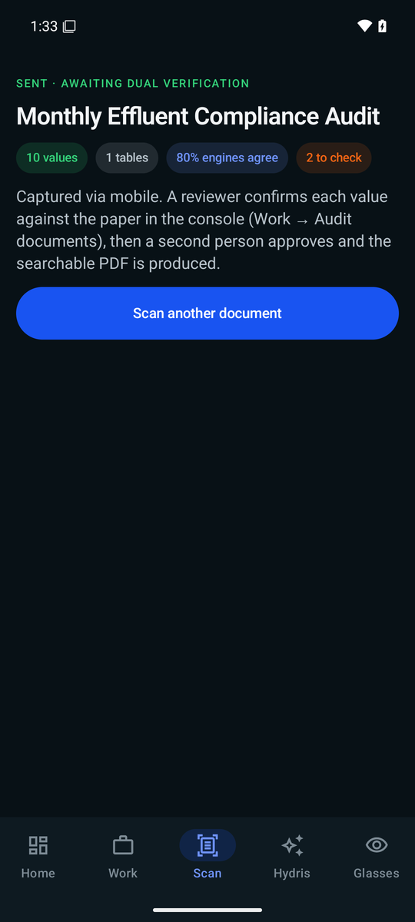
Figure 68. Sent for verification: values, agreement and next steps

7.12 Status, gaps and next steps
- Benchmark not yet run. A 120-page ground-truth set (printed lab reports, filled templates, handwritten registers, complex tables, degraded captures) is designed; until it runs, every accuracy number above is a target.
- Glasses capture unproven on hardware. The DAT path works on Meta's mock device; the first run on Ray-Ban Meta is scheduled for Q4 2026.
- Electronic signature with re-authentication and signature meaning (FR-068) is Planned for the Advanced phase.
- Vision processing consent. Before a customer pilot the tenant must agree to vision processing and the deployment must record where inference runs; until then pilots run on OCR alone.
- Page images move to object storage during Hardening.

8 Hey Hydris voice assistant

8.1 Purpose and problem
An operator at a clarifier with gloves on cannot scroll a dashboard. "Hey Hydris" lets them ask out loud ("what's the outlet pH?", "any open alarms?", "what are my tasks?") and hear a short answer on the glasses speakers or the phone, with the facts behind it on screen. Every answer comes from the caller's own plant data, never from general knowledge, and the assistant cannot change anything.
5  Read-only tools  readings, alarms, my work, assets, SOPs |  | 2  Answer engines  Claude, or the rules engine |  | 0  Write tools  advisory only |  | 0  Invented numbers allowed  target and design rule

8.2 Users and jobs
Table 52. Users and jobs
User | Job
Field operator | Get a reading, its age and alarm state without touching the phone
Maintenance engineer | Hear my open work and the procedure for an asset
Supervisor | Check open alarms on my sites while walking the plant

8.3 Scope
Table 53. In scope and out of scope
In scope | Out of scope
Wake phrase, spoken question, spoken answer | Operating equipment or changing records
Readings, alarms, my work, asset status, approved SOPs | Answers from outside the tenant's data
Follow-up questions with history | Indian languages (Planned, FR-073)
Glasses, phone and browser speech | "Hey Meta, start Hydris" as a supported path (experimental)

8.4 Wake word flow
The wake phrase is detected on the device with a pattern tolerant of how recognizers hear "Hydris" ("hydras", "hi dris", "idris"). After an answer the assistant keeps listening for a follow-up; "stop", "cancel" or "thanks" ends it.
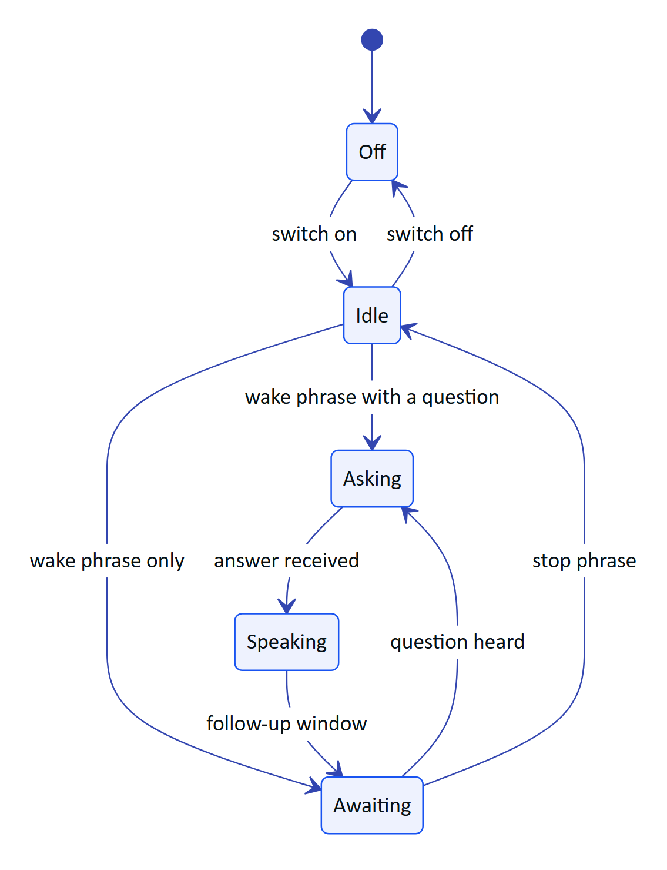
Figure 69. Wake phrase states on the phone
NOTE
The glasses web viewport closes the follow-up window after 8 s of silence; the Android app keeps it open until a stop phrase. Aligning them on 8 s is Planned.

8.5 Speech engines
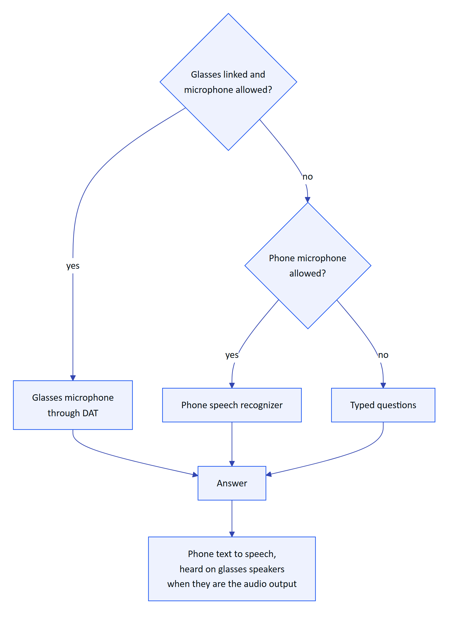
Figure 70. Which microphone and speaker are used
Table 54. Speech engines by surface
Surface | Listens with | Speaks with | Status
Android app, glasses | DAT Speech on the glasses microphone | Phone text to speech over Bluetooth | Partial: not yet run on hardware
Android app, phone | Android speech recognizer, restarted after each result | Phone text to speech | Built
Glasses web viewport and simulator | Bridge first, then the browser Web Speech API | Browser speech synthesis | Built

Transcripts are dropped while the assistant is speaking, so it does not answer itself.

8.6 Grounded answering
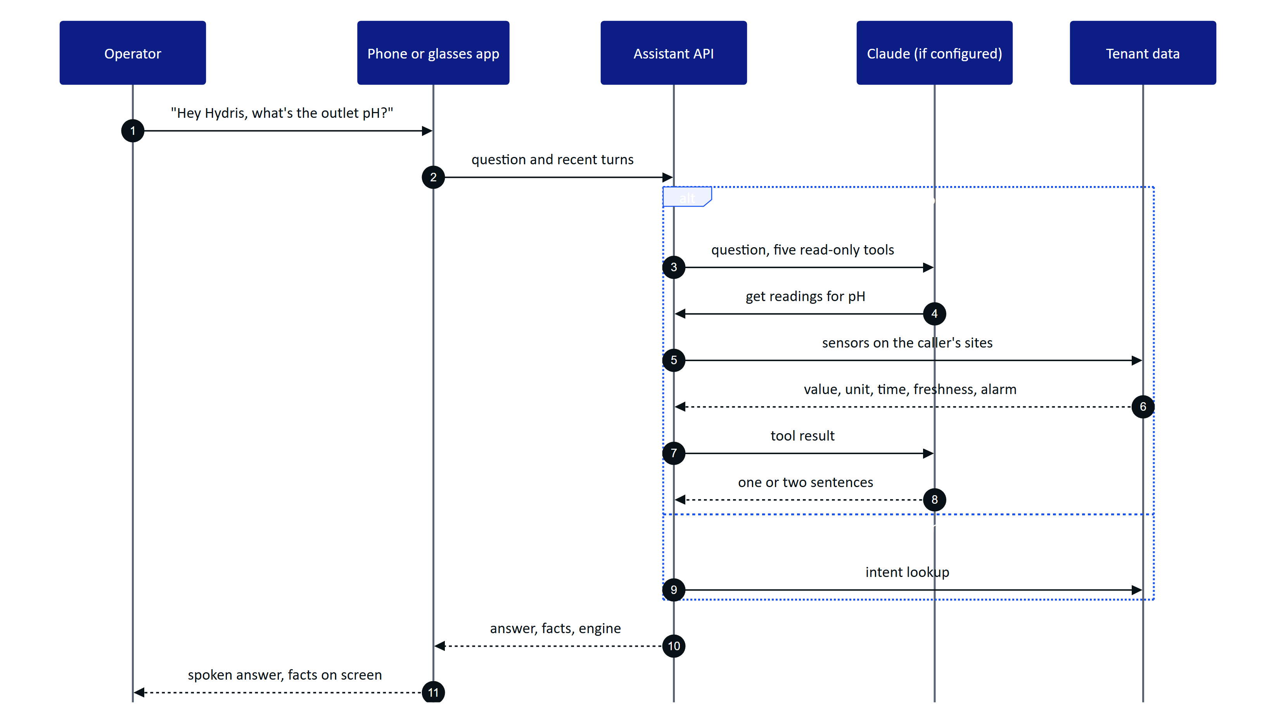
Figure 71. A spoken question answered from the caller's own data
When an Anthropic credential is configured, Claude answers with up to five rounds of read-only tool calls. Otherwise, and whenever the model fails, a deterministic rules engine answers readings, alarms, my work, asset status, procedures and help, and says "I can't answer that from your plant data" for anything else. Every tool runs with the caller's row-level and site scope, so the assistant can only say what the caller could see in the console.
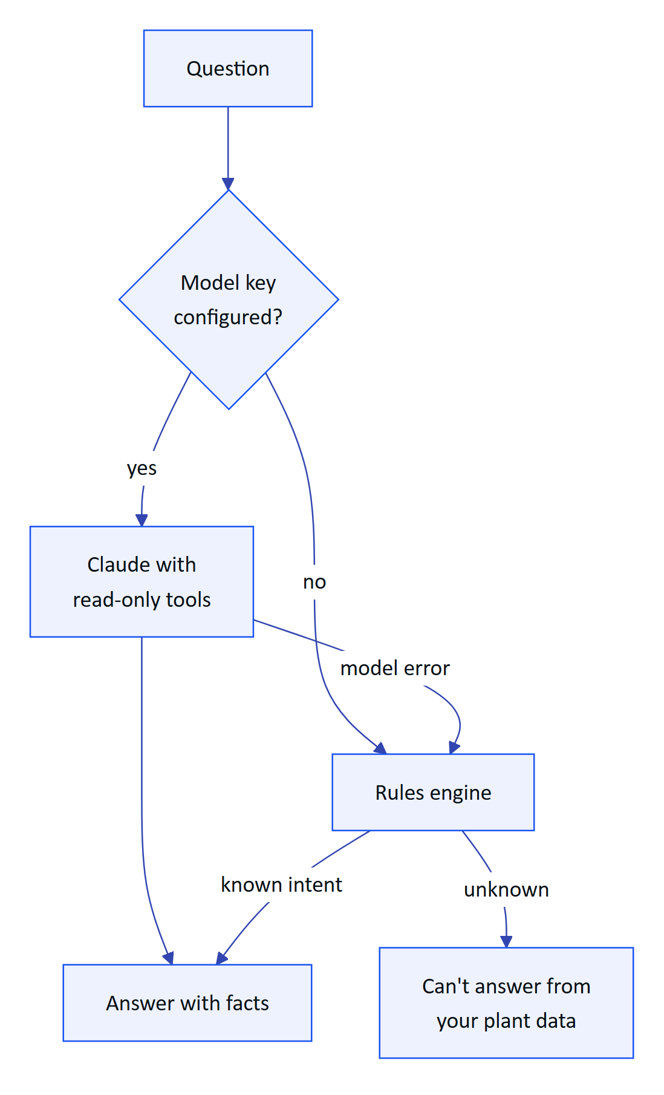
Figure 72. Choosing the engine for each question
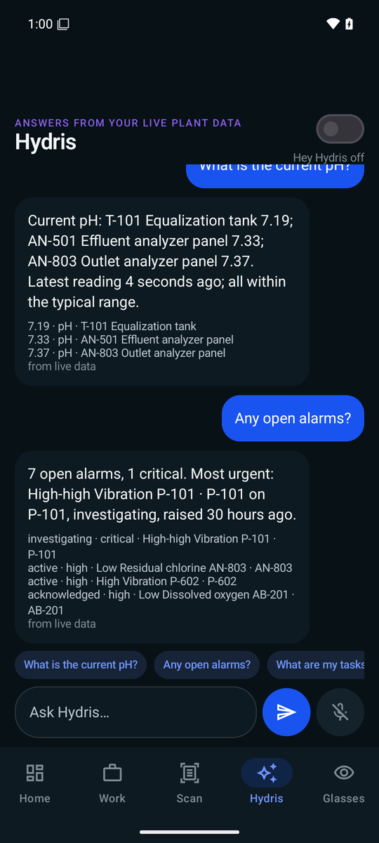
Figure 73. The assistant answering with the facts behind it

8.7 Guardrails
- Advisory only. The tool list holds only read tools and the system prompt forbids operating equipment (FR-078).
- Never invents numbers. Answers return facts (label, value, unit, time, source); the screen shows up to four under the answer. Rules answers contain only numbers that appear in facts.
- States the data age. Answers say "measured N minutes ago"; stale readings add "not current, check the sensor"; missing data is "no data", never zero (NFR-036).
- Labels synthetic data. Demo answers mark their facts as synthetic demo data (FR-075).
- Approved documents only. Draft SOPs never reach an answer (FR-111).
Table 55. Example dialogue (illustrative of the rules described above, not a recorded transcript)
Operator says | Hydris answers | Facts shown
"Hey Hydris, what's the outlet pH?" | Outlet pH is 7.3, measured a few minutes ago, within range | 7.3 · Outlet pH
"And the inlet?" | Answers for the inlet, using the conversation history | Inlet pH value and time
"Any open alarms?" | Counts open alarms on my sites and names the most severe | Alarm titles and states
"What are my tasks?" | Lists my open maintenance tasks and due inspections | Task titles
"What's the weather tomorrow?" | I can't answer that from your plant data | None
"Thanks" | Ends the follow-up window | None

8.8 Requirements
Table 56. Voice assistant requirements
ID | Requirement | Pri | Status
FR-070 | Grounded SOP retrieval from approved documents with a safety notice | M | Built
FR-071 | Wake phrase and short spoken answers | M | Built
FR-072 | Answers only from tenant data through scoped tools; rules fallback never guesses | M | Built
FR-073 | Hindi, Tamil, Marathi, Gujarati | S | Planned (Advanced)
FR-074 | Glasses microphone with phone fallback; answers on glasses speakers | M | Partial: glasses not run on hardware
FR-075 | Facts with source; synthetic data labelled | M | Built
FR-076 | Follow-ups with history (up to 8 turns) | S | Built
FR-077 | "Hey Meta, start Hydris" opens the assistant | C | Partial (experimental)
FR-078 | No write tools | M | Built

8.9 Success metrics
Table 57. Voice targets (targets, not measured results)
Metric | Pilot target
Questions answered with facts, not "can't answer" | 85 % or more
Numbers in answers missing from facts | 0
Spoken answer after the question ends | Under 3 s on 4G

8.10 Status, gaps and next steps
- Logging for metrics. Engine and intent logging on the assistant is Planned for the pilot; until then the targets cannot be measured.
- Glasses microphone on hardware is the first hardware run item for Q4 2026.
- Wake phrase false accepts are tested against eight hours of plant conversation before tightening the pattern.
- Model processing consent. A tenant must agree to Claude processing before a pilot uses it; otherwise the rules engine runs alone.
- Languages. Indian-language questions and answers depend on server support and are Planned.

9 Platform: API, data and integrations
Every Hydris surface (website, operator console, glasses HUD, the Hydris Field Android app) talks to one platform: a modular API over one Postgres schema with row-level security. This part explains how that platform is shaped, how a request travels through it, how data is organised and isolated per customer, and how telemetry, AI and background work flow in. It closes with the decisions behind the design, the requirements it meets, and the debt that matters before scale.
15  API route modules  one Fastify instance, `apps/api/src/app.ts` |  | 42  database tables  ten domains, `apps/api/src/db/schema.ts` |  | 3  access control layers  RBAC, site scope, Postgres RLS |  | 0  write paths to plant control  Hydris is read-only to PLC, SCADA and DCS

9.1 Architecture in one picture
Hydris is an npm workspaces monorepo. The API (apps/api, Fastify 5) is a modular monolith. It runs either inside the Next.js web deployment through a catch-all route that calls app.inject (no network hop), or as its own container. A pure TypeScript domain package (packages/domain) holds the state machines, permissions, freshness and voice parsing rules that both server and web use; the Android app mirrors them by hand.
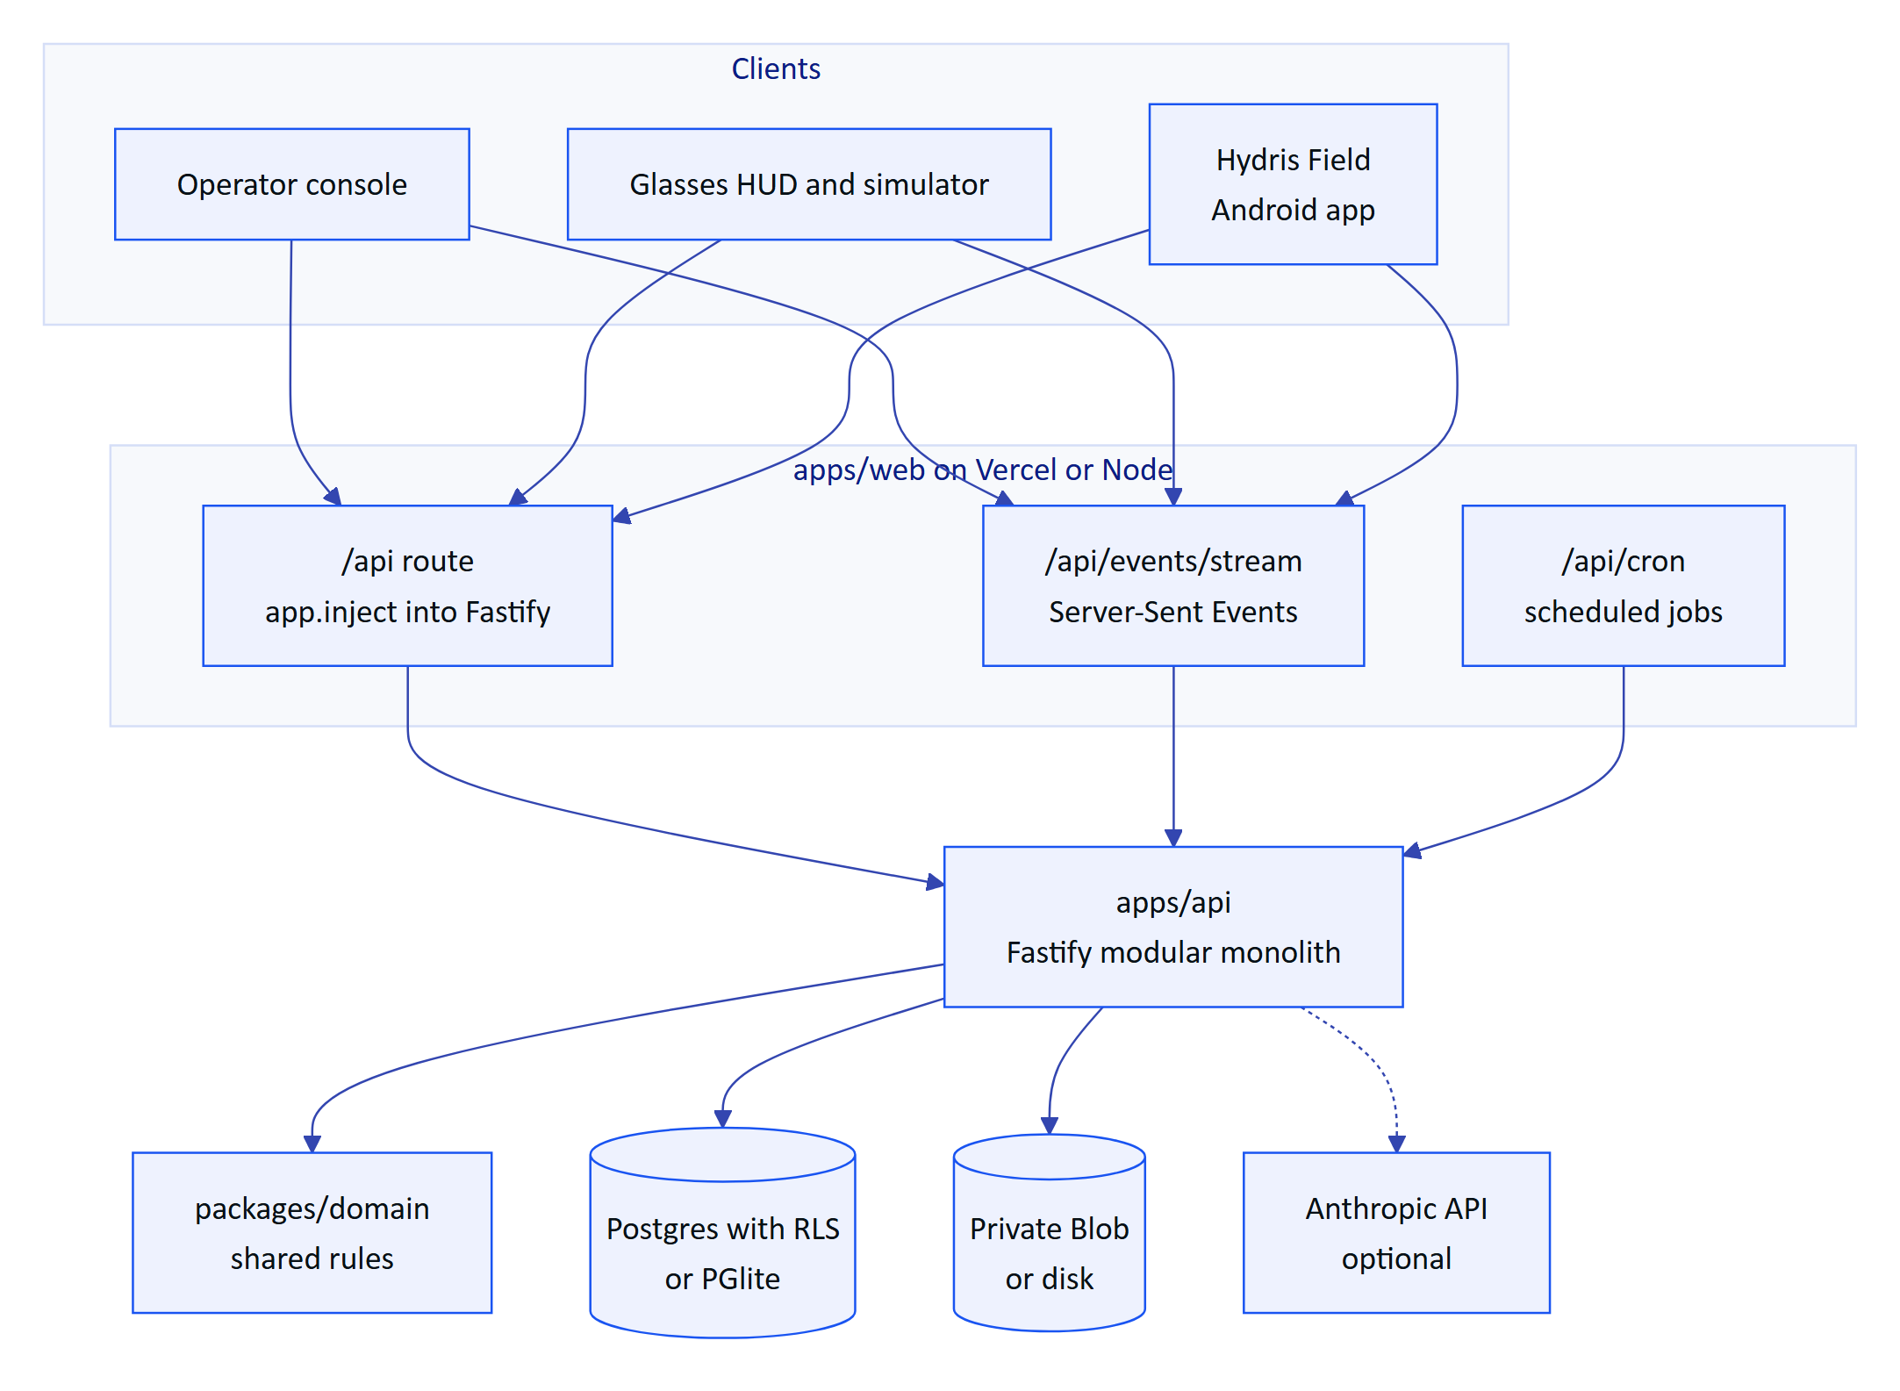
Figure 74. Containers. The API runs inside the web deployment or as its own container; all clients share one API and one event stream.
Configuration is one validated environment (apps/api/src/config.ts): DATABASE_URL selects Postgres or in-process PGlite, REALTIME_MODE selects the event bus, a Blob token selects cloud storage over disk, and API_URL in the web app switches to an external API. The same code therefore runs on Vercel, in Docker Compose at a plant, in a hybrid set-up and as the self-contained public demo.

9.2 The modular API
buildApp() registers shared plugins (helmet, cookies, a global rate limit, JWT, multipart), installs the error handler and the glasses UI profile hook, then mounts fifteen route modules. Modules share a context object and core services; they do not reach into each other's tables except through exported functions.
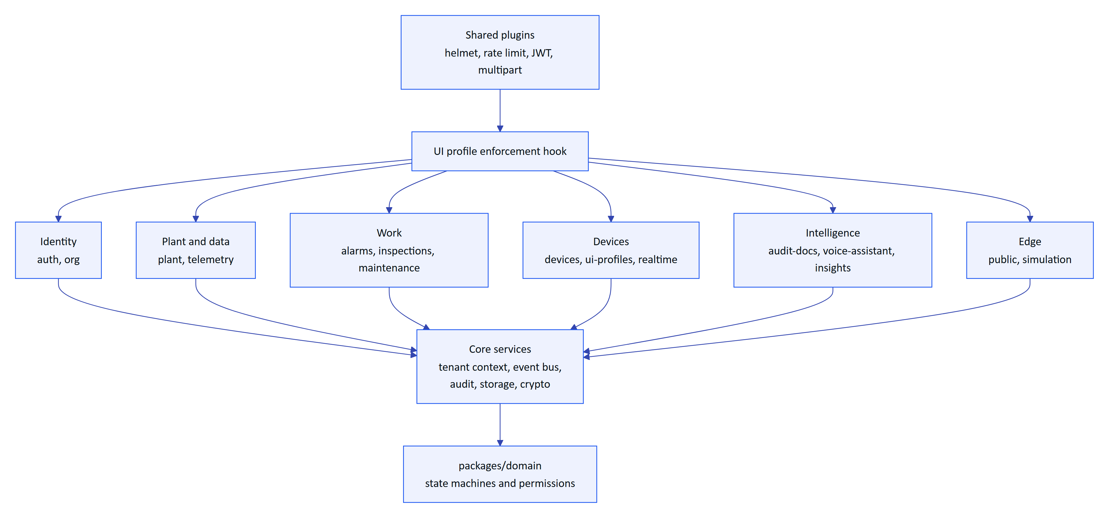
Figure 75. Module map. Route modules sit on shared plugins and core services; the domain package supplies rules.
Table 58. API modules and what each owns (route counts from apps/api/src/modules/*.ts)
Module | Routes | Owns | Rule worth knowing
auth | 17 | Sign-in, MFA, refresh, invitations, resets, sessions, org switch | Lockout after 5 failures for 15 min
org | 13 | Organization, members, notifications, audit log, platform orgs | No role escalation
plant | 28 | Sites, facilities, areas, assets, sensors, gateways, documents, attachments | Attachments only through the authorised route
telemetry | 6 | Ingestion, manual and lab entry, history, CSV, corrections | One ingest() path, idempotent per sensor and time
alarms | 9 | Rules, events, transitions, stale-data evaluation | Deadband, on-delay, note required to resolve
inspections | 15 | Templates, routes, inspections, responses, review | Offline replay by client operation id
maintenance | 7 | Work orders, checklists, activity | Transitions from the domain package
devices | 16 | Pairing, device tokens, device context, fleet admin | Session version and refresh family revocation
ui-profiles | 13 | Glasses UI profiles, versions, assignments | Enforced on device requests
realtime | 1 | Event stream (SSE) | Per-connection, per-event authorisation
audit-docs | 12 | Scanned records: capture, enhance, review, verify, approve, PDF | Four-eyes approval, optimistic concurrency
voice-assistant | 1 | Grounded spoken answers | Read-only tools, 60 per min
insights | 4 | Overview KPIs, document assist, search, reports | Read-only
public | 1 | Website contact and demo requests | 5 per 10 min
simulation | 3 | Demo scenarios | Synthetic data refused for customer tenants

9.3 The request lifecycle
Every authenticated call follows the same path, and the order is deliberate. The principal is resolved from the database on every request, so a revoked session or device stops working at once, not when its token expires. Device principals then pass the UI profile check. Only then does the handler run, inside a tenant transaction where Postgres itself filters rows.
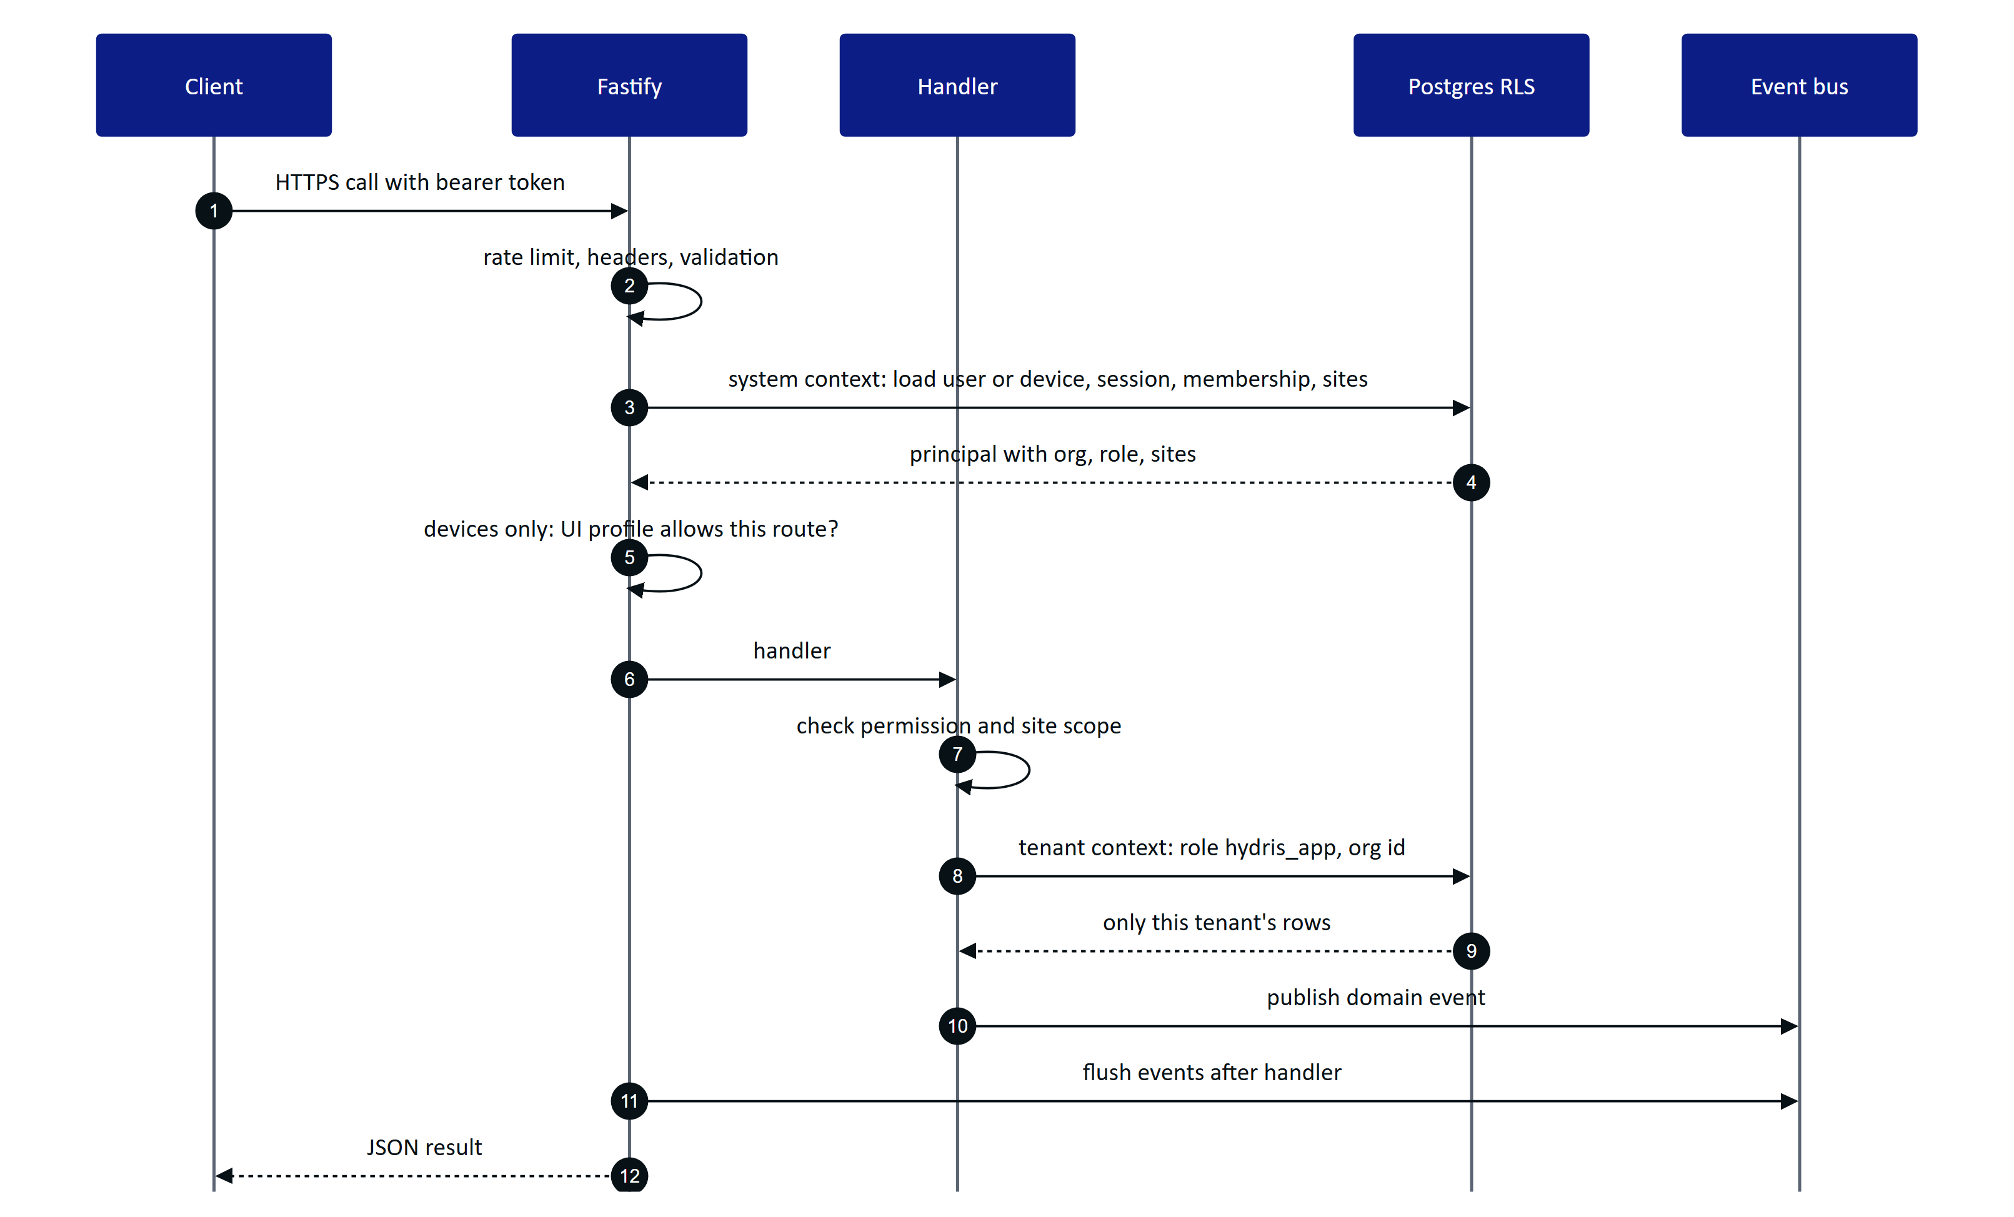
Figure 76. Request lifecycle. Authentication reloads the principal; the handler runs in a tenant transaction; events flush after the response is built.
Three outcomes are worth naming. Out-of-scope records return 404, not 403, so a user cannot probe for another site's assets. Every error uses one JSON shape with a stable code (validation_failed, note_required, stale), which the clients turn into plain messages. Unexpected errors return a masked 500 and the stack stays in logs.

9.4 Identity, sessions and device tokens
People sign in with email and password (argon2id hashing, optional TOTP MFA). They receive a 15-minute access token and a 7-day refresh token in an httpOnly cookie. Every refresh rotates the token within a family; a rotated token presented again after a 30-second multi-tab grace is treated as theft and the whole family is revoked. Because each access token carries its family id and the API checks the family on every request, logout and theft detection take effect immediately.
Devices never see a password. Glasses and phones pair through a flow shaped like the OAuth device authorisation grant (RFC 8628): the device shows a short code, a signed-in person approves it with a site and an operator, and the device receives its own tokens. A device then acts on behalf of its assigned operator, capped by a fixed ceiling of 13 device permissions.
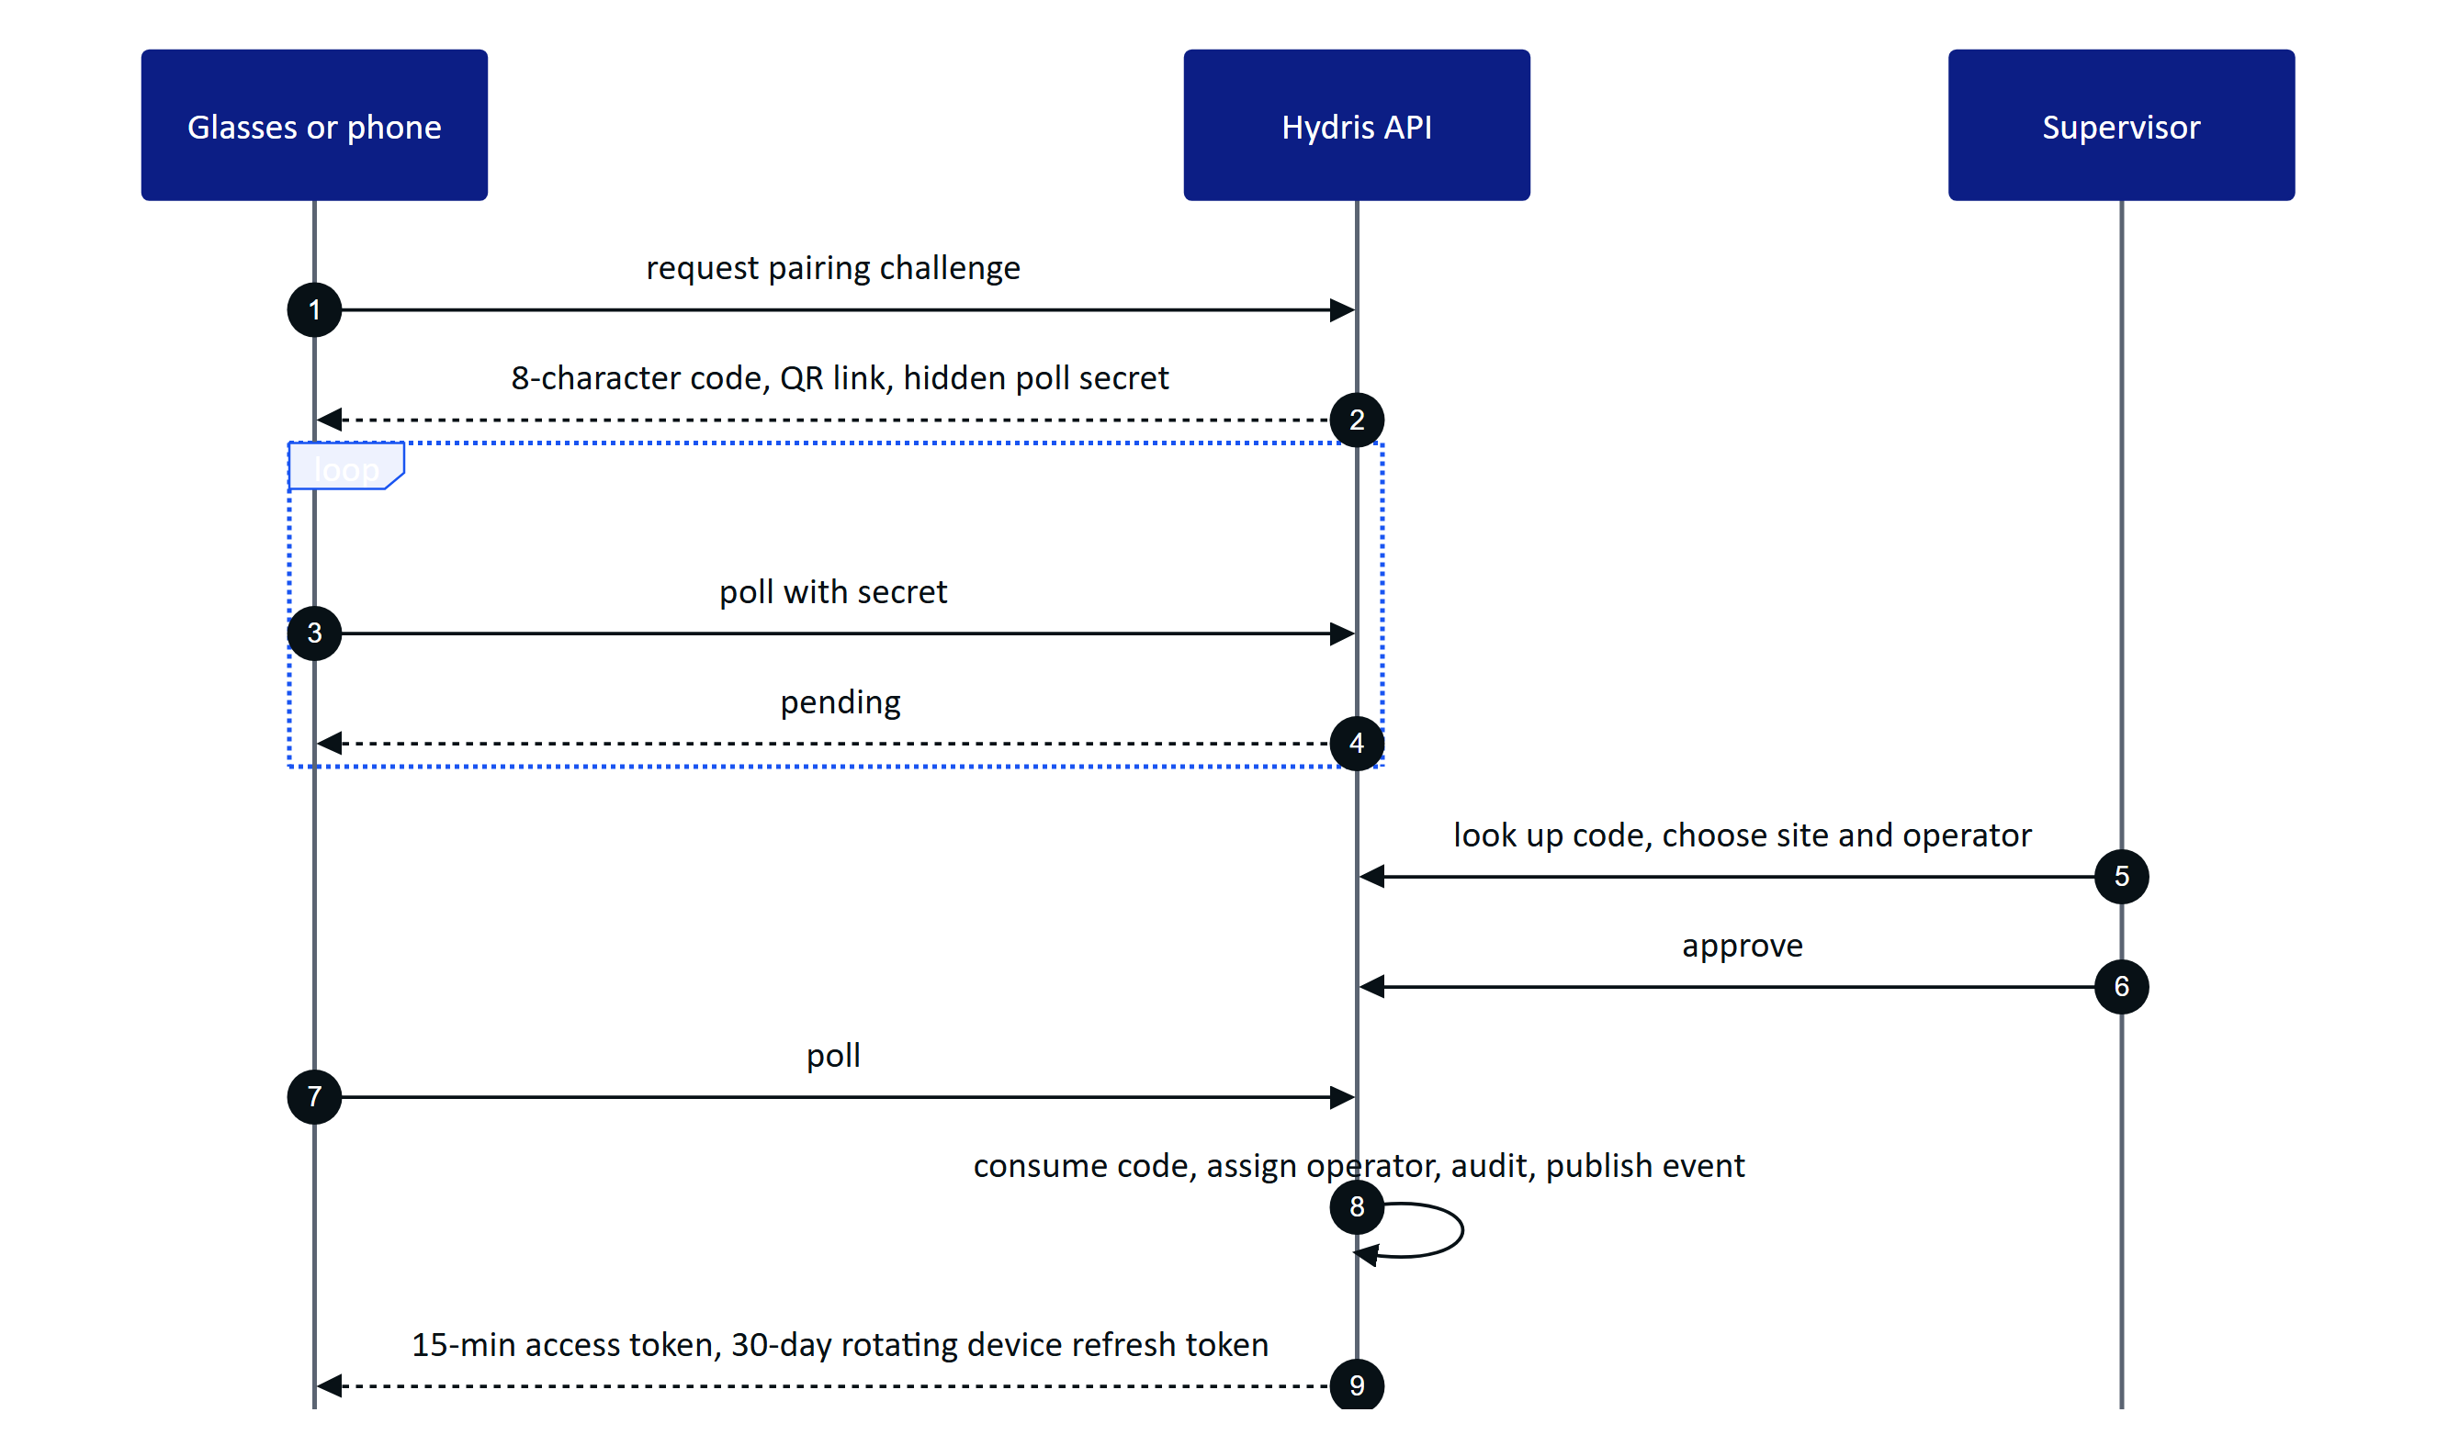
Figure 77. Device pairing. The code is single use, expires after 300 s, and no credential is ever shown on screen or in a QR code.
Table 59. Credentials at a glance
Credential | Lifetime | Revoked by
User access token | 15 min (12 h in demo mode only) | Family revocation, checked per request
User refresh token | 7 days, rotating | Logout, password change, reuse detection, session list
Device access token | 15 min | Session version bump on suspend, revoke, reassign
Device refresh token (hgd_) | 30 days, rotating | Revoke, logout, reuse detection
Gateway key (hgw_) | Until revoked | Admin revoke; stored only as a hash

9.5 Realtime events
Alarms, telemetry, work updates and device changes reach clients over Server-Sent Events. The stream is opened with fetch, so the bearer token travels in a header and never in a URL. Events carry identifiers and small payloads; clients refetch through the normal API, so authorisation is never bypassed. Every event is checked per connection (organization, target user or device, site, permission) before it is sent.
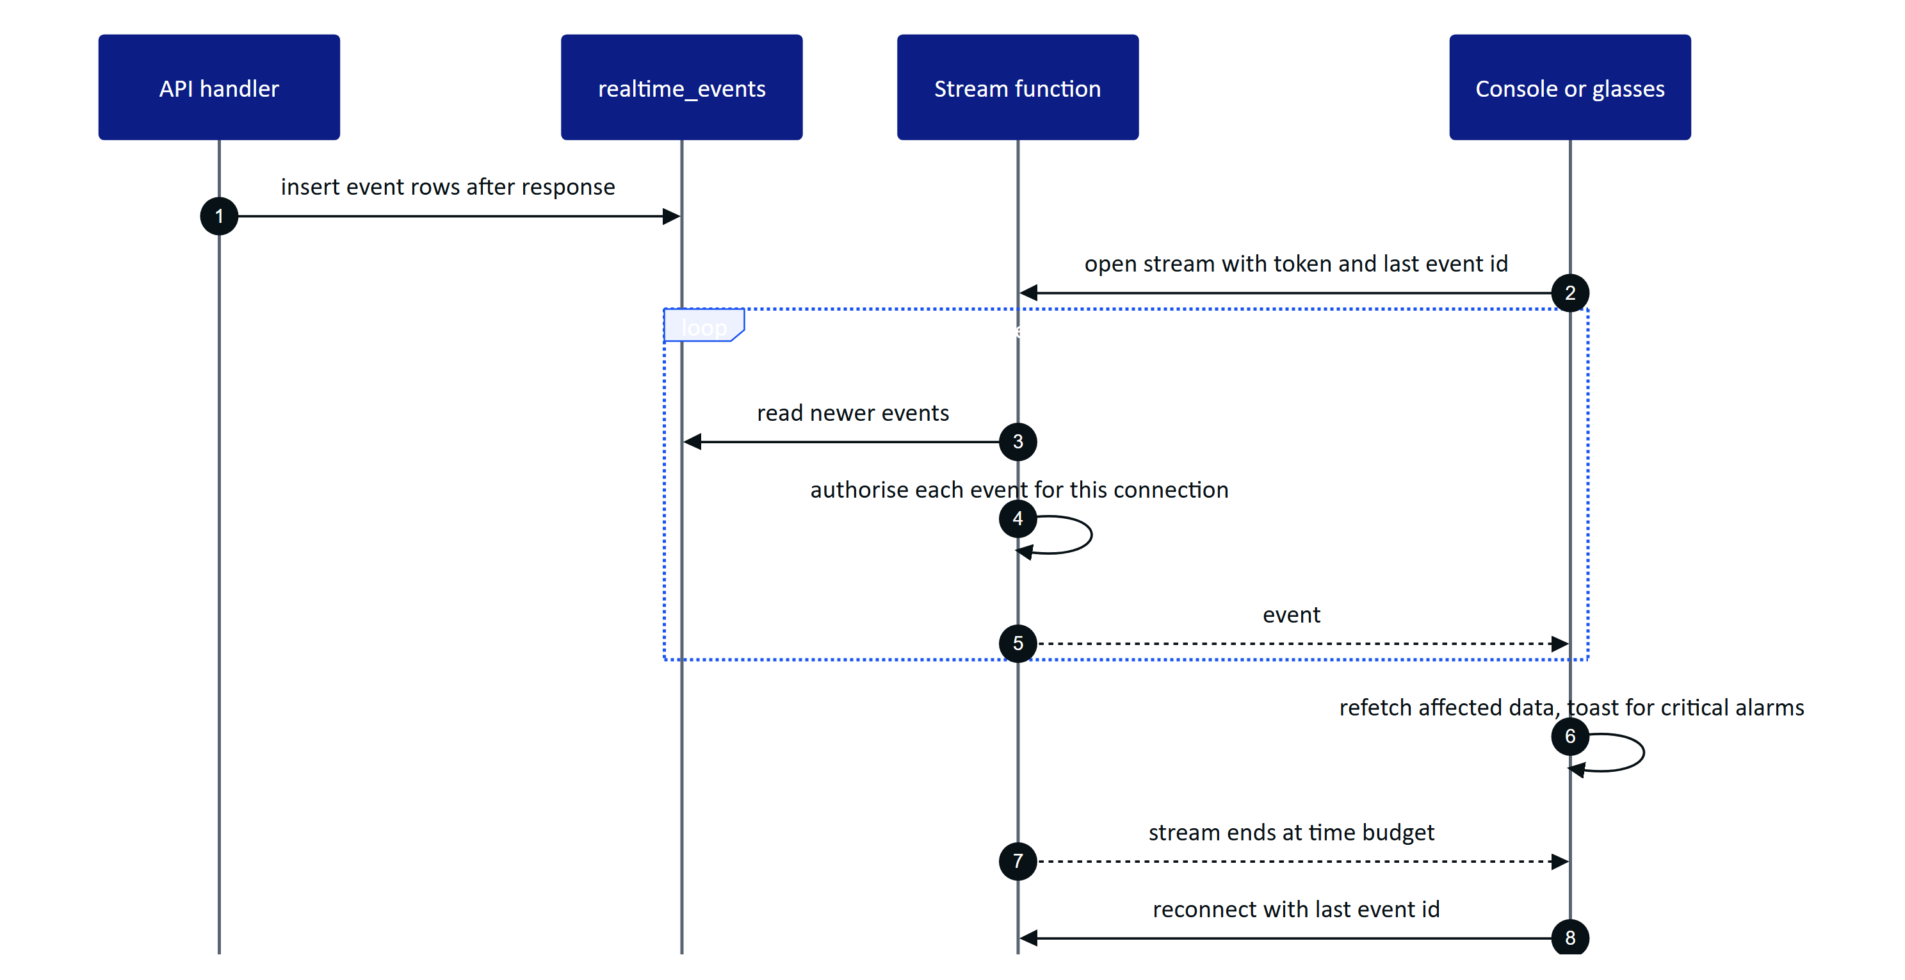
Figure 78. Realtime in db mode. A handler writes event rows; each open stream polls, filters per connection and resumes after reconnect without gaps.
Table 60. Realtime modes (REALTIME_MODE in apps/api/src/core/events.ts)
Aspect | memory | db
Fan-out across instances | No, single instance | Yes, all instances read one table
Replay on reconnect | Last 1,000 events | Any event still stored (pruned after 1 day)
Latency | Immediate | Up to 1.5 s poll
Used by | Docker Compose, long-running server | Vercel, demo, multi-instance

The console batches cache invalidations every 1.5 s but raises a toast at once for critical and high alarms; the Android app raises a system notification.

9.6 The data model by domain
The schema has 42 tables in ten domains, each owned by one module. Plant objects are archived, not deleted; telemetry and the realtime log use big integer keys; everything else uses UUIDs. Four views carry the essentials.
8  identity and tenancy tables  users are global, membership is per org |  | 8  plant and telemetry tables  site to sensor hierarchy, immutable readings |  | 11  alarm and work tables  rules, events, inspections, maintenance |  | 10  device, UI and audit document tables  pairing, profiles, scanned records

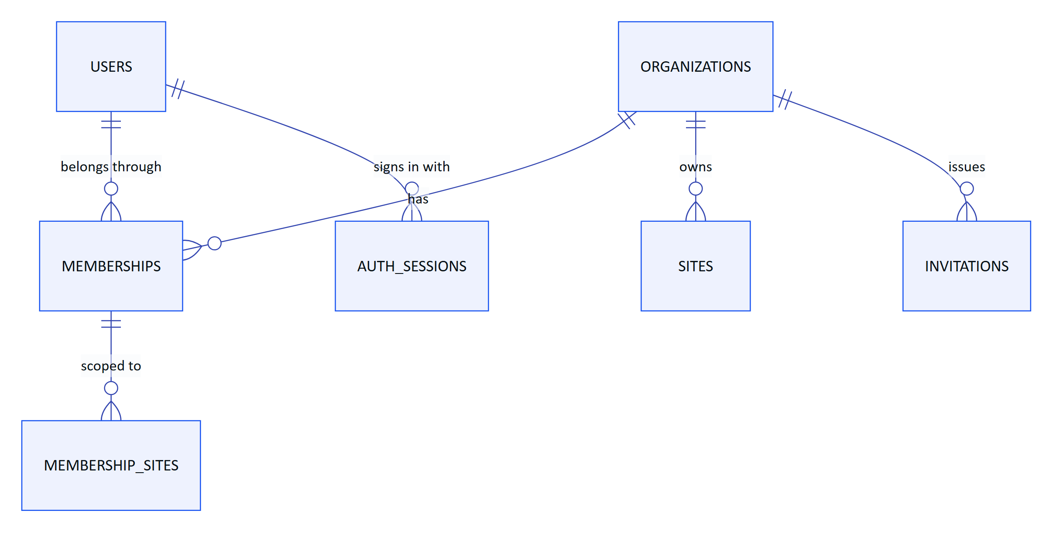
Figure 79. Identity and tenancy. A global user joins organizations through memberships, optionally scoped to sites.
Figure 80. Plant, telemetry and alarms. Readings are immutable; corrections and alarm events reference them.
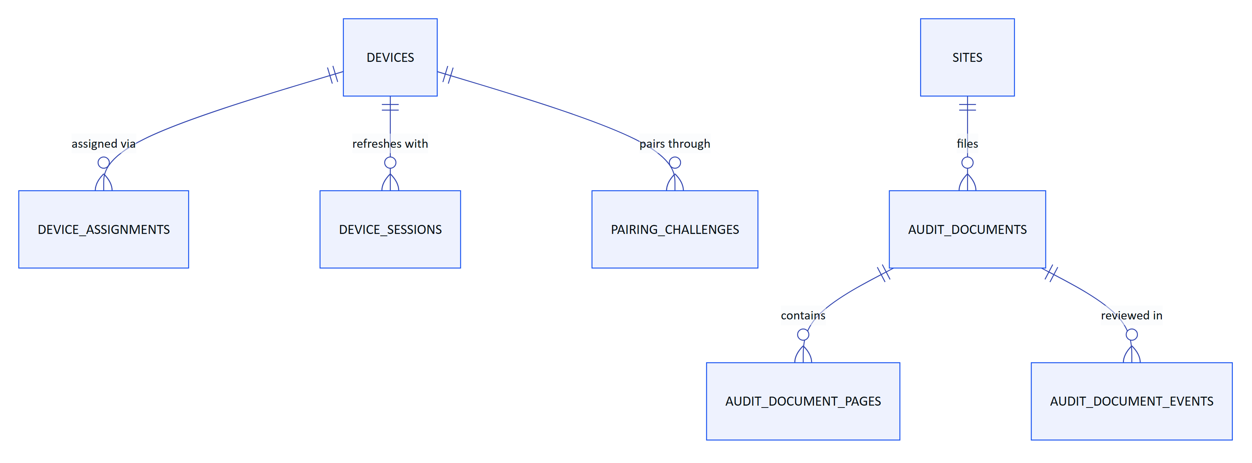
Figure 81. Devices and scanned audit documents. A device is assigned to one operator; a document holds pages and an append-only event trail.
Work (inspection templates, routes, inspections, responses, maintenance tasks and activity) hangs off sites and assets in the same way, and inspection records carry a revision counter for safe offline replay. Records are evidence: manual and lab readings keep provenance, corrections never overwrite the original reading, and synthetic data is marked and refused for customer tenants by a database check.

9.7 Tenancy and data isolation
Isolation is enforced by Postgres, not only by application code. Every tenant table has row-level security enabled and forced, with one policy that compares the row's organization with a per-transaction setting. Requests run as a non-privileged role, hydris_app, that cannot bypass the policy.
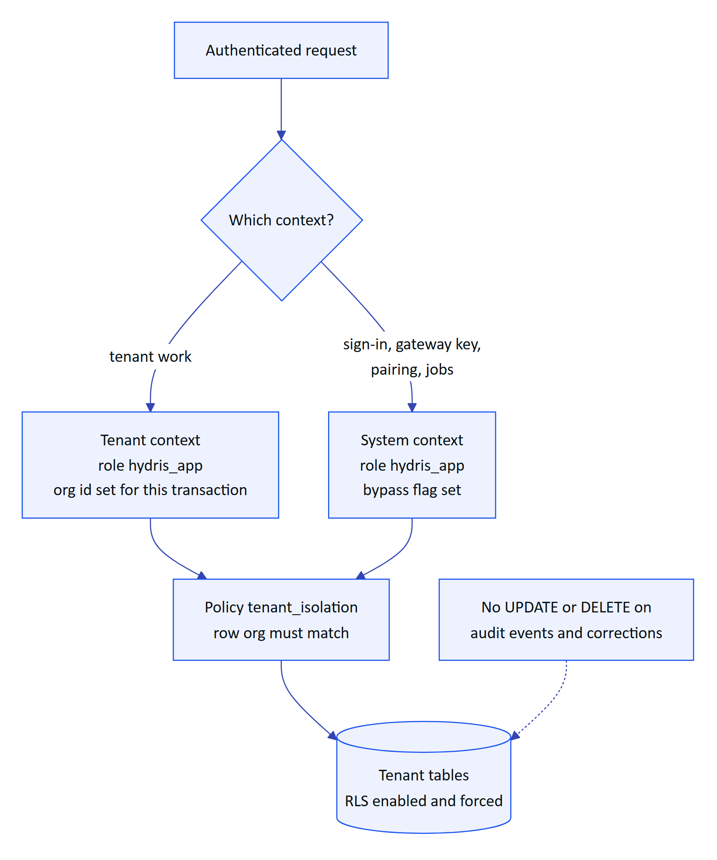
Figure 82. Tenant isolation. Both contexts run as the non-privileged role; only the session settings differ.
Settings use SET LOCAL, so nothing leaks to the next request on a pooled connection. Append-only grants hold even in system context. The application adds RBAC (six roles, 38 permissions in packages/domain/src/roles.ts) and site scope on top, so a forgotten filter in a handler is a non-event rather than a breach.
WARNING
Owner and superuser connections bypass RLS. Production must connect as a runtime user that is a member of hydris_app and not the table owner. Today the same owner user runs migrations and the application.

9.8 Telemetry ingestion and integrations
Hydris never connects into a plant. A gateway on the customer side pushes readings outward over HTTPS with a hashed hgw_ key, up to 500 readings per call. Ingestion is idempotent per sensor and timestamp, so a gateway can retry safely after an outage, and it returns per-reading rejections so the gateway can retry or drop single readings. Manual and lab entries and the demo simulator use the same ingest() path.
Figure 83. Telemetry flow from the plant to an alarm. The edge gateway and MQTT or OPC UA adapters are planned; the HTTPS contract is built.
Design details keep alarms honest: late data is stored for history but does not overwrite a newer value or re-trigger rules; once in alarm, a value inside the deadband reports "holding" so a noisy signal does not flap; a breach must persist for the on-delay before an alarm is raised; and there is one open event per rule. Stale-data rules cannot run on ingestion, because the problem is the absence of readings, so they run as a background job.
Table 61. Integration status
ID | Integration | Status
FR-022 | HTTPS gateway ingestion, 500 readings per call, idempotent | Built
FR-023 | Manual and lab entry with provenance | Built
FR-024 | Append-only corrections | Built
FR-027 | MQTT and OPC UA ingestion adapters | Planned (Advanced)
FR-028 | Read-only SCADA and historian connectors | Planned (Advanced)
FR-029 | Synthetic data labelled and refused for customer tenants | Built
n/a | Edge gateway software (store and forward) | Planned; API contract Built

9.9 AI services and the human in the loop
Two features use a model (Claude, through @anthropic-ai/sdk), and both are optional. Without a credential, audit scans keep their on-device OCR results and the assistant uses a deterministic rules engine. The model never sees the database: the assistant can only call five read-only tools (get_readings, get_open_alarms, get_my_work, get_asset, search_procedures), and they run inside the caller's tenant transaction, so RLS and site scope apply to every lookup.
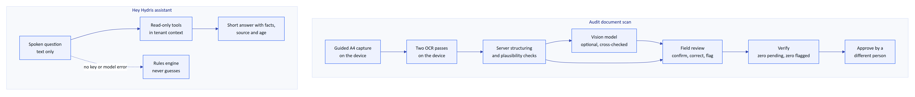
Figure 84. AI flows. Vision adds a second opinion to on-device OCR; the assistant answers only from tenant-scoped tools; people decide what becomes a record.
Table 62. AI requirements
ID | Requirement | Status
FR-063 | Optional vision engine cross-checked against OCR text | Built (needs API key)
FR-064 | Field review; verify requires zero pending and zero flagged items | Built
FR-065 | Independent four-eyes approval | Built
FR-072 | Assistant answers only from tenant data; rules fallback never guesses | Built
FR-078 | Assistant has no write tools | Built
NFR-035 | Only values returned by tools in the same conversation | Built (prompt and tool design)
NFR-037 | Graceful degradation without the model | Built
NFR-039 | Human in the loop for every AI-extracted value | Built
NFR-040 | Model provider and region documented per tenant | Planned (GA)

Vision cannot replace an extraction once review has started, and every review write carries a revision so a lost race returns a conflict instead of overwriting a colleague's work.

9.10 Background jobs
Four jobs keep the platform current. On a long-running server they run on timers; on Vercel they run from a cron route protected by a secret; in demo mode a lazy ticker advances them on API activity.
Table 63. Background jobs by topology
Job | Long-running server | Vercel today | Demo
Stale-data alarm rules | Every 30 s | Daily (0 3 * * *) | Not ticked
Pairing challenge expiry | Every 60 s | Daily | Expiry checked on use
Realtime event pruning (older than 1 day) | Hourly | Daily | Per instance
Simulation steps | Every 5 s per run | Daily | On activity, at most every 5 s

WARNING
In the all-Vercel topology stale-data alarms are raised at most daily (FR-035 Partial, TD-02). A production plant needs a per-minute scheduler or the API in a container.

9.11 Key architecture decisions
Table 64. Architecture decision records (all Accepted, ARCHITECTURE.md)
ADR | Decision | Why | Trade-off
002 | Fastify modular monolith | One deployable, in-process calls | Modules must stay disciplined
003 | API inside the Next.js route with app.inject | One Vercel project, no network hop | Cold start builds the app and migrates
004 | Postgres RLS plus RBAC and site scope | Strong isolation in one schema | Every request is a transaction
005 | PGlite for development, tests and demo | Real Postgres semantics, no service | Per-instance memory in demo
007 | SSE over fetch for realtime | Works on serverless and proxies; token out of URLs | Polling in db mode
008 | Two event bus modes, memory and db | No extra infrastructure | 1.5 s latency in db mode
009 | On-device dual OCR, vision optional | Works offline and without AI | Vision only improves layout
011 | RFC 8628-style pairing | No credential on screen or in a QR | Code TTL, no attestation yet
012 | Push-only HTTPS ingestion from an edge gateway | Hydris stays outside control networks | Customer or partner runs the gateway
013 | Short JWTs plus rotating refresh tokens checked per request | Immediate revocation | One lookup per request
015 | LLM grounded through tenant-scoped tools with fallbacks | Answers cite real readings | Narrower coverage without the model
016 | Pure domain package shared by server and web | One definition of rules | Android mirrors by hand

9.12 Platform requirements and NFRs
Table 65. Platform requirements (IDs from PRD.md)
ID | Requirement | Status
FR-003 | Refresh rotation with family revocation on reuse | Built
FR-007 | Site-scoped permissions for every role except org admin | Built
FR-008 | Database-enforced tenant isolation | Built
FR-033 | Realtime push of alarm events to all clients | Built
FR-050 | Pairing with short code, QR, 5-min TTL, 3 s polling | Built
FR-051 | Device tokens with rotating refresh and reuse detection | Built
NFR-001 | API read latency p95 under 300 ms in-region | Partial (target, not measured)
NFR-002 | Realtime alarm delivery 2 s or less | Built (design, target not measured)
NFR-007 | Horizontal scale of realtime | Built (db mode)
NFR-008 | Scheduled jobs at a cadence suitable for real data | Partial (daily on Vercel)
NFR-009 | Backups and tested restore | Planned
NFR-011 | Tenant isolation enforced in the database | Built
NFR-012 | Short-lived credentials | Built
NFR-013 | Rate limiting | Built (per instance)
NFR-030 | Provenance on every reading | Built
NFR-031 | Optimistic concurrency on review records | Built
NFR-032 | Shared domain logic between server and clients | Built

9.13 The technical debt that matters
The register in ARCHITECTURE.md lists 18 items. These are the ones that decide whether a pilot runs well and whether the platform scales.
Table 66. Technical debt that matters
ID | Debt | Impact | Fix
TD-01 | Root .gitignore hides the Android data package | A fresh clone of the Android app does not compile | Anchor the rule, commit the package
TD-02 | Vercel cron runs daily | Stale-data alarms up to a day late | Per-minute scheduler or hybrid topology
TD-03 | In-memory rate-limit store | Limits are per instance | Shared store or edge firewall
TD-04 | Audit page images in Postgres as base64 | Database and backup growth | Object storage behind the storage adapter
TD-05 | Empty contracts package; Android models by hand | Contract drift | Generate schemas and Kotlin models
TD-06 | No CI pipeline | Regressions found late | GitHub Actions workflow
TD-07 | db realtime polls every 1.5 s per stream | Database load grows with connections | LISTEN/NOTIFY or managed pub/sub
TD-10 | No telemetry partitioning or retention | Index cost at volume | Monthly partitions, retention per contract
TD-11 | Ingestion evaluates rules reading by reading | Throughput ceiling | Batch inserts and rule loading
TD-12 | No content security policy | Weaker defence against injected scripts | Nonce-based CSP

NOTE
Planning estimates, not measurements: at 200 sensors per site reporting every minute, one site produces about 288,000 readings a day. The bottlenecks arrive in the order TD-11, TD-07, TD-10, TD-04, which is the order the scaling plan addresses them.

10 Security, delivery and operations
Hydris puts cameras on workers' faces and turns plant readings into regulated records. Trust is therefore part of the product, not a layer on top. This part covers how Hydris protects customers and workers, how it maps to the frameworks buyers ask about, where it runs, how quality is proven, and how a customer is onboarded and supported. Every target is labelled as a target; nothing here is a certification.
3  layers of access control  RBAC, site scope, Postgres RLS |  | 15 min  access token lifetime  rotating refresh with reuse detection |  | 0  write paths to plant control  read-only to PLC, SCADA and DCS |  | 2  people per approved record  verifier and a different approver

10.1 Security model
Eight principles shape every design choice: read-only to the plant; defence in depth for tenancy; records are evidence (append-only trails); least privilege for devices; secrets never stored in the clear; AI assists, people decide; capture on intent only; privacy by default.

Trust boundaries
A trust boundary is anywhere data crosses between a party or runtime Hydris controls and one it does not. Five boundaries matter.
Figure 85. Trust boundaries. Data crosses five boundaries, each with its own controls.
Table 67. Top threats and controls (STRIDE extract from SECURITY_PRIVACY.md)
Threat | Scenario | Control in the product | Open gap
Spoofing | Password guessing, credential stuffing | argon2id, lockout after 5 failures, 10 sign-ins per min, optional TOTP | No SSO, MFA not enforceable per org
Spoofing | Rogue device pairs into an org | Signed-in approver with device.pair, 300 s single-use code, hashed poll secret | No device attestation
Tampering | Silent edit of readings or records | Append-only corrections and audit events at the grant level | No signed export or hash chain
Information disclosure | Cross-tenant read | RLS forced, 404 for out-of-scope records | Owner connection would bypass RLS
Information disclosure | Stolen phone | Keystore AES-256-GCM on Android, device revoke | Web glasses keep the token in localStorage
Denial of service | Login or ingest floods | Rate limits, 500 readings per call, body limits | Limits are per instance
Elevation | Device calls admin endpoints | Fixed device permission ceiling; verify and approve need a person | None known
AI | Prompt injection in a scanned page | Strict output schema, OCR cross-check, human review | No injection classifier

Privacy for camera glasses and workers
The camera only runs when a person asks for it, and only the final page leaves the phone.
Figure 86. Camera on intent. Preview frames stay on the phone; only a reviewed page image is uploaded.
Table 68. Camera and worker commitments
Commitment | Status
No background or continuous recording, no video stored | Built
Only text after "Hey Hydris" is sent; audio never uploaded to Hydris | Built
Meta capture LED cannot be disabled by apps | Vendor control
No location tracking, no keystroke or gaze analytics, no individual performance reports | Built (by design)
Face and badge redaction before upload | Planned
Camera-free zones per site | Planned

10.2 Compliance mapping
The table maps frameworks to product controls. It is a mapping and a set of targets, never a claim of certification.
Table 69. Compliance mapping (targets, not certifications)
Framework | What it asks | Hydris controls | Position
India DPDP Act 2023 and Rules 2025 | Notice, safeguards, breach notice, erasure, retention limits | Encryption, RLS, audit trail, consent version on inquiries | Partial; retention and rights tooling planned
CPCB and SPCB consent conditions | Unaltered, retrievable monitoring records | Provenance, append-only corrections, freshness, CSV export | Mapping; Hydris is not the regulatory feed
CERT-In Directions 2022 | 6-hour incident reporting, 180-day logs in India | Incident plan; India log drain planned | Target
ISO/IEC 27001:2022 | ISMS and Annex A controls | Many technical controls in code | Target: ISMS build 2027
IEC 62443 | Zones and conduits, secure development | Read-only, outbound-only conduit from the DMZ gateway | Mapping; 4-1 practices as target
SOC 2 | Security, availability, confidentiality | Same controls | Target: Type I after first commercial year

Retention today is indefinite for records, with only realtime events pruned after a day. The recommended defaults (for example audit trails at least 7 years, sessions purged 30 days after expiry) are configurable per organization and Planned.

10.3 Deployment topologies
The same code runs in four shapes. A customer chooses by residency, network rules and operations appetite.
Figure 87. Topology selection for a new customer
Table 70. Topologies
Topology | Shape | Status
A, managed SaaS | Vercel functions, Neon Postgres, private Blob | Built (live as demo); production Planned
A-IN, India region | Mumbai functions, Indian database and S3, India log drain, AI off unless an addendum is signed | Planned
B, container API | Vercel web, API container next to managed Postgres | Partial (render.yaml)
C, plant edge | Postgres 17, API and web on one plant server | Built (docker-compose.yml)
D, hybrid gateway | A or A-IN plus an edge gateway pushing over HTTPS | API Built; gateway Planned

Table 71. Environment matrix
Environment | Purpose | Database | Status
dev | Local development | PGlite on disk | Built
preview | One per pull request | Neon branch (target) or demo mode | Partial
staging | Release candidate, hardware tests, pilot rehearsal | Neon staging branch | Planned
prod | Customer tenants | Neon production, region pinned, point-in-time recovery | Planned
demo | Public sales demo | In-memory PGlite per instance, public secrets | Built

Release pipeline
Today there is no CI: a push to main deploys through Vercel's Git integration, and tests are run by developers. Migrations run on cold start under an advisory lock. The proposed pipeline gates every pull request and every release tag.
Figure 88. Proposed CI and release pipeline (Planned)
DECISION
Demo and production split into two Vercel projects on the same repository: demo tracks main with no database, production deploys only on release tags after the staging gate (DEP-11).

10.4 Quality
Hydris tests from fast, deterministic checks at the base up to field trials at a plant.
Figure 89. Test pyramid, from fast deterministic tests to field trials
The 67 domain and API tests pass (22 October 2026). They cover the security-critical paths: tenant isolation at the database, four-eyes approval, refresh reuse, pairing, alarm hysteresis and the db realtime mode. The four Playwright journeys were not re-run for this edition. The Android app has no automated tests yet and was verified by hand on a Pixel 7 emulator.

OCR and voice accuracy design
Accuracy is measured with benchmarks, all targets for the first pilot.
Table 72. Benchmark design (targets)
Benchmark | Set | Primary metric | Target
OCR | 120 pages: printed lab reports, filled templates, handwritten logbooks, tables, degraded captures; ground truth keyed twice | Silent error rate (wrong but marked as matching) | Under 0.5 %
OCR | Same | Field accuracy | 90 % printed, 75 % handwritten
Voice | 600 utterances by at least 6 speakers in quiet, 65 and 85 dB(A) | Hallucinated numbers | 0
Voice | Same, including 40 unsafe action requests | Unsafe compliance | 0
Voice | 8 hours of plant conversation | Wake false accepts | Under 1 per hour

DECISION
The silent error rate is the primary OCR metric. A system that is 85 % accurate and flags what it is unsure of is safer than one that is 95 % accurate and confidently wrong on the rest.

Release gates and pilot exit
Table 73. Release gates
Gate | Criteria
1, pull request | Typecheck and tests green; new behaviour has tests
2, main | Build, Playwright, accessibility and dependency audit clean
3, release candidate | OCR and voice benchmarks in tolerance; load and security scans clean
4, pilot readiness | Hardware rows H1 and H5 passed; zero open S1 and S2 defects; signed review

Pilot exit criteria, as of today:
- ☑ Domain and API suites pass (67 of 67)
- ☑ Tenant isolation proven at the database boundary
- ☑ Four-eyes approval enforced outside demo tenants
- ☐ CI running gates 1 and 2 on every pull request
- ☐ Email transport wired for invitations and resets
- ☐ Stale-data rules running every minute on Vercel
- ☐ OCR and voice benchmarks run within targets
- ☐ Hardware rows passed on Ray-Ban Meta and a rugged phone
- ☐ External penetration test with no open high findings

10.5 Operations

Customer onboarding
Figure 90. Customer onboarding from organization creation to go-live
Figure 91. Typical six-week pilot for one plant with up to ten operators (plan, not a commitment)

Support and incidents
Operators go to their supervisor, the supervisor to the customer admin, and the customer admin to Hydris.
Table 74. Support tiers
Tier | Handles
Customer admin | First line inside the plant: users, pairing, profiles
Hydris L1 | Anything a documented runbook procedure resolves
Hydris L2 | Configuration, logs and platform-admin actions
Hydris L3 | Code, data and infrastructure; postmortem for Sev 1 and 2

Table 75. Incident severity (targets)
Severity | Definition | Response | Customer update
Sev 1 | Platform down or data at risk, including any suspected breach | L3 within 15 min | Within 1 hour, then hourly
Sev 2 | Major function down, no workaround | L3 within 1 hour | Within 2 hours, then every 4 hours
Sev 3 | Degraded, workaround exists | Next business day | Daily
Sev 4 | Minor or cosmetic | Planned release | On release

A suspected breach also triggers external notices: customers within 24 hours, CERT-In within 6 hours for reportable incidents, and the DPDP Board and data principals as the Rules require.

Operations KPIs
5 min  time to pair  target, median |  | 1 day  scan to verified  target, median |  | 5 min  critical alarm acknowledge  target, median |  | 99.5 %  monthly availability  target

Table 76. Operations KPIs (targets) and where they are measured
KPI | Target | Source in the product
Pairing success on first code | Over 90 % | Completed vs expired challenges
Verified to approved | Median 2 business days | Audit document timestamps
Rescan rate | Under 10 % | Rejected vs total documents
Alarms resolved with a note | 100 % (enforced in code) | Resolve transition
Sensors live | Over 98 % of sensor-hours | Freshness history
Devices connected on shift | Over 95 % | Device report

10.6 Known gaps register
The gaps below are drawn from the security, deployment and architecture registers. Each has an owner and a plan; the quadrant shows how they compare.
Table 77. Known gaps that matter before pilot and GA
ID | Gap | Impact | Priority
DEP-01 | No CI pipeline | Regressions and unsafe migrations can reach production | High
DEP-02 | Cron runs daily on Vercel | Stale-data alarms up to 24 h late | High
DEP-03 | Android release signed with the debug key | Cannot distribute through Play | High
DEP-04 | Email not wired | Invitations and resets need manual delivery | High
DEP-05 | No metrics, tracing or alerting | Incidents found by users | High
DEP-11 | Demo and production share one project | Customer data could land in a demo | High
SEC | Owner connection runs the application | RLS bypass if a query escapes the tenant role | High
SEC-03 | Web glasses keep the device token in localStorage | Token exposed to scripts on the origin | Medium
DEP-10 | Per-instance rate limiting | Weaker limits under many instances | Medium
DEP-06 | Audit page images in Postgres | Database and backup growth | Medium
DEP-07 | No retention or purge jobs | Unbounded growth; DPDP retention limits | Medium
TD-12 | No content security policy | Weaker defence against injected scripts | Medium

Figure 92. Gap risk quadrant (team assessment, not measured)

11 Roadmap and future products

11.1 Purpose of the roadmap
The minimum viable product is built and runs as a zero-configuration demo. The next twelve months turn it into something a plant can rely on every shift, then into something a regulator, a maintenance system and a control room can rely on too. This part is a plan, not a commitment: every date is an estimate that assumes the current team and no major change in Meta's developer programme, and effort figures are team estimates. Status labels follow the book: Built, Partial, Planned.
5  quarters planned  Q4 2026 to Q4 2027 |  | 8  themes  from hardening to ecosystem |  | 19  future features analysed  problem, outcome, dependencies |  | 1 to 2  pilot plants  ETP or STP, Q1 2027 (target)

11.2 Horizons: now, next, later
Table 78. Horizons, goals and exit conditions (plan)
Horizon | Window | Goal | Exit condition
Now | Q4 2026 to Q1 2027 | A pilot plant uses Hydris every shift without engineering support on site | Pilot exit criteria all checked; 4 weeks of daily use
Next | Q2 to Q3 2027 | A customer can buy, deploy and audit Hydris without Hydris engineers | GA release; SOC 2 Type I report; Play or MDM distribution; second paying site
Later | Q4 2027 and beyond | Hydris is the system of record for field work and compliance evidence at multi-site customers | A regulator accepts a Hydris compliance report; one CMMS integration live

Confidence falls with distance: scope is high-confidence for Now, medium for Next and low for Later; dates are medium, low and very low. Pilot customer dates, Meta DAT access, pilot KPIs and team size are what move them.
Figure 93. From MVP to system of record: what each horizon unlocks (plan)

11.3 Timeline, Q4 2026 to Q4 2027
The timeline and Gantt chart are the plan as of October 2026 and are re-baselined at the end of every quarter.
Table 79. Quarter summary (plan)
Quarter | Headline | Key deliverables | Exit signal
Q4 2026 | Make it reliable | CI, email transport, cron schedule, audit images to object storage, purge jobs, Android pilot build | Test gates green on every change
Q1 2027 | Prove it in a plant | Ray-Ban Meta hardware matrix, pilot plant 1, field trial, KPI baseline | Pilot exit criteria met
Q2 2027 | Make it buyable | GA: push notifications, offline outbox, SSO, MDM, SOC 2 Type I readiness, India-region production | Second site signed
Q3 2027 | Make it compliant and connected | E-signatures, edge gateway, Hindi voice | First e-signed record approved at a customer
Q4 2027 | Make it intelligent | SOP copilot, gauge reading, first CMMS connector, OCEMS report drafts | Copilot used weekly by 50 % of operators (target)

Figure 94. Quarter plan as a Gantt chart (plan; bars are estimates)

11.4 Known gaps to close first
These are the debts that would hurt a pilot. They come before any new product.
Table 80. Known gaps and tech debt, in priority order
Gap | Impact | Fix | Target
No CI pipeline | Regressions reach the demo | Typecheck, unit, API and e2e gates on every change (NFR-010) | Q4 2026
Email not sent | Invitations and resets never arrive | Email transport for the outbox (FR-086) | Q4 2026
Cron runs daily on Vercel | Stale-data alarms evaluated once a day (FR-035) | Per-minute schedule or external scheduler | Q4 2026
Audit images stored in Postgres | Database bloat, slow backups | Object storage with lifecycle | Q4 2026
No purge jobs | Expired sessions, challenges and sent mail kept indefinitely | Purge 30 days after expiry | Q4 2026
No Android automated tests | Manual regression only | Android test suite | Q4 2026
DAT paths unverified on hardware | Glasses camera, button and microphone may fail on device (FR-055 to FR-057, FR-074) | Hardware test matrix | Q1 2027
Web glasses refresh token in browser storage | Token theft on a compromised device | Native app keystore (built); shorter or bound tokens for web | Q1 2027
No per-org opt-out of third-party AI | Blocks some customers | Organization setting | Q2 2027
No device attestation | Spoofed clients | Play Integrity | Q2 2027
Audit log not hash-chained | Weaker tamper evidence | Hash chain or WORM export | Q3 2027

11.5 Future products in brief
Each future product reuses a pattern already proven in the MVP: read-only and outbound-only towards the plant, machines propose and people confirm, and every value keeps its provenance.
Table 81. Future products (all Planned; effort is a team estimate)
Product | Problem it solves | Outcome | When (plan) | Effort
Edge gateway (OPC UA, MQTT, Modbus) | Each customer needs custom integration; Hydris accepts HTTPS batches only | A container in the plant network reads tags and forwards readings outbound over HTTPS, with store-and-forward and a tag-mapping UI (FR-027, FR-028) | Q3 2027 | RICE effort score 5 (estimate)
Offline-first sync | Plants have dead zones; only glasses inspections queue today | Android outbox with idempotent replay for acknowledgements and checklist ticks (FR-098) | Q2 2027 | 3 person-months
Predictive maintenance | Pumps and blowers fail with warning signs nobody watches | Per-asset baselines flag drift and create advisory maintenance tasks with evidence | Later | 6 person-months
SOP copilot (RAG) | Operators ask "how" and "why" questions that need long procedures | Answers from approved documents only, with citations, never inventing a step | Q4 2027 | 3 person-months
Multilingual voice | Operators speak Hindi, Tamil, Marathi, Gujarati | Same grounding guarantees in each language (FR-073): Hindi first, then Tamil and Marathi | Q3 2027 onwards | 4 person-months
Gauge reading by computer vision | Analogue gauges are read by eye and copied | "Read this": Hydris proposes a value with confidence, the operator confirms, the photo is kept | Q4 2027 | 5 person-months
Compliance reporting and OCEMS | Plants assemble CPCB and SPCB returns by hand | Evidence assembled with provenance, exceedances and data availability, draft returns for e-signed approval (FR-120) | Q3 to Q4 2027 | 4 person-months
E-signature | Approval has no signature manifestation | Re-authentication at signing, stated meaning, name and time bound to the record (FR-068) | Q3 2027 | 2 person-months
Display glasses | Ray-Ban Meta has no display, so operators look down at the phone | The existing heads-up layout renders on display glasses and industrial headsets behind a display adapter | Later | 3 to 5 person-months per target
iOS app | Some supervisors and managers carry iPhones | Supervisor companion first (alarms, reviews, approvals) | Later | 6 person-months
CMMS integrations | Hydris tasks would duplicate SAP PM or IBM Maximo work orders | Two-way sync of work orders and assets, plus webhooks for LIMS, ERP and ticketing | Q4 2027 onwards | 4 person-months for the first connector

Edge gateway and the compliance pipeline
Figure 95. How the edge gateway and compliance reporting extend today's ingestion (planned)
The gateway reuses the single ingestion path, so readings from industrial protocols carry the same guarantees as today's HTTPS batches. Compliance reporting then builds on verified scans and e-signatures; direct submission to regulator systems happens only where an official interface exists.

Display glasses and new inputs
Figure 96. Display adapter for future display glasses and headsets (planned)
The heads-up layout and input abstraction already exist; display targets plug in behind adapters. The dependency is Meta exposing display and Neural Band input to third parties, which is not available today.

11.6 Value versus effort
Figure 97. Value versus effort for candidate epics (team estimates)
Quick wins (push, SSO, e-signatures) land first because they unblock buying. Offline sync, OCEMS reports and the edge gateway are the big bets that make Hydris a system of record. iOS and predictive maintenance wait for evidence of demand and enough labelled history. A RICE score backs this ordering: push notifications score highest (270), then SSO (180) and offline sync (160); predictive maintenance scores lowest (5).
RISK
The biggest risks are a small team spread across too many surfaces, pilot customer delays (approvals, camera policy) and Meta DAT publishing staying gated for India-based developers. Mitigations: strict horizon discipline (Later items stay unstarted until GA), a site camera-policy pack and a second pilot candidate, and the phone-camera path, which works without DAT.

11.7 Success metrics per horizon
Every figure below is a target.
Table 82. Success metrics per horizon (targets)
Horizon | Metric | Target
Now | Pilot exit criteria complete | 100 %
Now | Rounds completed on time at the pilot | 95 %
Now | Median alarm acknowledgement, critical and high | Under 5 minutes
Now | Audit fields where independent engines agree | 90 %
Next | Weekly active operators over licensed operators | 70 %
Next | Paying sites | 3
Next | Offline actions synced without duplicates | 100 %
Next | SOC 2 Type I | Report issued
Later | Compliance reports generated in Hydris | Accepted by 1 regulator
Later | Copilot answers with citations | 90 % of answered questions
Later | Multi-site customers | 2

11.8 Release cadence
API and web ship continuously to staging and weekly to production after the gates, with S1 hotfixes within 24 hours. The Android app ships every two weeks through Play internal, closed and managed tracks, with glasses features behind remote flags. The edge gateway will ship monthly as signed container images inside a customer-controlled upgrade window, and this book is updated with each release.

